VaaaN/Engineering/SD/UM/013/00

**VaaaN Infra Tech Pvt. Ltd.**

**18-April-2015**



**Project:**

**Client:**

**Document No. TM103401D504**

**Document Ver. V1**

User Manual



**toll*M*ax®**

**User’s Manual**

**Version 5.0**



Copyright Notice

This document contains proprietary information of VaaaN Infra Pvt. Ltd. No part of this document may be reproduced, stored, copied, or transmitted in any form or by means of electronic, mechanical, photocopying or otherwise, without the written consent from VaaaN Infra Pvt. Ltd.

# Revision History

|  |  |  |  |  |
| --- | --- | --- | --- | --- |
| Version No. | Date | Prepared by/ Modified by | Reviewed by | Significant Changes |
| 1.0 | 23/7/2013 | Pankaj Sharma | Arun Yadav | First draft with toll basic functionality. |
| 2.0 | 28/7/2014 | Pankaj Sharma | Arun Yadav | ETC and SSWIM functionality updated. |
| 3.0 | 16/9/2014 | Pankaj Sharma | Arun Yadav | GUI and version changes up-gradation. |
| 4.0 | 17/04/2015 | Anu Singal  Pankaj Sharma | Arun Yadav | Multi user login functionality updated.  TCA-Towed, ODC-Re Cash up, TDAT-Associated transactions and GUI changes. Updating Reporting Feature. Added Depot functionality. Add hand held and backup service.  #To reset SSWIM via customized and normal keyboard.  #WDMS module addition. |
| 5.0 | 05/01/2016 | Pankaj Sharma | Arun Yadav | ETC manual, Exempt transaction with document scanner, Supervisor card for exempted transaction, POS multiple trips recharge option, Multi plaza smart card/Barcode validation, Smart card touch & go functionality, TDAT enhanced operation, Customer SMS notification for sale/recharge, Handheld data import functionality, Hardware manual/automatic control via TCA. |

**Table of Contents**

Revision History 3

Abbreviation/ Terminology 8

Audience 9

Reference Documents 9

Purpose of the Document 9

Scope 9

Introduction to toll*M*ax® 10

1. toll*M*ax® 11

1.1. Login………… 11

1.2. Screen Attributes 12

2. Toll Collection Application 12

2.1. Toll Collection System 13

2.1.1. Window Header 14

2.1.2. Selection of Vehicle class 14

2.1.3. Reg. No. 15

2.1.4. Pass ID 15

2.1.5. Description 16

2.1.6. Finish 16

2.1.7. Current Transaction 17

2.1.8. H/W Status 17

2.1.9. Vehicle Image 18

2.1.10. Last Two Transactions 18

2.1.11. Window Footer 20

2.1.12. Rate Profile 20

2.1.13. Journey Type 20

2.1.14. Payment Method 21

2.1.15. Types of Transaction 21

2.1.15.1. Cash Transaction 21

2.1.15.2. Exempt Transaction 22

2.1.15.3. Fleet Transaction 22

2.1.15.4. Towed Transaction 23

2.1.15.5. ETC Transaction 24

2.1.15.6. SSWIM Transaction 24

2.1.15.7. Bleed Off Transaction (Mid Shift Clearance) 26

2.2. Live Video Stream 27

2.3. User Multiple Login Restriction Functionality 27

2.4. Logout …………………………………………………………………………………………………………………………………………………..27

3. Operator Declare and Clearance module 28

3.1. Cash Float 29

3.2. End-Shift Clearance 31

3.3. End Shift Declare 35

3.4. Mid Shift Declare 40

3.5. Handheld 43

3.5.1. Create a Handheld User 43

3.5.2. Create a Handheld Device ID 44

3.5.3. Assign/Issue a Handheld Device to a Handheld User 44

3.5.4. See Details of Previous Issued Handheld Details 50

3.5.5. Receive Data from Handheld Device 50

3.6. Reliever Functionality 53

3.7.Shift Close Functionality 53

4. Transaction Discrepancy & Audit Tool 54

4.1. Search Criteria 54

4.2. Transaction List Count 59

4.3. Transaction Detail Section 59

4.4. Transaction Operation 62

5. Real Time Monitoring & Controlling System 65

5.1. How RTMCS Works 65

5.1.1. Lane 66

5.1.2. Barrier Gate 66

5.1.3. TLS 66

5.1.4. PRESENCE LOOP 66

5.1.5. EXIT LOOP 66

5.1.6. TLC DOOR 66

5.1.7. Transaction no 66

5.1.8. TC Class 66

5.1.9. Fare 67

5.1.10. Journey 67

5.1.11. Pmt. Mode 67

5.1.12. Amount 67

5.1.13. Date & Time 67

5.1.14. User ID 67

5.1.15. Events 67

6. Smart Card Operations 68

6.1. Smart Card 68

6.1.2. POS-Lane operations 69

6.1.3. Information 69

6.1.4. Card operations 70

6.1.4.1. Sale 70

6.1.4.2. Recharge 80

6.1.4.3. Refund 81

6.1.4.4. Blacklist 83

6.1.4.5. Balance Info 86

6.1.4.6. Card Replacement 88

6.1.4.7. Veh. Reg. Edit 89

6.1.4.8. Duplicate Receipt 91

6.1.4.9. Depot Details 91

7. Reporting 96

7.1. Report Selection 97

7.2. Report Category 97

7.2.1. Transactional Reports 97

7.2.1.1. Toll Rate Report 98

7.2.1.2. Traffic Count Report 100

7.2.1.3. Transaction Detail Report 100

7.2.1.4. AVC Transaction Report: 101

7.2.1.5. Mismatch Transaction Detail Report 103

7.2.1.6. Audited Transaction Detail Report 103

7.2.2. Configurational Reports 104

7.2.2.1. User Detail Report 104

7.2.3. MIS Reports 105

7.2.3.1. User Login-Logout Report 107

7.2.3.2. Journey Traffic Count 108

7.2.3.3. Day-Wise Traffic Count Report 109

7.2.3.4. Hourly Traffic Count Report 110

7.2.3.5. Exempt Transaction Report 111

7.2.3.6. Toll Event Report 112

7.2.3.7. AVC Accuracy Report 114

7.2.3.8. Traffic Count and Collection Summary Report 114

7.2.3.9. Traffic Count Summary Report 114

7.2.3.10. Exemption Report 114

7.2.3.11. Pass Multi Read Detail Report 115

7.2.3.12. Daily Traffic and Revenue Report 116

7.2.3.13. Monthly Traffic and Revenue Report 117

7.2.3.15. Traffic Revenue Histogram Report 119

7.2.3.16. Pie Traffic Revenue Histogram Report 119

7.2.3.17. Daily Traffic Revenue Histogram Report 121

7.2.3.18. Weekly Traffic Revenue Histogram Report 121

7.2.3.19. Shift Clearance Report 121

7.2.3.20. AVC Accuracy Class wise Comparison 122

7.2.3.23. User Login Report 123

7.2.3.24. Daily Shift Wise MIS Report 124

7.2.3.25. Manual Ticket Count Report 124

7.2.3.26. Lane Wise Revenue Report 124

7.2.4. Financial Reports 124

7.2.4.1. Revenue Report 125

7.2.4.2. Operator Revenue Report 127

7.2.4.3. Cash Float Report 127

7.2.4.4. Reconciliation Report 128

7.2.4.5. Shift wise Toll Collection Report 128

7.2.4.6. Manual Toll Collection Report 130

7.2.4.7. Cancelled Transaction Report 131

7.2.4.8. Operator Revenue by Hour Report 131

7.2.4.9. Revenue before Audit 131

7.2.4.10. User Clearance Report 132

7.2.4.11. TMS Consolidate Revenue Report 133

7.2.4.12. Lane Wise Revenue Report 133

7.2.5. Statistical Reports 134

7.2.6. Pre-Paid Card Reports 134

7.2.6.1. Pre-Paid Card Sales Details Report 135

7.2.6.2. Pre-Paid Card Recharge Report 135

7.2.6.3. Pre-Paid Card Refund Report 135

7.2.6.4. Pre-Paid Card Blacklist Report 136

7.2.6.5. Pre-Paid Card UnBlacklist Report 136

7.2.6.6. Pre-Paid Card Activity Report 136

7.2.6.7. Customer Account Activity Report 136

7.2.6.8. Pre-Paid Card Frequency Report 136

7.2.6.9. Smartcard Card Revenue Report 136

7.2.6.10. ETC Revenue Report 136

7.2.7. WIM Reports 146

7.2.7.1. WIM Overload Detail Report 147

7.2.7.2. WIM Revenue Report 147

7.2.7.3. WIM Overweight Revenue Report 148

7.2.8. NHAI Reports 151

7.2.8.1. Monthly Fee Statement 152

7.2.8.2. WIM weekly Traffic Census Report 154

7.2.8.3. Weekly Traffic Census 155

8. File\Media Transfer Service 156

9. WIM Disputed Management System 157

9.1. Selection of transaction 157

9.2. Transaction Information 158

9.3. Vehicle Image 158

9.4. Weight by SSWIM & Static Bridge 159

9.5. Penalty Amount 159

9.6. Finish a Transaction 159

# Abbreviation/ Terminology

toll*M*ax® 🡺VaaaNInfra’s solution for Highway Toll Collection Process

toll*M*ax® - TCA 🡺 Toll Collection Application

toll*M*ax® - TDAT 🡺 Toll Discrepancy Auditing Tool

toll*M*ax® - MCM 🡺 Master Configuration Module

toll*M*ax® - RTMCS 🡺 Real Time Monitoring and Control System

toll*M*ax® - RM 🡺 Report Module

toll*M*ax® - POS 🡺 Point of Sale (Pre-paid Operations)

toll*M*ax® - ODC 🡺 Operator Declare and Clearance

MBC 🡺 Manual Booth Controller

OHLS 🡺 Over-Head Light Signal

TLS 🡺 Traffic Light Signal

AVC 🡺 Automatic Vehicle Classification

IR 🡺Infra Red

TMS 🡺 Toll Management System

UFD 🡺 User Fare display

TL 🡺 Traffic Light

TC 🡺 Toll Collector

TLC 🡺 Toll Lane Controller

ETC 🡺 Electronic Toll Collection

SSWIM 🡺 Slow Speed Weigh In Motion

WDMS 🡺 WIM Disputed Management System

# Audience

Toll operator, Supervisor, Administrator

# Reference Documents

NA

# Purpose of the Document

The purpose of the document is to provide the reader information of the functional specifications of toll***M****ax*® solution and a way the toll***M****ax*® solution satisfies those requirements. The document also provides operational procedures of existing software modules in toll***M****ax*® solution to satisfy the functional requirements. The document will provide different features, functionalities, interfaces and constraints of lane and plaza systems in tolling elucidation.

# Scope

The scope of this document is to explain toll***M****ax*® solution for user perspectives and operational specifications. It serves as a user manual for the toll***M****ax*® solution and elaborates its features and functionalities. The document describes the operations like selection of vehicle, journey, rate, generation of receipts, point of sale operations, auditing, real time monitoring, operator toll clearance and generation of reports. This document provides the details of managing operations e.g. authorizing users, declaring parameters to support toll operations. The document is meant to describe following points:

* To classify the generation of receipts according to defined vehicle classes for a normal and reversible lane
* To define required parameters for successful toll operations such as vehicle class, toll rates, payment methods, journey using Master Configuration module
* To allow automatic collection of revenue using electronic/cash payment
* To control booth equipment like keyboard, smartcard reader, barcode reader, barrier gate, loop and related hardware
* To control the lane equipment like traffic light, OHLS, camera, sensors
* To update lane real time statuses at plaza location
* To report any incident, anomaly, violation or discrepancy that occurs in lane
* To find transactions using multiple filter options using TDAT module
* To audit a transaction with corresponding video & image
* To generate card detail like card type, card status, deposit amount, effective or expiry date of card, value used and discount id for a specific card
* To process prepaid operations such as sale, recharge, replacement, vehicle registration number edit, blacklist/un-blacklist for POS
* To declare and clearance of toll operator collection using ODC module

# Introduction to toll*M*ax®

Highway toll collection is an important tax collection method, which is applicable for the commuter using well-constructed roads and is a major contributor to the government revenue system. There are thousands of kilometer of highways in India and thousands number of commuters using those highways in their day-to-day life. ‘

Most of the manual toll collection systems are gradually replaced by software systems, which are more efficient to use, and provides accurate data. Software toll collection systems are more pilferage proof than the ones operated manually.

In line with industry’s demands and standards, VaaaN Infra has developed a new toll collection system acknowledged as toll***M***ax®. toll***M***ax® is developed on latest Microsoft® technology and is designed to work on latest Windows® operating systems. toll***M***ax® is designed in such a way so that it can provide accurate data, security, mobility of data, ease of use, configurability and reporting with minimum efforts.

toll***M****ax*® is proven to be a perfectly suitable & reliable solution for automated toll collection in Indian traffic conditions. toll***M****ax*® being a flexible yet effective tool, facilitates’ in configuring database, sales, cash declaration, auditing, monitoring and controlling lane operations & incidents.

In the current scenarios, a huge amount of money and resources are needed to manage highway toll collection system. A more accurate and reliable software system is necessary to manage all the operations. toll***M***ax® has been designed to achieve these targets and provides efficient and accurate way to manage the entire workflow by categorizing functionalities into different modules, which are explained in the document.

A revenue generation and related operations delivers accurate sum depending upon a vehicle class using a toll road. A pattern has been verified and regulated as per NHAI norms, which allows a toll plaza to charge a specific penalty amount from a overweight vehicle.

# toll*M*ax®

toll***M***ax® is categorized by modules, which are explained in the subsequent parts of the document:

1. Toll Collection Application
2. Master Configuration module
3. Toll Clearance Module
4. Transaction Discrepancy and auditing tool
5. Real time monitoring and controlling system
6. POS
7. Reporting

To restrict unauthorized access, to maintain data security and integrity according to the roles & responsibility defined for a specific user, all these modules can be accessed only by providing valid credentials. A login mechanism developed is common for all the modules.

## Login

All the modules can be accessed by double clicking on the module icon existing on desktop of a system. A login screen pops up and with the help of valid credentials i.e. user name and password, a module can be accessed.

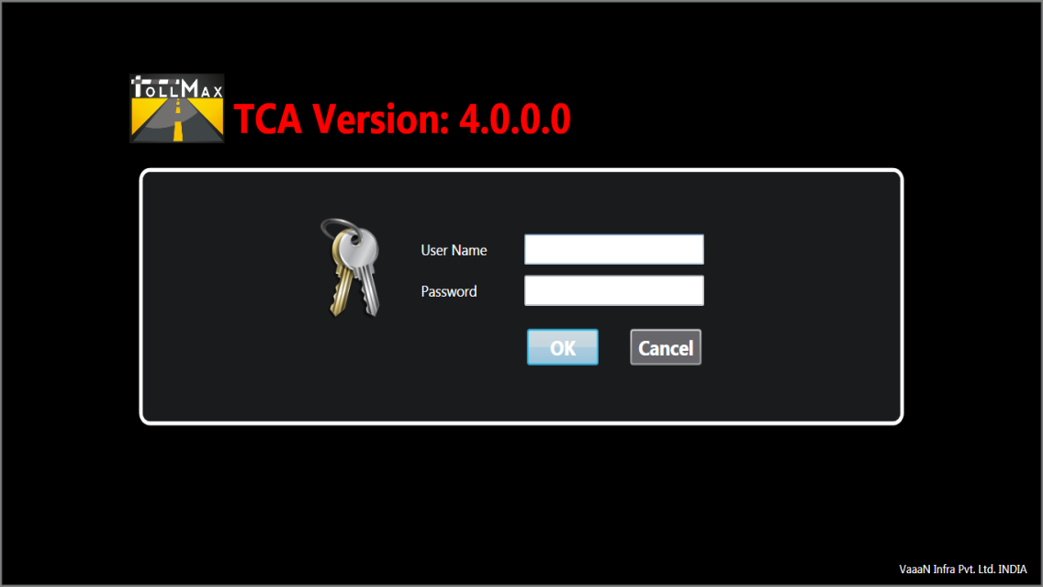

Figure 1

* toll***M***ax® is an access controlled application. System administrator in plaza defines username and password for each user to access a specific module
* Maximum five attempts are allowed for a user to provide valid login credentials
* Login window will be locked for a specific period, if maximum attempts are failed for a particular user
* Case sensitivity for username and password is configured using master configuration module
* An invalid user message will be shown on the left bottom of the login screen, if the username or password provided by a user is invalid

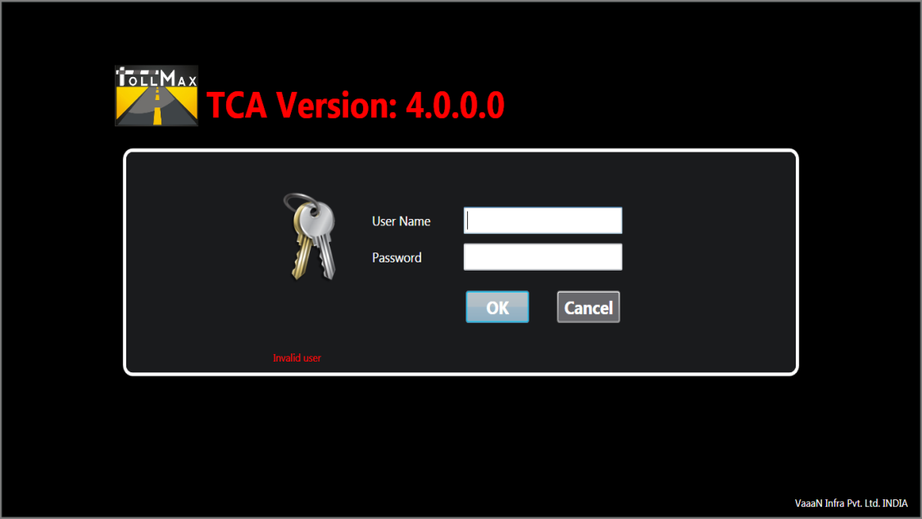

Figure 2 - Login Screen, Invalid user

## Screen Attributes

|  |  |
| --- | --- |
| **Terms** | **Description** |
|  | Logo of toll***M***ax® |
| Username | User name is provided by system administrator |
| Password | Password is provided by system administrator |
| OK | Confirmation to access an application |
| Cancel | Exits from the login screen |
| Version 4.0.0.0 | Version of toll***M***ax® solution |

# Toll Collection Application

Toll Collection Application is an integral part of toll***M***ax® that has been developed to manage lane operations. It is installed on each lane systems and provides a controlled access to generate revenue via processed transactions.

Toll Collection Application is a main lane transaction processing system and a major data source for toll***M***ax® that is having a strong coupling with all other modules like master configuration, toll clearance, reporting, transaction audit tool etc.

This module is a user friendly application, which allows a toll collector to select valid options from the master screen step by step. The selection of vehicle class, journey type, payment methods are configured using master configuration module which can be used in Toll Collection Application installed on lanes.

All predefined set of events, incidents & transactions are detected and transferred to the toll plaza server. To support the efficiency, performance and handling of transactional data, some system services plays a vital role in data transmission from lane to plaza or vice-versa. The system services are Data Transfer Service (DTS), Event Messenger Service (EMS), Local Data Service (LDS), Plaza general Service (PGS), Hardware Controller Service (HCS), Lane General Service (LGS), Automatic Vehicle Classification Service (AVCS) and Service Monitor (SM). They provide real time data to toll plaza server and help in monitoring & managing operations occurring at lane location.

Following hardware can be integrated with the toll***M***ax® TCA application:

|  |  |  |
| --- | --- | --- |
| • Traffic Light | • Exit Barrier | • UFD |
| • Smart card reader | • Barcode reader | • AVC |
| • License plate Image Capture Camera | • OHLS | • Induction Loops |
| • Incident capture Camera | • Light Screen Sensor | • Receipt Printer |
| • Panic Alarm | • Revolving light | • Fog light |
| • Over Height Sensor | • Smart Card Reader | • IR Barrier Safety |

The TCA can be configured in two modes as follows:

* **Manual**

In manual mode, lane is controlled by operator and most of the payments are in cash however smart card reader is also available as an alternative mode of payment.

* **Automatic**

To support automatic operations lanes are equipped with ETC (Electronic toll collection) that works without any human intervention by accepting all valid electronic means of payment. It is a customized component that can be added as and when required according to the system requirement and is not a default feature of the TCA.

**Toll Lane Controller**

Toll lane controller (TLC) is an automated hardware solution, designed to maintain efficient traffic flow and helps in managing the real time control of lane equipments. It is integrated and controlled with TCA module, which in turn reduces turnaround time for each transaction resulting in increase in operator’s productivity for each lane.

The TLC is equipped with latest technology hardware, which is used to control and deliver the desired productivity of transactional data in a controlled manner. The input and output to hardware is maintained in accordance with the toll collection module. The TLC supports the functioning of hardware such as barrier gate, OHLS, traffic light, induction loops etc.

## Toll Collection System

Toll collection application is a part of toll***M***ax® solutions which is used to operate lanes.

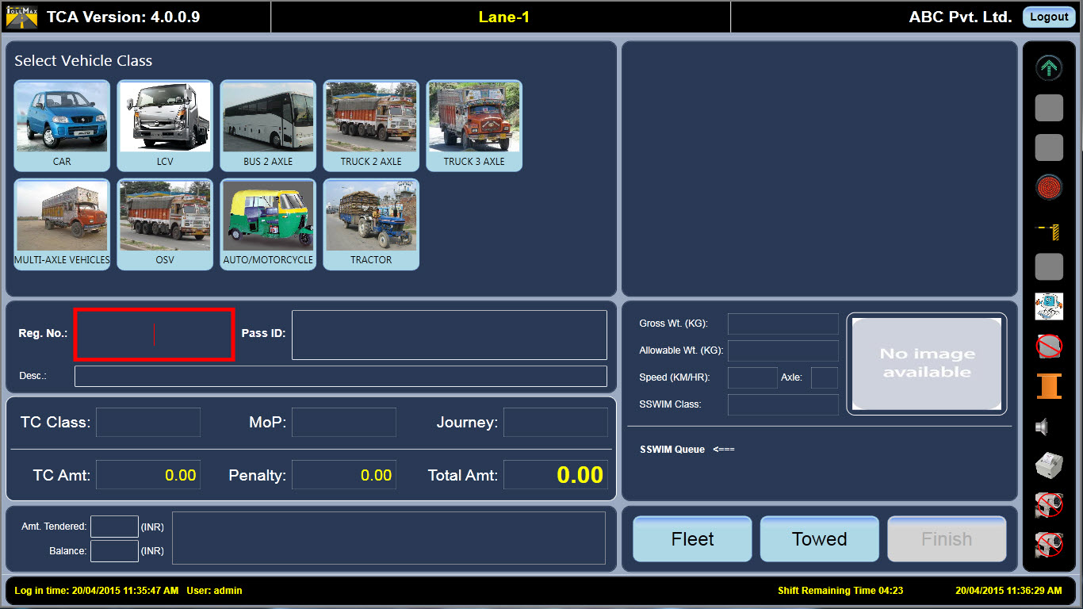

Figure 3 - Toll Collection Application

The TCA screen is categorized in following sections:



## Window Header

The window header displays the top part of TCA.



Figure 4 - TCA Header

The application’s header defines:

|  |  |
| --- | --- |
| **Terms** | **Description** |
|  | Logo of toll***M***ax® |
| Toll Collection Application | Name of the application |
| VaaanInfra | Name of the company |

## Selection of Vehicle class

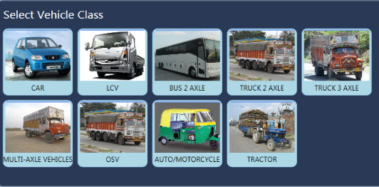

Figure 5 - Vehicle Classes

This section provides a toll collector to select a desired vehicle class using a single click or with the help of customized keyboard.

## Reg. No.

Lane operator needs to enter vehicle registration number in the textbox available on TCA screen. The vehicle registration number can accept alphanumeric characters. It can accept up to a maximum of 12 characters.



Figure 6

## Pass ID

It is a part of transaction receipts and used for faster transactions on lanes. The text box for barcode and smart card ID is provided on the TCA screen to read smart card and barcodes encoded on the receipts, which is meant to define the type of a journey e.g. journey on single/multiple plaza.



Figure 7

The barcode functionality can be defined as follows:

* Valid Barcode and smart card cases are:
* If the smart card or barcode receipt is valid for the lane, the system may automatically finish the transaction using barcode reader and opens the barrier gate with a successful transaction
* If the system is not configured to finish the transaction automatically, the transaction would unsuccessful
* If there is any problem regarding scanning of smart card or barcode, the encoded smart card serial number and barcode on receipt can be manually entered into the text box provided on the TCA screen
* If an invalid smart card serial number or barcode is entered, an error message will be displayed
* 16 Character long encrypted barcode will contain all the necessary information regarding the associated successful transaction
* Invalid smart card and Barcode cases are:
* If smart card or bar-coded receipt is expired
* If smart card or barcode length entered by toll collector is not correct
* If smart card or barcode is valid for single plaza and commuter is using it on multiple plazas
* If smart card or barcode is valid for single journey, same barcode slip cannot be used by commuter for return journey
* If smart card or barcode is issued for a particular vehicle class and commuter is using it for different vehicle class

## Description

The priority for description text box for a particular transaction in a TCA is configured using master configuration module. A brief description can be mentioned for completion of any specific transaction and saved with the transaction id in the database. The description text box can accept up to a maximum of 200 characters.



Figure 8

## Finish

Default or before completion of transaction, finish button is in disabled mode as shown below.



Figure 9

After providing necessary information for cash type transaction, finish button is in enabled mode as shown below.



Figure 10

## Current Transaction

The current transaction displays the vehicle class, road name, payment mode, journey type and the toll rate as per vehicle class selection. All the options are selected by the lane operator to complete a specific transaction.

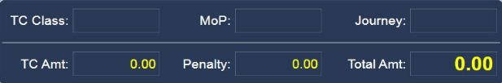

Figure 11 - Current Transaction

|  |  |
| --- | --- |
| **Terms** | **Description** |
| TC Class | Vehicle class selected by toll operator |
| MOP | Selection by TC as requested by commuter |
| Journey Type | Selection by TC on request of commuter |
| TC Amt. | Toll rate configured using MCM. The amount is displayed on the screen automatically, which is a part of application’s operation. |
| Penalty | The amount charged for overweight vehicle |
| Total Amt. | It is the sum of TC amount and penalty |

## H/W Status



Figure 12 - Hardware Status

|  |  |
| --- | --- |
| **Terms** | **Description** |
| OHLS | Indicates whether a toll collector is logged in lane module by green and red signal. |
| Loop | It is a metal detector sensor. When a vehicle reaches the loop, its presence is detected. |
| Traffic Light | Once the transaction is validated, the green light is activated and when the loop detects the vehicle exit, the light automatically turns back to red. |
| Barrier Gate | It is located on the toll lane booth. The barrier is in up-state once the toll fee has been collected by the toll collector. As the vehicle leaves the lane, the loop detects it and closes the barrier gate automatically. |
| OHLS | The purpose of the OHLS is to indicate the toll collector is logged in or not. Red signal indicates that the lane is closed and green signal signifies that the lane is open. |

All the hardware could be controlled with a configurable tag in MCM; by clicking on a hardware icon, hardware could be meticulous as manual and automatic mode.

## Vehicle Image

The vehicle images are maintained as per configured vehicle class.

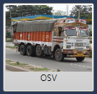

Figure 13 - Vehicle Image

## Last Two Transactions

Last five transactions are displayed on the lane in descending order. Latest transaction processed by lane operator is highlighted in yellow color.



Figure 14 - Last Three Transactions

* In **Amt. Tendered**, you can see the total amount given by commuter to the toll operator.
* In **Balance**, you can see the balance amount that toll operator needs to return to the commuter.

A specific transaction details can be viewed by double clicking on one of the last five transactions reflecting on the screen. The transaction details are displayed as follows:

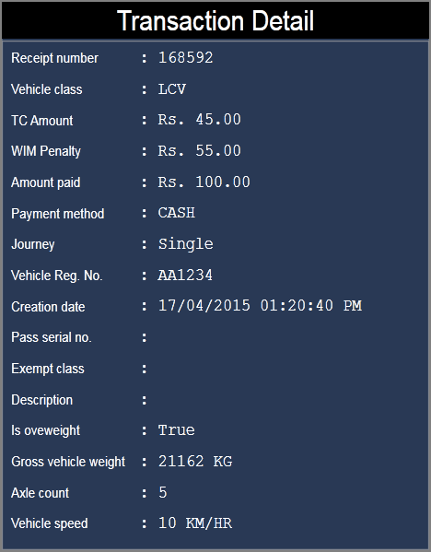

Figure 15 - Transaction Details

|  |  |
| --- | --- |
| **Terms** | **Description** |
| Receipt number | Transaction number |
| Vehicle Class | It shows the selected vehicle class in respect with specific transaction ID |
| TC Amount | Configured toll rate |
| WIM Penalty | The amount charged for overweight vehicle |
| Amount Paid | The total amount paid by the commuter |
| Payment Method | Payment method selected by lane operator for specific transaction Id |
| Journey | Journey type selected by lane operator for specific transaction ID |
| Vehicle Registration Number | It shows the vehicle registration number in respect with specific transaction ID |
| Creation Date | It shows the date and time when transaction was created |
| Pass serial No. | If payment method is smartcard, it shows the serial number of smart card |
| Exempt Class | Its shows the exempt class, if transaction is of exempt type |
| Description | The description of transaction |
| Is Overweight | It shows whether the vehicle is overweight or not |
| Gross vehicle weight | It shows the actual weight of the vehicle. This WIM is used to measure the vehicle weight |
| Axle Count | It shows the axle count of the vehicle |
| Vehicle speed | It shows the speed of vehicle |

## Window Footer

The TCA module footer is displayed as follows:



Figure 16 - TCA Footer

Following is the explanation for window footer is as follows:

|  |  |
| --- | --- |
| **Terms** | **Description** |
| Log in time | Login date and time of a toll collector |
| User | Displays username of a toll collector |
| Lane | Displays the lane number |
| Shift | Displays the shift number |
| Shift time | Displays the remaining time of a shift |
| 16/09/2014 05:07:42 PM | System’s current date and time |



## Rate Profile

The journey can be configured as per requirement using master configuration module. It is the profile for the journey according to the multi plaza travelling of a commuter.

In TCA after selecting the vehicle type, lane operator is required to select the journey using a click on it or through customized keyboard.



Figure 17 - Selection of Rate Profile



## Journey Type

Journey type is used to define a journey classification for any vehicle arriving on toll booth. The journey class can be configured as per requirement using master configuration module.

For example, the possible journey type could be configured as follows:

* + Single Journey
  + Return Journey
  + Daily Journey

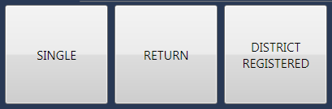

Figure 18 – Journey Selection

After selection of the Rate Profile, lane operator is required to select journey type. A journey could be selected by clicking on it or through customized keyboard.

## Payment Method

After the selection of rate profile and journey type, payment method has to be selected as a final step of a toll transaction. The toll rate for a particular vehicle class can be configured using master configuration module. In case of exempt transaction, the selection of exempt class is required as another step to complete a transaction through TCA module. The payment method can be selected using a click on it or through a customized keyboard. On selection of all the required mentioned parameters from the TCA screen, the application automatically fetches an amount from the database, which is configured as a part of toll rate using master configuration module.

For example, the possible payment method could be configured as follows:

* Cash
* Exempt

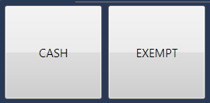

Figure 19 - Selection of PM

## 2.1.15. Types of Transaction

## 2.1.15.1. Cash Transaction

The selection of cash payment method reflects the payment mode for a particular vehicle class.



Figure 20 - Cash Transaction

* Payment amount is calculated as per vehicle class and created rate profile
* The barcode information and time limit duration mentioned as a part of operation for barcode is decided by the plaza manager
* When a transaction is finished successfully, barrier gate will be in up-state automatically after printing a receipt



## 2.1.15.2. Barcode Transaction

* Return journey and handheld receipts are generated with barcode on it.
* A commuter pays an amount for the returning to the same plaza, for which no charges would be applicable.
* Enter a vehicle registration number in the TCA, press tab or pass serial number button and scan a barcode receipt with barcode scanner to complete a transaction.
* A multi plaza barcode validation functionality is added as a part of closed tolling
* Barcode read and go functionality is added, in which barcode receipt is read by a barcode reader which entering vehicle registration number and selecting vehicle class to process a transaction
* Bar code transaction (Expired receipt)

If a commuter tries to use an expired bar-coded receipt on toll lane, the message appears on TCA screen as “Scanned barcode pass has been expired”

* Bar code transaction (Invalid Vehicle Class Selection)

If a commuter tries to use a bar-coded receipt which was generated for other vehicle class, the error message appears on the TCA screen as "Selected vehicle class not matched with barcode vehicle class”

* Bar code transaction (Valid Vehicle Class Selection)

If a commuter uses a bar-coded receipt which was generated for valid vehicle class, the barcode reader will scan it and the transaction will be successful

## 2.1.15.3. Smart Card Transaction

* Smart Card Transaction (Valid Card)

1. Punch the smart card over the Smart Card Reader installed on toll lane
2. The smart card will be accepted and the transaction will be successful

* Smart Card Transaction (Expired)

1. Punch the smart card over the smart card reader installed on toll lanes
2. The smart card shall not be accepted and an error message appears as “The smart card has been expired.”

* Smart card touch and go functionality is added, in which a smart card is punched on smart card reader without entering vehicle registration number and selecting vehicle class to process a transaction

## 2.1.15.4. Exempt Transaction

The exempt type transactions as meant for the commuters with return journey pass, defense, agricultural, VIP’s etc. The method of transaction remains same as it is in cash type transaction. The selection of vehicle class, rate profile, journey type, payment method and an exempt class for which an exempt transaction is required to be processed, are some of the mandatory fields.

A document scanner capture image functionality is to verify the actual exempted reason with image of a document captured during exempt transaction could be enabled and disabled with xml tag via MCM, in which document scanner name is required to be input in the provided text box.

Also, a supervisor card functionality for exempt transaction is a part of TCA, in which supervisor is responsible to process an exempt transaction with an issued smart card. This functionality could be applicable to specific exempt class and is configurable as desired.

A document scanner is configured to work with different operating systems like Windows 7/8/10/XP.

The selection of exempt classes can be done through following screen:

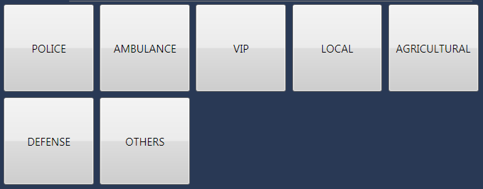

Figure 21 - Exempt Class, Selection Screen

## 2.1.15.5. Fleet Transaction

Fleet transaction is the continuous run of vehicles through a lane. These crossing vehicles are meant to be VIP’s or Government officials. The transaction in fleet case is taken as exempted.

Below is the figure, which displays the in-active status of fleet mode on TCA:



Figure 22

When a fleet button is selected via customized keyboard or clicks through mouse, another mode is displayed on TCA which is shown below:

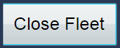

Figure 23

Until and unless a close fleet button is not pressed and vehicles are crossing a lane, fleet mode is be active. When a button is pressed, a receipt is generated displaying the number of vehicles crossed the lane.

Fleet transaction is configurable as per usage. It can be enabled or disabled from MCM.

## 2.1.15.6. Towed Transaction

Towed transaction as a name suggests is a transaction in which a proceeding vehicle pulls a preceding vehicle (mostly in halted state). When a payment method is selected as cash, towed button is activated as shown below:



Figure 24

A pop up message window box appears informing to proceed with towed transaction.

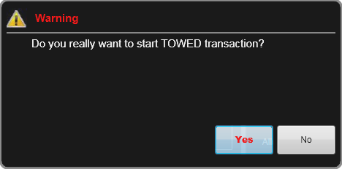

Figure 25 – Pop up window

From the above pop up window, press yes button to proceed with towed transaction. Enter vehicle registration number, select vehicle class, payment method and process two transactions. Until and unless two vehicles crossed a lane, another normal transaction could not be processed on lane. A close towed button is required to click to finish towed transaction:



Figure 26

## 2.1.15.7. ETC Transaction

A process of undertaking lane transaction via electronic toll collection resembles ETC transaction. The commuter with a valid ETC tag (which is stickled on a wind shield of a vehicle) enters a toll lane and tag reader installed in a lane reads a tag with verified information from ETC tag. A valid tag allows a commuter to cross a lane by making a barrier gate in up-state, while if a tag is invalid message appears on toll collection screen and transaction is supposed to be incomplete.

If a vehicle class is having a valid tag placed on the wind screen of a vehicle, and transaction is not validating automatically; enter a vehicle registration number in the text box of TCA and press enter button to validate a tag manually.

RFID handheld ETC reader functionality, in which a ETC tag placed on a wind screen of a vehicle, is read by a handheld device and a transaction is automatically inserted in the database.

The process for ETC transaction is shown below:

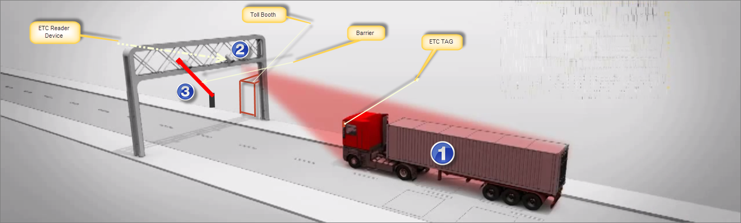

Figure – ETC Transaction

## 2.1.15.8. SSWIM Transaction

Slow speed weigh in motion transaction are processed on lane with a penalty amount for overweight vehicles crossing a toll lane. A device named WIM is installed on lane site which automatically weighs a vehicle. The communication is held between WIM and application. Due to communication, toll operator could visualize whether a vehicle class in a queue is overweight or not. As per configured rates, penalty would be charged from commuter. The information produces by a WIM will get displayed on TCA screen as shown below:

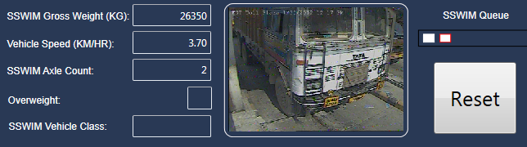

Figure 28 – SSWIM Transaction

A vehicle weight crossing over WIM shall be displayed in SSWIM Gross Weight (KG), vehicle speed in Km/hr, axle count, overweight information and vehicle class given by WIM. Since a WIM is installed in lane 22 meters back from the point an exit loop is installed, vehicles WIM information is queued with an image of vehicle and when a vehicle reaches a toll collection, information of that particular vehicle shall be displayed.

**2.1.15.8.1. WIM Reset**

**How TC will get to know that SSWIM hardware is not working properly?**

There can be following scenarios, in case of hardware failure:

* **No Weight Found**: The toll collector will not be able to see the weight of any vehicle or can see 0 weight of vehicle in **SSWIM Queue** section.

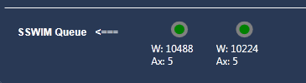

Figure – SSWIM Queue

* **Wrong Axle Displaying**: When SSWIM will show the wrong axle count of the vehicle that is available at presence loop. For example, the vehicle standing at presence loop is Car, but WIM shows the axle count of the preceding vehicle (truck).
* **Wrong Weight Displaying**: When SSWIM will show the wrong weight of the vehicle that is available at presence loop. For example, WIM shows the weight of car as 40,000 kg or MAV as 2000kg.

**How to reset the complete SSWIM system?**

The toll collector can reset the weight of vehicles that exist in between the SSWIM and the presence loop. The **SSWIM Queue** section shows the weight of all vehicles exist in between the SSWIM and the presence loop.

To reset the SSWIM system, the toll collector needs to press **WIM Reset** button available on customized keyboard. The popup window appears as below.

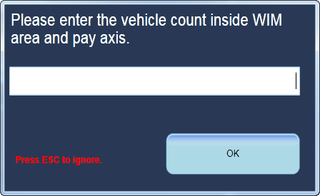

Figure – Reset SSWIM

Write the number of vehicles available in SSWIM queue whose weight, the toll collector needs to discard.

Suppose there are four vehicles available in between WIM and the presence loop, the toll collector can perform following actions.

* To discard the weight of first two vehicles, write the vehicle count as 2.
* To discard the weight of all vehicles available in SSWIM queue, write 0. The weight of all vehicles is discarded.
* To discard the weight of vehicle which is standing at presence loop, write 1. The weight of vehicle standing at presence loop is discarded.

**The following outcomes are possible, if toll collector forgot to reset the SSWIM system:**

* Wrong weight can be displayed for the vehicle available at presence loop. Same weight will be associated with its transaction.
* Wrong penalty will be calculated by the system
* Wrong TC amount can be charged by the commuter

## 2.1.15.9. Bleed Off Transaction (Mid Shift Clearance)

This is a transaction in which toll operator needs to deposit the mid-shift clearance amount to the cash collector. This transaction is also created by using ODC module.

On **TCA** screen, toll operator needs to press **Ctrl + M** keywords together. The **Mid-Shift Clearance** window appears as below.

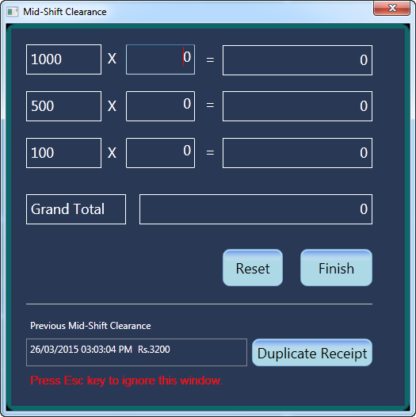

Figure – Mid Shift Clearance Main

Write the count or number of particular denomination. You can see the total amount of particular denomination. In **Grand Total** field, the total amount of all denominations appears.

Select **Finish** button. Two receipts come out from receipt printer for both toll collector and cashier.

Select **Reset** button, if you want to reset all fields to their default values. You can see the following details on printed receipt:

* **Lane**: The lane number on which clearance was declared
* **Plaza**: The plaza number on which clearance amount will be deposited
* **Shift**: The shift number in which clearance was declared
* **Toll Collector**: The collector who declared the mid-shift clearance
* **Date**: The date and time when toll collector declared the clearance
* **Amount**: The total amount that was declared by toll operator

Both toll collector and cashier are required to sign the receipt. Cashier is the person who collects the amount from toll collector and deposits this amount to the specified plaza number.

**See Previous Mid Shift Clearance Record**

You can see following details of previous mid shift clearance:

* Date and time when clearance declared
* Total amount declared

**Take the print of duplicate receipt**

Select **Duplicate Receipt** button. The duplicate receipt is generated. In this receipt, you can see the same details that you see in original receipt.

**Note**: Toll operator needs to use **Tab** button to perform all actions of the **Mid-Shift Clearance** window.



## 2.2. Live Video Stream

The live video streaming is a part of toll collection application. This facility is beneficial for the toll collector to recognize a vehicle class and the vehicle registration number. The zoom-in and zoom-out buttons are provided in the customized keyboard, which will allow a toll collector to determine a vehicle registration number by zooming in and out a live video stream.

## 2.3. User Multiple Login Restriction Functionality

In tolling solution, there are lots of man power working to operate different sections of plaza such as lane, server, auditing, operator declaring and clearing, and such kind of activists. A lane is the revenue generation podium, through which all other operations are maintained.

Since, concerning about any happenings occurred due to misinterpretation in login ids’ of toll collector as per revenue collection; functionality is added in toll collection application to restrict a user id to login in two lanes simultaneously. If a user is already logged in any lane, that particular id is not allowed to login in other lane at the same time. A toll collection application responds with a message, that the same user is already logged in another lane.

## 2.4. Logout

The automatic logout of a toll collection application depends on the shifts, configured in master configuration module. The time appears on TCA screen, reflects the remaining time of a particular shift OR the time in which application will be logged out automatically. Clicking on OK button closes the application for a particular toll collector.

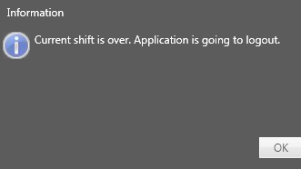

Figure 32 - Automatic Logout

# 3. Operator Declare and Clearance module

Operator Declare and Clearance module will provide an interface for keeping a record of every activity performed by Toll Collector, customer service operator or by the POS operator in a shift. Recording each activity is required for every shift by any of the above said individual. Actual procedures at a plaza may differ from the description here and may include additional accounting paperwork that is not part of the toll***M***ax® solution.

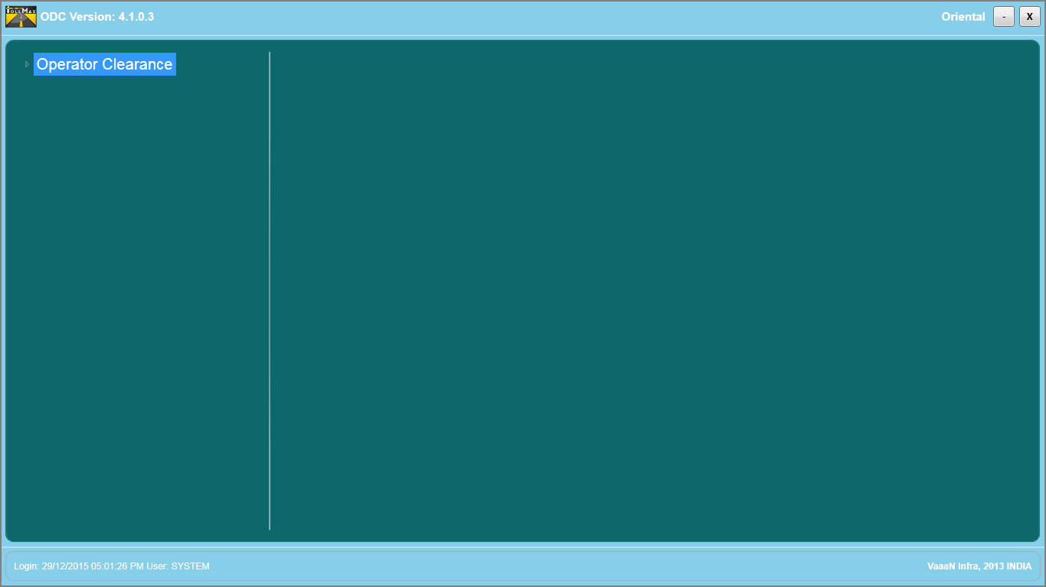

Figure 33 - ODC Screen

The module will facilitate in performing operations mentioned below:

* Cash float
* Mid-Shift Declare
* End-Shift Declare
* End-Shift Clearance

## Cash Float

Cash float is a cash amount, which is provided to toll operator in the beginning of the shift by a supervisor. Before providing the cash to the operator, the supervisor has to assign the amount to the operator through toll***M***ax® software application (Operator Declare & Clearance tool) by selecting necessary options.

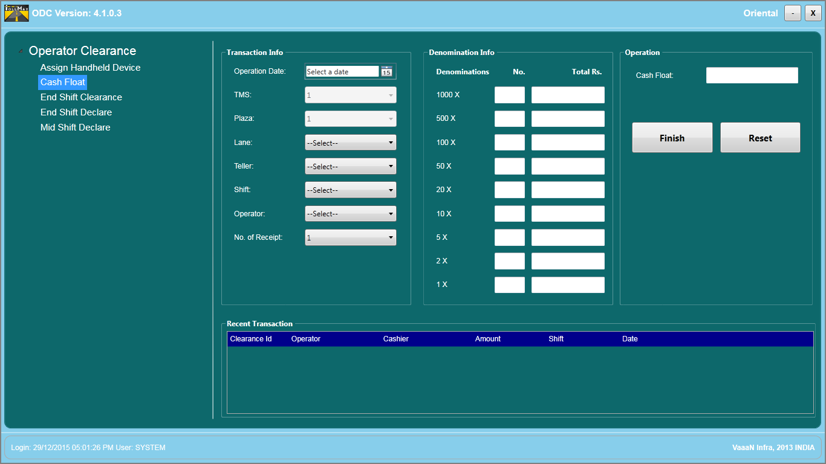

Figure 34 - Cash Float Screen

**Transaction Info**

The parameter for a particular toll operator can be selected using desired filters with respect to the selection of a lane, a shift and an operator. The number of receipts to be generated for a particular transaction can be selected as one or two.

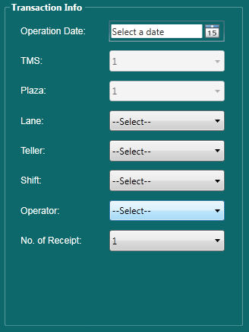

Figure 35 - Transaction Information

The Transaction Info layout is described as:

|  |  |
| --- | --- |
| **Terms** | **Description** |
| Clearance Date | The clearance date is used to select the desired date for which clearance has to be processed. |
| TMS | Selection of TMS id. |
| Plaza | Selection of plaza id. |
| Lane | Selection of a particular lane. |
| Teller | Selection of a teller. |
| Shift | Selection of a particular shift. |
| Operator | Selection of an operator. |
| No. of Receipt | Selection of the desired number of receipts to get printed. |

**Cash Float Info**

The amount assigned to a particular toll operator is displayed in the cash float information. The denominations of amount given to an operator is populated here as a sum of all given entries.



Figure 36 - Cash Float Information

## End-Shift Clearance

The toll operator is required to proceed in the last phase of revenue generated from a particular lane. The system toll and the toll collection are categorized for a toll collector as a surplus or deficit amount. Any discrepancies in the collected amount can be recognized using end-shift clearance module. This module operates on the data completeness of the transactional data from lane to plaza.

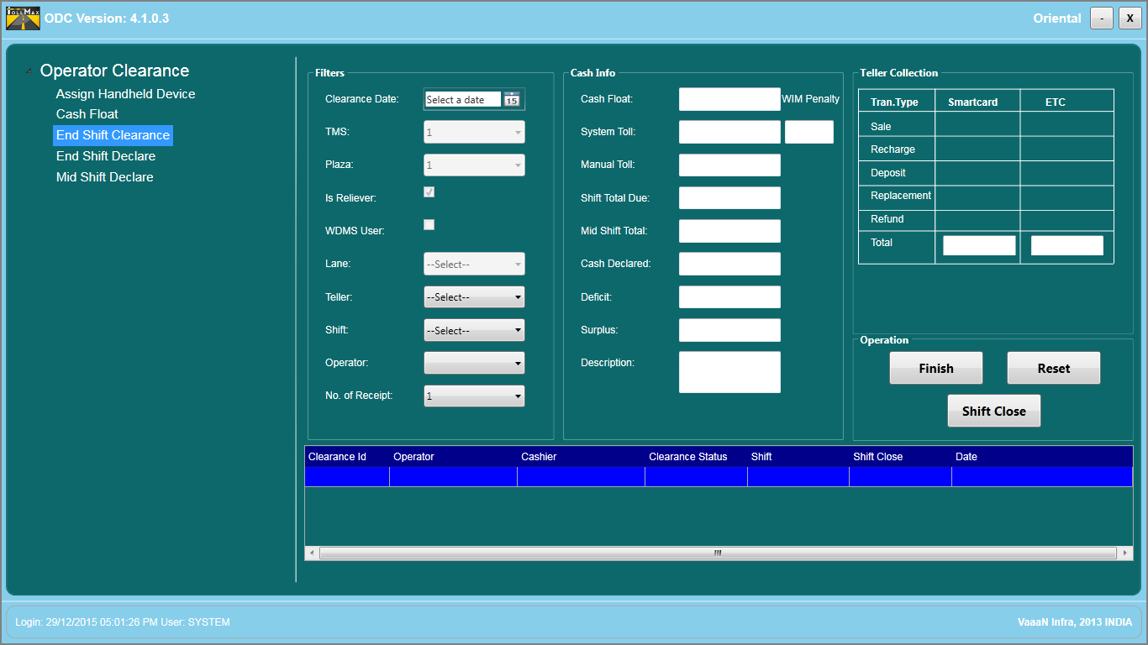

Figure 37 - End-Shift Clearance Screen



End-Shift Clearance screen is categorized as follows:

**Transaction Info**

The parameter for a particular toll operator can be selected using desired filters with respect to the selection of a lane, a shift and an operator. The number of receipts to be generated for a particular transaction can be selected as one or two.

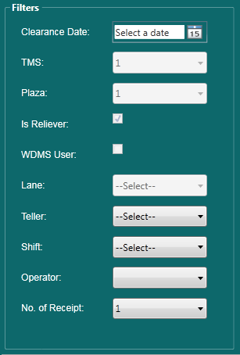

Figure 38 - Transaction Information

The Transaction info layout is described as:

|  |  |
| --- | --- |
| **Terms** | **Description** |
| Clearance Date | The clearance date is used to select the desired date for which clearance has to be processed. |
| TMS | Selection of TMS id. |
| Plaza | Selection of plaza id. |
| Lane | Selection of a particular lane. |
| Teller | Selection of a teller. |
| Shift | Selection of a particular shift. |
| Operator | Selection of an operator. |
| No. of Receipt | Selection of the desired number of receipts to get printed. |

**Cash Info**

It is the cash reconciliation process, to verify the amount collected by lane operator. The information of all the sub-modules generates here. On the basis of the previously declared amount, auto generation of amount is displayed in cash info after the selection of desired filters from transaction info.

|  |  |
| --- | --- |
| **Terms** | **Description** |
| Cash Declared | This parameter defined as defined sum of system toll and manual toll collection. |
| Cash Float | This parameter defined as funds or amount given by supervisor to lane operator in the start of shift. |
| Mid Shift Total | This parameter defined as funds or amount given by lane operator to supervisor during mid of shift. |
| Shift Total Due | It is the amount calculated by addition of cash float, system toll collection, manual toll collection, and subtraction of mid shift clearance and end Shift declare. |
| Deficit | If cash fund declare by lane operator is less than the cash fund declare by system. |
| Surplus | If cash fund declare by lane operator is more than the cash fund declare by system. |
| Description | At end of shift, a brief description about cash fund, as entered in the GUI by the lane operator regarding end shift clearance. |

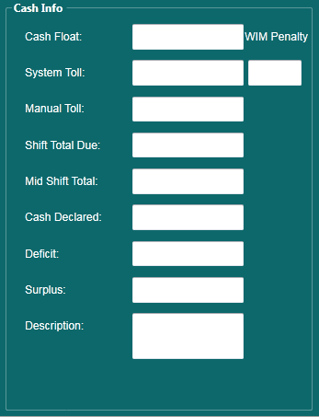

Figure 39 - Cash Information

The Cash Info layout given as follows:

|  |  |
| --- | --- |
| **Terms** | **Description** |
| Cash Declared | This parameter defined as defined sum of system toll and manual toll collection. |
| Cash Float | This parameter defined as funds or amount given by supervisor to lane operator in the start of shift. |
| Mid Shift Total | This parameter defined as funds or amount given by lane operator to supervisor during mid of shift. |
| Shift Total Due | It is the amount calculated by addition of cash float, system toll collection, manual toll collection, and subtraction of mid shift clearance and end Shift declare. |
| Deficit | If cash fund declare by lane operator is less than the cash fund declare by system. |
| Surplus | If cash fund declare by lane operator is more than the cash fund declare by system. |
| Description | At end of shift, a brief description about cash fund, as entered in the GUI by the lane operator regarding end shift clearance. |

**Teller Collection**

This parameter defines the amount collection done by a POS operator for smart card sale, recharge and replacement.

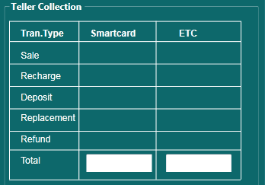

Figure 40 - Teller Collection

The Teller Collection Info layout given as follows:

|  |  |
| --- | --- |
| **Terms** | **Description** |
| Smart Card | This parameter defines the total fund collection by sale and reissue/recharge of Smart card. |
| ETC | This parameter defines the total fund collection by sale and reissue of ETC. |

**Finish button**

This button used by shift operator to complete the specific transaction at “End shift clearance” screen for a particular lane operator.



Figure 41

**Reset**

This button used by shift operator to reset the specific transaction.



Figure 42

**Shift Close**



Figure 43

Shift close functionality in end-shift clearance is used to close a particular shift for a particular date. The selection of a shift can be done via screen shown below:

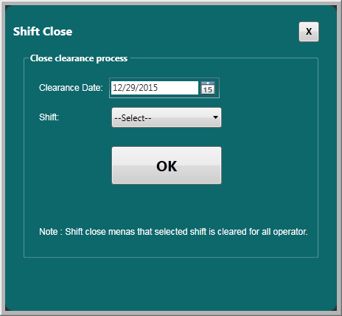

Figure 44 – Shift Close Screen

Once a shift is closed using desired date and shift, a clearance operator shall not be permissible to process end-shift clearance. If all the shifts are closed, then for a date selection a message will appear reflecting all shifts closed for a selected date.

## End Shift Declare

Before the end of a shift, the lane operator has to declare, the total collected amount. In this scenario, a record is maintained in accordance with the acceptance of toll operator and shift supervisor. The entries are thus generated by shift supervisor for a particular lane and toll operator.

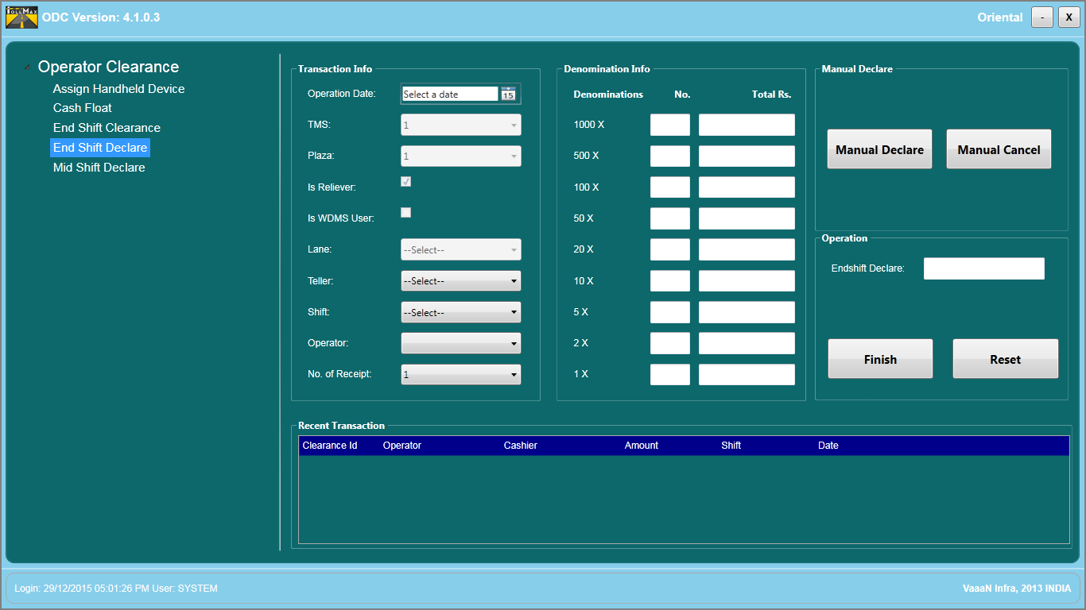

Figure 45 - End-Shift Declare Screen

End Shift Declare screen is categorized as follows:



**Transaction Info**

This parameter defines the particular tranaction done by shift supervisor for specific lane operator with respect to shift, lane and plaza.

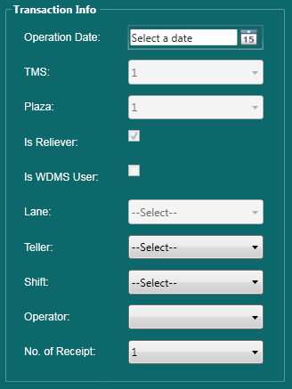

Figure 46

The Transaction Info layout given as:

|  |  |
| --- | --- |
| **Terms** | **Description** |
| Clearance Date | The clearance date is used to select the desired date for which clearance has to be processed. |
| TMS | Selection of TMS id. |
| Plaza | Selection of plaza id. |
| Lane | Selection of a particular lane. |
| Teller | Selection of a teller. |
| Shift | Selection of a particular shift. |
| Operator | Selection of an operator. |
| No. of Receipt | Selection of the desired number of receipts to get printed. |

**Denomination Info**

This parameter defines cash reconciliation process, to verifying the amount collected by lane operator.

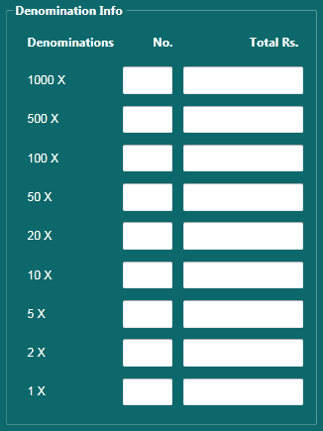

Figure 47 – Denominations

The Denomination layout given as follows:

|  |  |
| --- | --- |
| **Terms** | **Description** |
| Denomination | It is the cash reconciliation process, to verifying the amount collected by lane operator and is entered in numerals. |
| No. | It shows the count or number of particular Denomination. |
| Total Rs. | It shows the total amount of particular Denomination. |
| Total Amt. | It shows the grand total of total Rs. |

**Manual Collection**

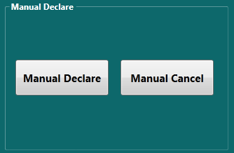

Figure 48 - Manual Toll Declare and Cancel Buttons

* Working of manual toll and cancellation of manual tickets

Manual toll declare steps given as follows:

* Select the vehicle class.
* Select the journey type of particular vehicle class.
* Enter the number of vehicles passed from plaza.
* Fare rate will be displayed automatically from database.
* Enter the Start Sr. number and end Sr. no of specific vehicle class.
* Click on Ok.
* Click here for manual toll declare.

By clicking this new window is pop out for calculation of amount received by manual tickets. The **Manual Toll Declare** window appears as below.

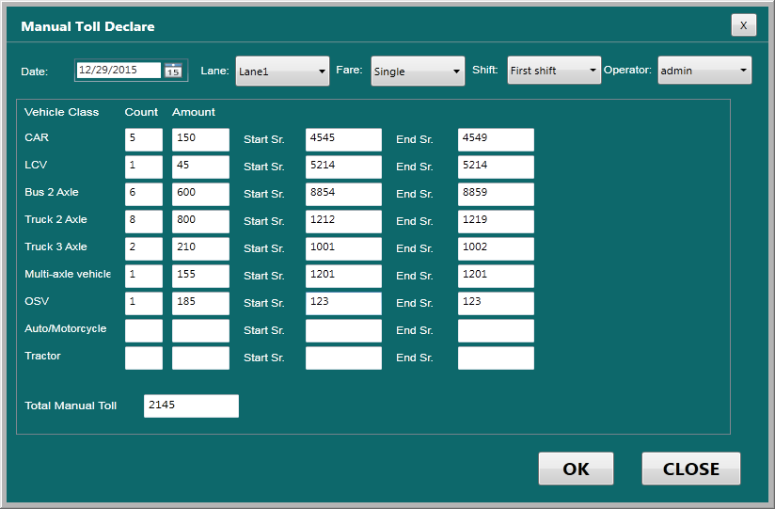

Figure 49 - Manual Toll Declare

Cashier needs to add following details:

* **Date**: Select the date for which cash has been declared
* **Lane**: Select the lane in which all transactions created
* **Fare**: Select the fare that was used for transactions
* **Shift**: Select the shift in which transactions created
* **Opearator**: Select the operator who declared the amount

For each vehicle class, you can add following details.

* In **Count**, write total number of corresponding vehicle class crossed the lane. For example, total number of cars crossed
* In **Amount**, the total amount is automatically calculated on the basis of count of vehicle
* In **Start Ser**, write the starting serial number that was used for first corresponding vehicle class
* In **End Ser**, the last serial number used for last corresponding vehicle is automatically displayed. This number is displayed basis on the total number of vehicles passed.

In **Total Manual Toll**, cashier can see the grand total amount collected by lane operator manually on selected date.

**Manual Ticket Cancel**

By clicking manual cancel button, new window pops out for the cancellation of manual ticket.

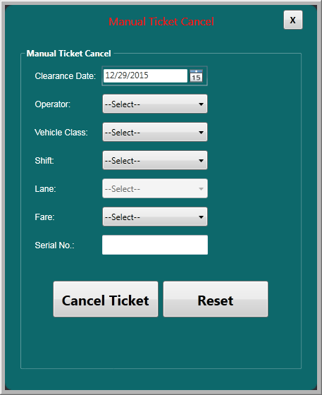

Figure 50 - Manual Ticket Cancel

**Finish Transaction**



Figure 51

This button used by shift operator to complete the specific transaction at “End shift declare” screen for particular lane operator.

**Reset**



Figure 52

This button used by teller operator to restart the specific transaction.

## Mid Shift Declare

In between of specific shift, if the collected amount is of higher concern or huge amount is collected, then for security reasons the cash is submitted to plaza. The operator may declare the amount in the mid of the shift in case of excess collection of amount in the cash drawer. The operator can declare multiple mid-shift amounts. In this scenario, a record is maintained in accordance with the acceptance of toll operator and shift supervisor. The entries are thus generated by shift supervisor for a particular lane and operator.

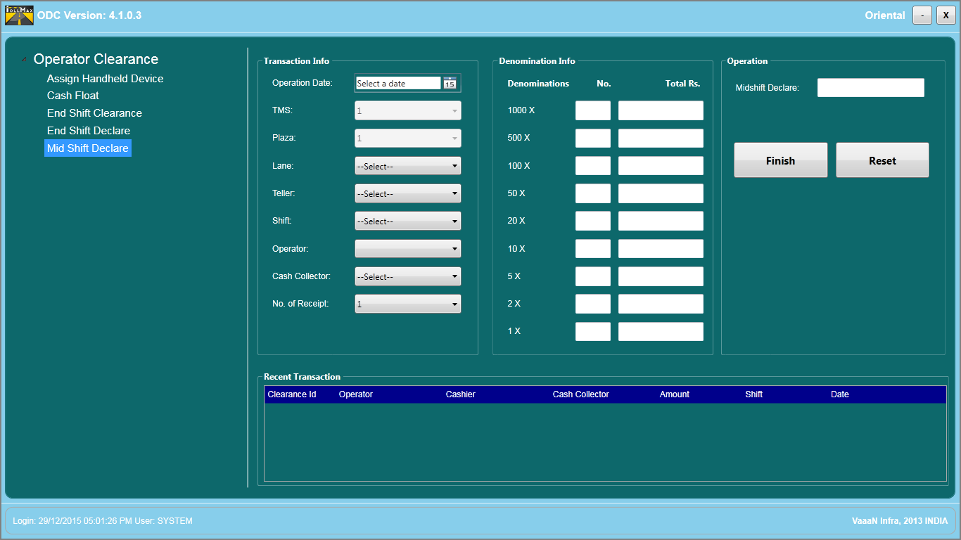

Figure 53 - Mid-Shift Declare Screen

**Transaction Info**

This parameter defines the particular tranaction done by shift supervisor for specific lane operator with respect of shift, lane, plaza.

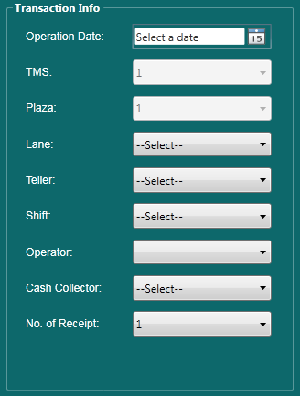

Figure 54

The Transaction Info layout given as:

|  |  |
| --- | --- |
| **Terms** | **Description** |
| Clearance Date | This parameter defines date of particular transaction done by shift supervisor. |
| TMS | This parameter defines Identification number of TMS. |
| Plaza | This parameter defines identification number of Plaza. |
| Lane | This parameter displays the listing of all lanes exist on current plaza. |
| Teller | This parameter displays the Identification number of teller. |
| Shift | This parameter defines the list of all shifts. User can select the current shift. |
| Operator | This parameter defines two types of operator: Super User, Admin. |
| No. of Receipt | It display the no. of receipt user selected from transaction info. |

**Denomination Info**

This parameter defines cash reconciliation process, to verifying the amount collected by lane operator.

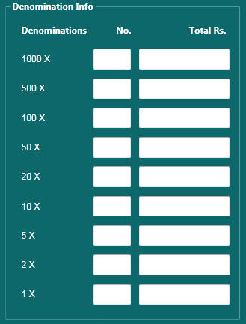

Figure 55 - Denomination Screen

The Denomination layout given as:

|  |  |
| --- | --- |
| **Terms** | **Description** |
| Denomination | It is the cash reconciliation process, to verifying the amount collected by lane operator. |
| No. | It shows the count or number of particular Denomination. |
| Total Rs. | It shows the total amount of particular Denomination. |
| Total Amt. | It shows the grand total of total Rs. |

**Mid Shift Declare**



Figure 56 - Mid-Shift Deposit Amount Display

The Mid-Shift Deposit layout given as follows:

|  |  |
| --- | --- |
| **Terms** | **Description** |
| Mid Shift Deposit | It is the grand total collected by lane operator during mid of shift. |

**Finish Transaction**



Figure 57 - Button to finish mid-shift declare

This button used by teller operator to complete the specific transaction at “Mid shift clearance” screen for particular lane operator.

**Reset**

This button is used for reset the transaction.



Figure 58

## Handheld

Handheld device is a small computing device having a display screen with touch input and keyboard. This device can be equipped with Wi-Fi, Bluetooth capabilities that can allow connections to the internet and other devices such as an automobile.

There can be following conditions, when we can use this device:

* Lane system not working
* Heavy Traffic

### 3.5.1. Create a Handheld User

To create a new handheld user, please see **User** section in **MCM** module for detailed instructions.

### 3.5.2. Create a Handheld Device ID

After creating a new handheld user, you need to create a handheld device unique ID. (Please see **Handheld ID** section in **MCM** module for detailed instructions.)

### 3.5.3. Assign/Issue a Handheld Device to a Handheld User

Following are steps to issue a device to the user:

1. Open the **ODC** module as below.

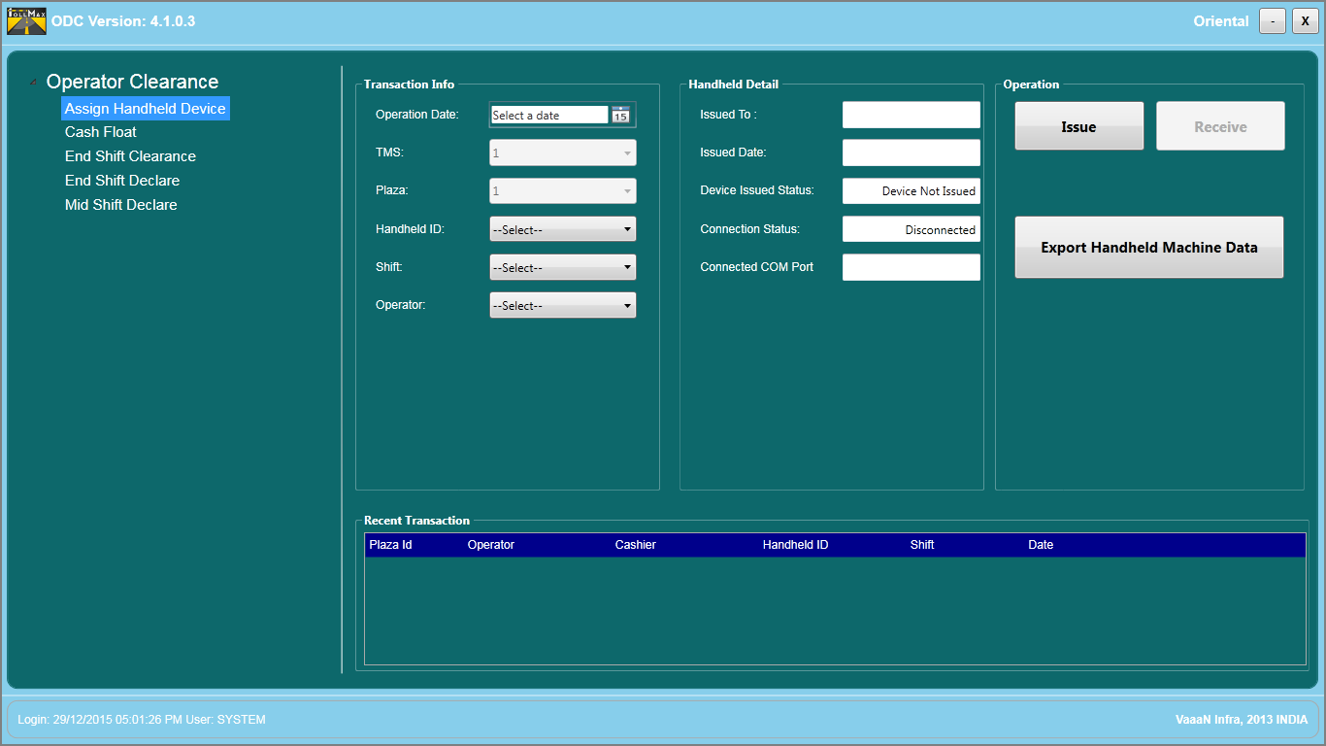

Figure 59 - ODC main screen

1. This screen is categorized into three sections.

* Left Sidebar
* Main Right Side Area
* Right Section

1. At the left sidebar, by default you can see that the **Assign Handheld Device** option is selected.
2. Connect the handheld device with system, in which ODC module is already installed. In **Handheld Detail** section, the status is displayed as Connected.
3. In the main right side area, you need to specify following details.

* **Operation Date**: Select the desired date when you issue the device to specific user.
* **TMS**: Select TMS id.
* **Plaza**: Select plaza id.
* **Handheld ID**: Select handheld ID.
* **Shift**: Select the required shift.
* **Operator**: Select the required operator.

1. **Handheld ID**: Select the ID. The message appears that you need to download the handheld device ID from open application.

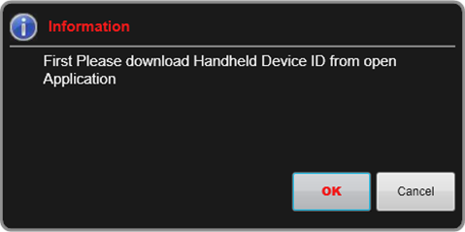

Figure 60 – Download Handheld ID

1. Click on **Ok** button and the window appears as below.

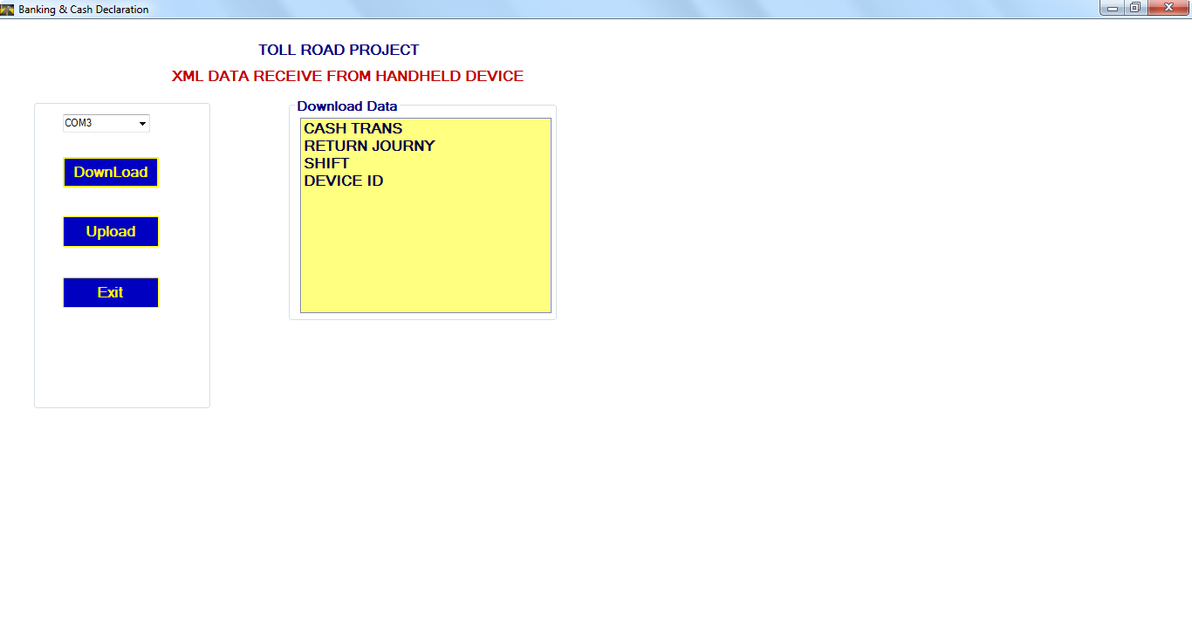

Figure 61 – Cash Declaration

1. Select the required COM port. Click on **Download** button, and the **Download Data** section appears.
2. Double click on **Device ID** option to download the device ID.

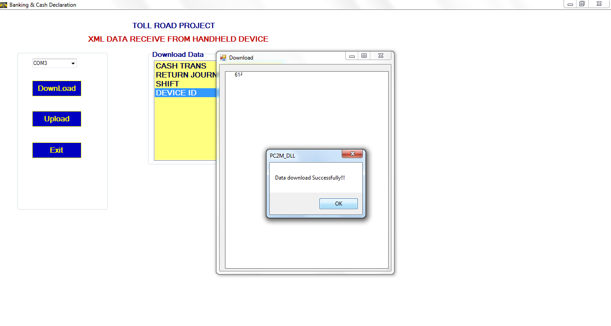

Figure 62 – Data Downloaded Successfully

1. You can see the message that ID is downloaded successfully. Click on **Exit** button. The message appears to confirm, whether you want to issue the handheld device or not, as below.

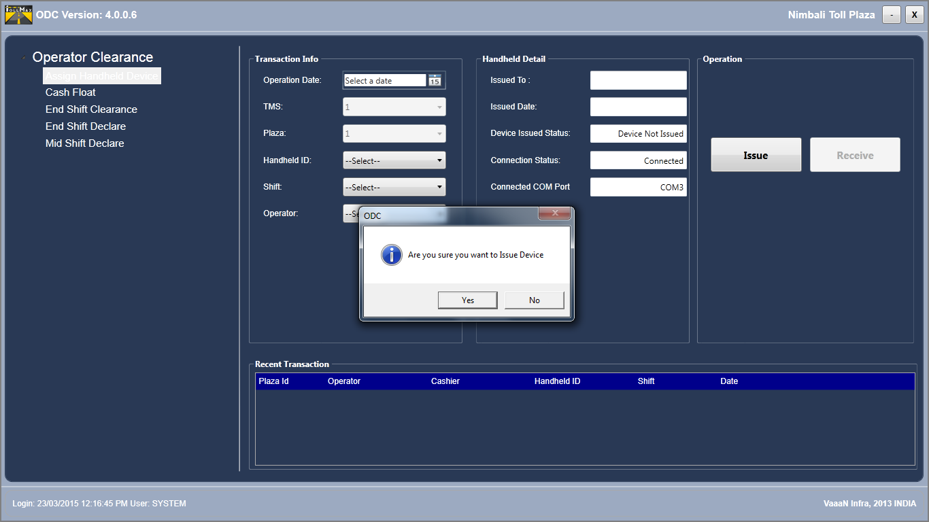

Figure 63 – Confirmation of Issuing Device

1. Click on **Yes** button.
2. Select the shift and operator name from **Shift** and **Operator** drop-down lists respectively. The message appears that you need to download the shift information as below.

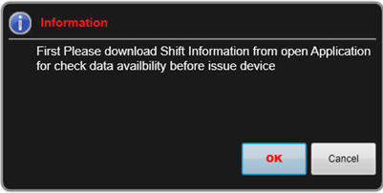

Figure 64 – Download Shift Information

1. Click on **Ok** button. The window appears as below.

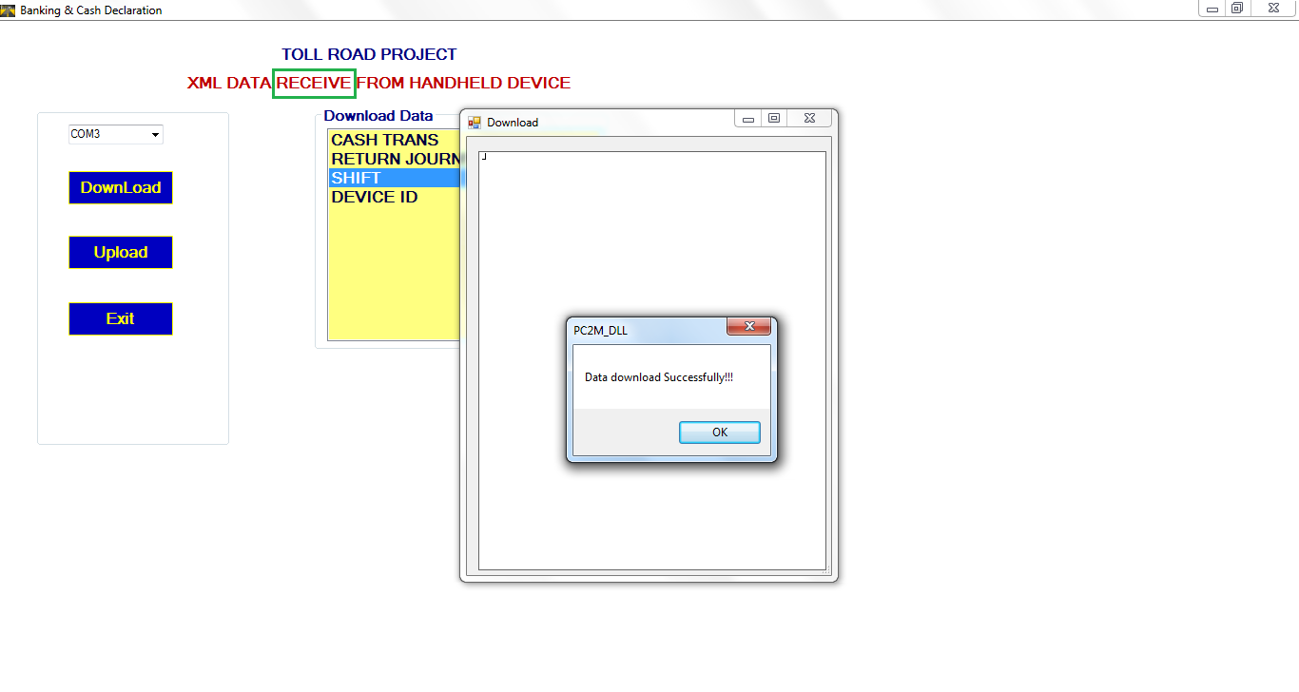

Figure 65 – Downloaded Shift Data Successfully

1. Double click on **Shift** option. The message appears that the shift data is downloaded successfully.
2. Click on **Ok** button. Then, click on **Exit** button to exit the window.

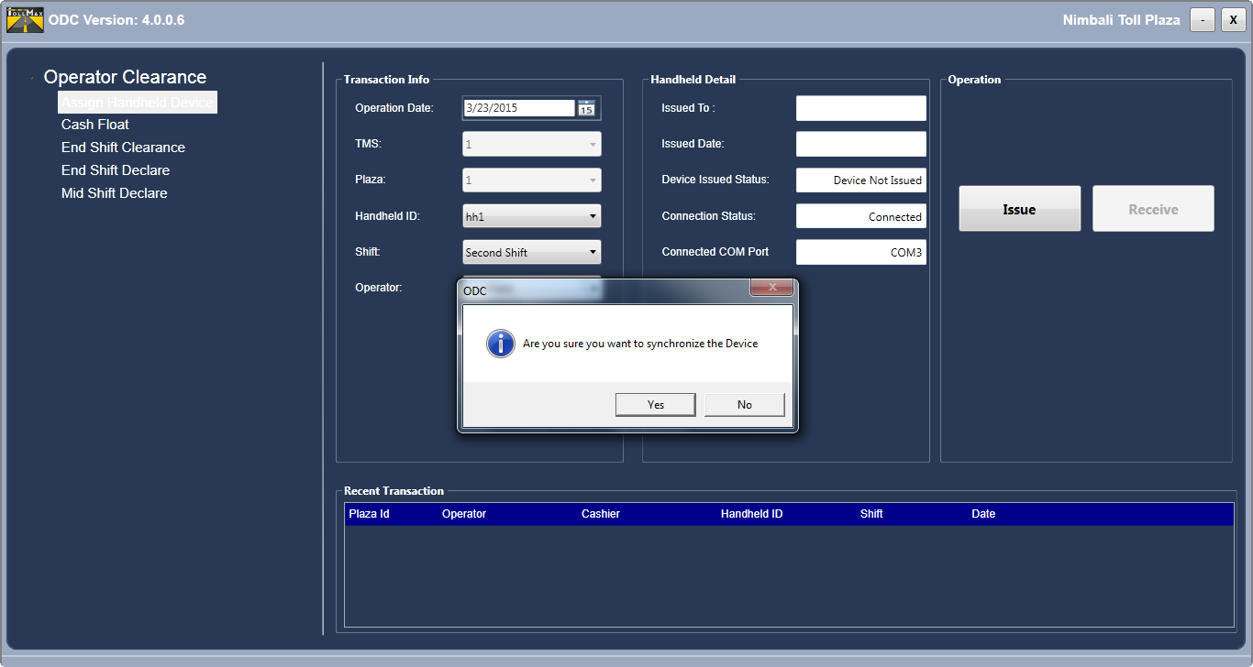

Figure 66 – Synchronize Data

1. In **Operation** section, you can click on **Issue** button. When you are issuing the device to user, the **Receive** button is in disabled form.
2. The message appears to upload all the data.

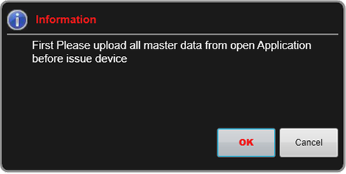

Figure 67 – Upload Master Data

1. Click on **Ok** button and the window appears.
2. Click on **Upload** button to upload all the master data, as below.

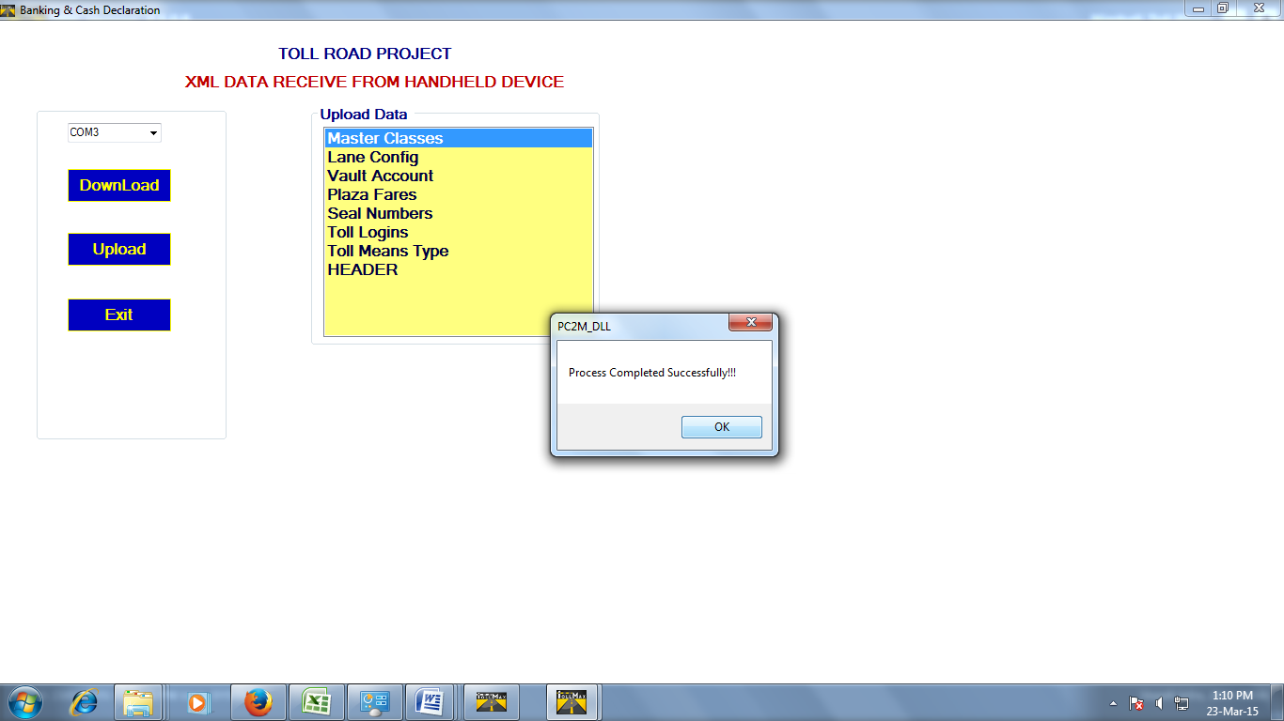

Figure 68 – Uploaded Data Successfully

1. In **Upload Data** section, double click on each data option to upload it. When you upload all the data, the message appears that the process is completed successfully.
2. Click on **Exit** button to exit the window. You can see that the device is issued to required operator as below.

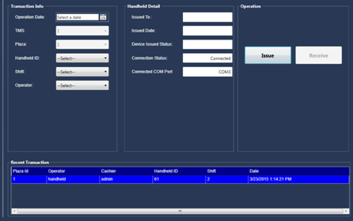

Figure 69 – See Recent Transaction

1. At the bottom of screen, in **Recent Transaction** section, you can see the following details of recent transaction.

* **Plaza Id**: The id of the plaza.
* **Operator**: The operator to whom handheld device issued.
* **Cashier**:
* **Handheld ID**: The id of the handheld device
* **Shift**: The shift number
* **Date**: The date when device was issued to operator.

### 3.5.4. See Details of Previous Issued Handheld Details

If any user is already issued to handheld device, you can see the details in **Handheld Detail** section as below.

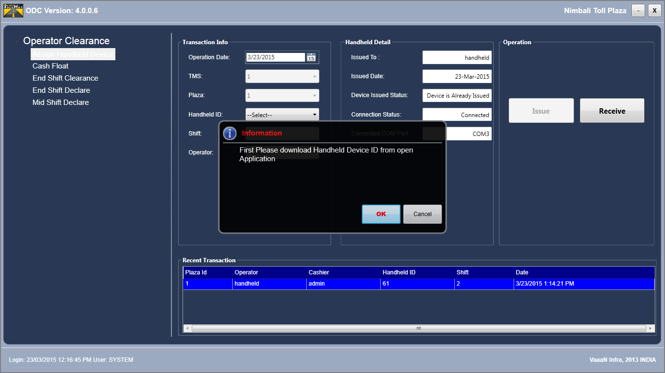

Figure 70 – Previous Handheld Detail

You can see the following details:

* **Issued To**: The name of user to whom the handheld is currently issued
* **Issued Date**: The date when handheld was issued
* **Device Issued Status**: The status whether the device is issued or not
* **Connection Status**: The status whether the device is connected to user or not
* **Connected COM Port**: The port number with which handheld device is connected

### 3.5.5. Receive Data from Handheld Device

After issuing a handheld device to the required user or operator, you can receive the data from a device. You need to follow the below steps.

1. Open the **ODC** module.



Figure 71 – Download Handheld ID

You need to specify following details:

1. In **Operation Date**, select the date when you are receiving data from handheld.
2. As you select handheld ID from **Handheld ID** drop-down list, the message appears that you need to download the device ID. Click on **Ok** button and the window appears as below.

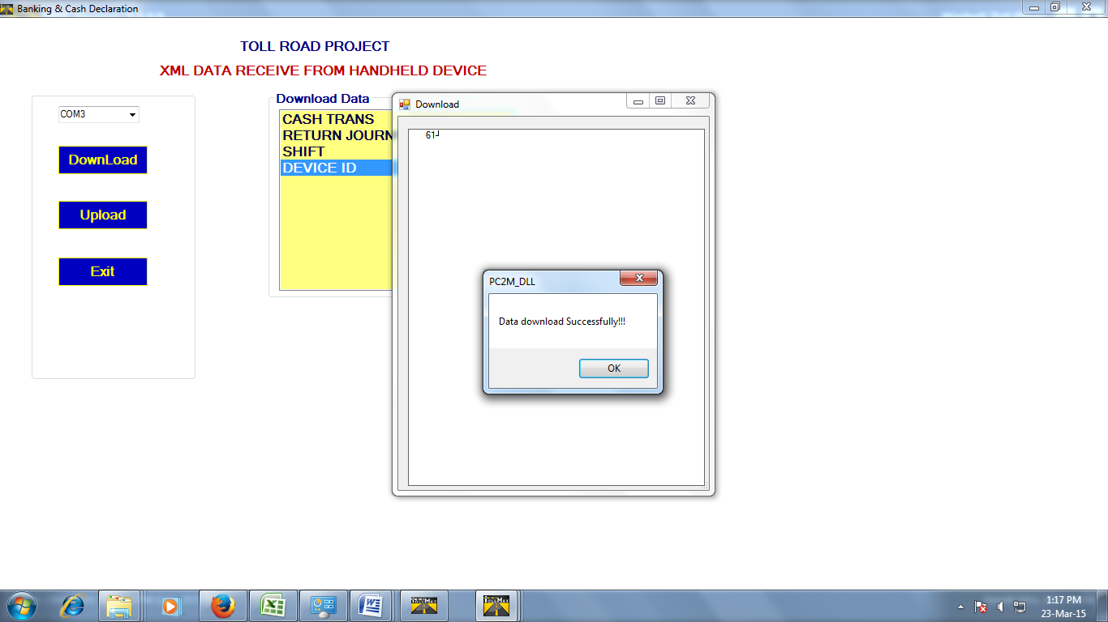

Figure 72 – Downloaded Device ID Successfully

1. Select the required COM port. Double click on **Device ID** option available in **Download Data** section.
2. Click on **Ok** button.
3. Click on **Exit** button to exit the window.
4. When you select the shift from **Shift** drop-down list, the message appears as below.

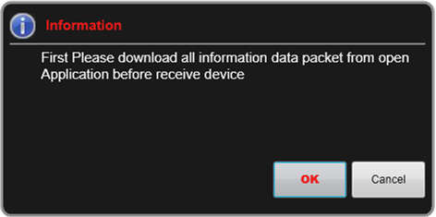

Figure 73 – Download All Data

1. You need to download the data before receiving device. Click on **Ok** button. The window appears as below.

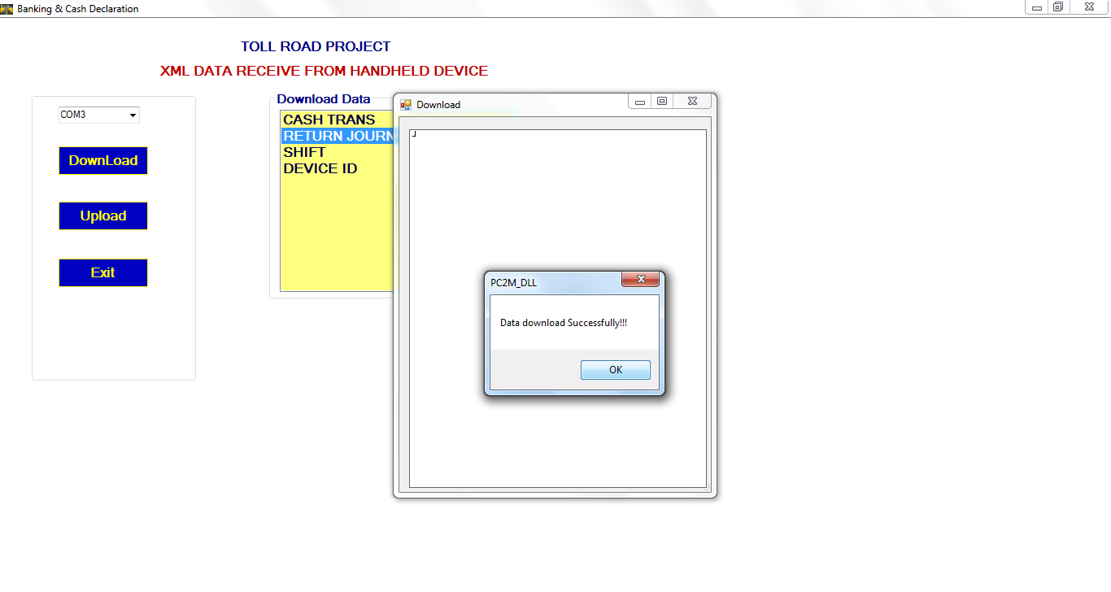

Figure 74 - Data Downloaded Successfully

1. Click on **Download** button and the **Download Data** section appears. You need to download all the data such as cash transaction, return journey, shift, and device ID.
2. Double click on each data option and the data is downloaded successfully.
3. Click on **Exit** button to exit the window.

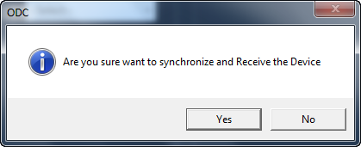

Figure 75 – Confirmation To Synchronize and Receive Device

1. The system asks you to confirm whether you want to receive the device or not. Click on **Yes** button.
2. When you are receiving the data, the **Issue** button is in disabled form. In **Operation** section, you need to click on **Receive** button. The message appears as below.

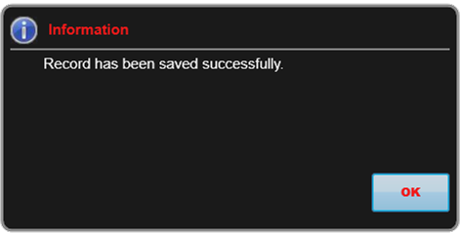

Figure 76 – Record Saved Successfully

## 3.6. Reliever Functionality

The reliver is an operator which is responsible for processing transactions on many lanes. The cash float is assigned as per a particular lane and can declare amount in mid-shift with a user id.

There is a check box in end-shift declare screen, by making it checked, lane and teller filters gets disabled and an amount collected by a reliever can be declared using a particular user id.

Also, there is a checkbox in end-shift clearance screen, by making it checked, lane and teller filter gets disabled and a process of clearance can be taken place as it is processed for other toll operators. The purpose of this functionaltiy is to provide some rest to toll collector in case of emergency or some discrepancies.

## 3.7.Shift Close Functionality

In **End shift clearance** section, **Shift Close** button is available which resemble closing a particular shit of a day when cashup of all users in that shift are completed. If any user is left for cashup, their information would be shown in a pop up message box. Closing a shift means, cashier would not be allowed to select a shift for any type of transaction via ODC for the closed shift.

# Transaction Discrepancy & Audit Tool

Transaction audit module is installed in plaza systems. It is a fraud tracking and violation control module, through which auditor can manipulate any type of discrepancy that may exists between inputs coming from Automatic Vehicle Classification system and selected operator’s vehicle class from the lane. The different functions performed by transaction audit are mentioned as follows:

* Displaying transactions by the selection of different filters based on start/end date, start/end time, plaza, lane, shift, vehicle class etc.
* Auditing transactions by viewing transaction on the basis of AVC and operator class
* Different transactions options available to audit the transactions from lane are operator correct, operator fault, AVC correct, cancel transaction, run through, exempt denied, exempt correct
* Review description or review count of specific transaction
* To view image and video for a particular transaction

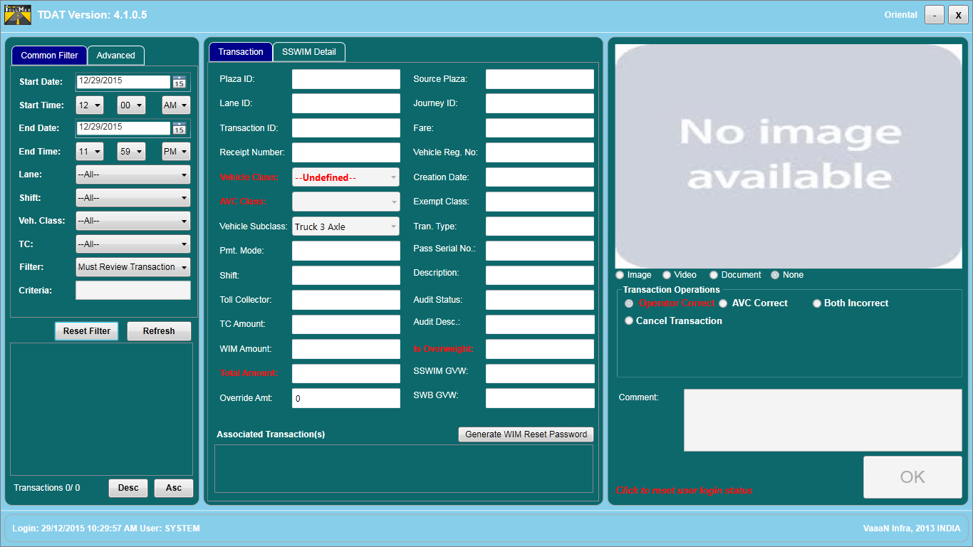

Figure 77 - TDAT Screen

## Search Criteria

## 

## 

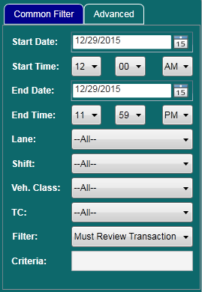

Figure 78 - Search Criteria Screen

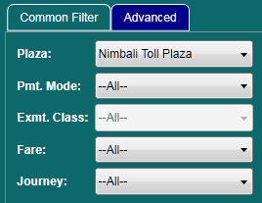

Figure 79 – Advanced filter

**Start date**

This parameter defines, for which particular date user wants to do start auditing of inputs coming from AVC system and lane operator computer**.** By default, it is the current date. To change (back date) it, click on calendar icon and choose the desired date or we can type manually.

**Start Time**

This parameter defines for which specific time user wants to do start auditing of inputs coming from AVC system and lane operator computer**.** By default, it is the 00:00:00. Time represents in the form of hr: mm: sec.

**End date**

This parameter defines, for which end date user wants to do auditing of inputs coming from AVC system and lane operator computer. By default, it is the current date. To change (back date) it, click on calendar icon and choose the desired date or we can type it manually.

**End time**

This parameter defines for which specific time user wants to do end auditing of inputs coming from AVC system and lane operator computer. By default, it is current system time. Time represents in the form of hr: mm: sec.

**Plaza**

This parameter defines the identification number of specific plaza. Here default it is 1.

**Lane**

It is identification number of specific lane. Here, default it is all. User can change desired lane from the drop down list.

**Shift**

It is identification number of specific shift. Here, default it is all. User can change desired shift from the drop down list.

**Vehicle class**

This parameter defines for which specific vehicle class user wants to do auditing of inputs coming from AVC system and lane operator computer. Here, default it is all. User can change desired vehicle class from the drop down list.

**Toll Collector**

It is login id of a specific user.

**Pmt. Mode**

The specific mode could be selected form this filter.

**Filter**

Filter is used to categorize the type of transaction. Here, default it is all transactions. User can choose following filter from the drop down list.

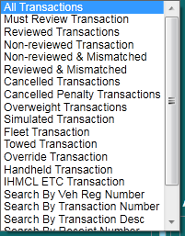

Figure 80 - Filters

* **All transactions**

The desired selection of filters results in the generation of all the transaction for a particular lane and shift.

* **Must Review Transaction:** This is the transaction that must be reviewed by auditor.There can be two cases where auditor must review the transaction:

• Transaction is of exempt type

• Mismatch of vehicle class selected by toll operator and the vehicle class generated by AVC system.

Select this option to generate the list of transactions that must be reviewed by auditor.

* **Reviewed transaction**

Reviewed transaction filter selection generates the list of transactions that has been already reviewed by shift supervisor.

* **Non reviewed transaction**

This filter is used for auditing transaction with certain transaction operations.

* **Cancelled transactions**

The cancelled transaction filter is used to generate all the cancelled transactions in the transaction grid.

* **Non-reviewed & mismatched**

Non-reviewed and mismatch filter selection generates the list of transactions which are not reviewed by shift supervisor and having discrepancies in inputs coming from AVC and operator vehicle class.

* **Search by Veh Reg no**

The search by vehicle registration number filter is used to search a transaction by vehicle registration number.

* **Search by transaction no**

The search by transaction number filter is used to search a transaction by transaction number.

* **Search by transaction desc**

The search by transaction description filter is used to search a transaction by transaction description. A RFID handheld transaction could be visualized by entering description as “RFID HHM”.

* **Search by receipt no**

This filter is used to search a transaction by receipt number and for cancelling audited transaction.

* **Search by pass serial no**

Barcode and smart card transaction could be searched by entering pass serial number in criteria text box.

* **Overweight transactions**

Manual or automatic WIM overweight transactions could be seen by selecting this filter.

* **Simulated transaction**

In case if barrier is forced to be down through TCA, those transactions could be seen by selecting this filter.

* **Fleet transaction**

Multiple passing of vehicles through a lane could be seen by selecting this filter.

* **Towed transaction**

This filter is used to display towed transactions.

**New added functionality**

* A feature is added for return journey auditing. If a return journey receipt is not used on lane, it is allowed to cancel else not.
* If AVC is not in the plaza then mismatched transaction should not come in the

"Must Review" filter and is configurable.

* Vehicle class can be changed for overloaded transaction.
* SSWIM and static weigh bridge gross vehicle weight is shown on master screen as a description.

**Criteria**

By default the criteria text box is in disabled state and is only enabled for some filters as mentioned below:

* Search by veh. reg. no
* Search by trans no
* Search by tran desc

**Refresh**

The “Refresh” button is used to fetch the filtered transactions from the database, when the user select filter option from the drop down list.



## Transaction List Count

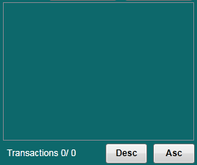

Figure 81 - Transaction Display Grid

A list of transactions that matched the filter criteria will appear in this display area. Click a specific transaction ID in the list to view the details. The transaction Ids can be ordered in ascending or descending order by clicking on Asc or Desc button.

## Transaction Detail Section

Following are the details of selected transactions:

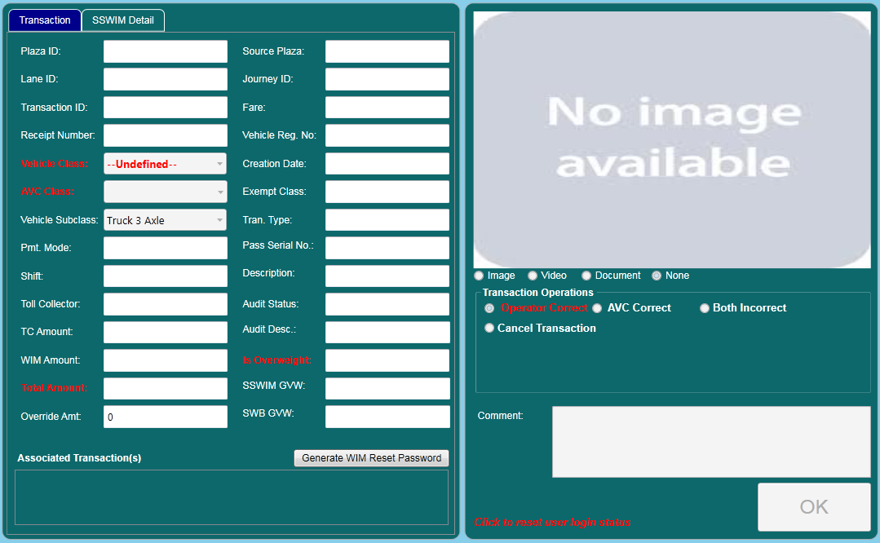

Figure 82 - Transaction Detail Section

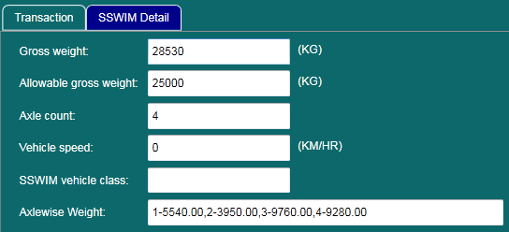

Figure 83 – SSWIM Details

**Plaza ID**

This parameter defines the Plaza ID of a selected transaction.

**Lane Id**

This parameter defines the Lane ID of a selected transaction.

**Transaction ID**

This parameter defines the transaction ID of a selected transaction.

**Receipt Number**

This parameter defines the receipt number of a transaction.

**Vehicle Class**

This parameter defines the vehicle class of a selected transaction.

**AVC Class**

This parameter defines the vehicle class that is classified by the AVC system.

**WIM class**

This parameter defines the vehicle class that is classified by the WIM system.

**Total Amount**

This parameter is the addition of TC and penalty amount.

**Amount**

This parameter defines the toll amount of the selected transaction.

**Journey Id**

This parameter defines the journey type of selected transaction.

**Fare**

This parameter defines the fare type of selected transaction.

**Transaction Type**

This parameter defines the status of lane .i.e. weather lane is working in normal mode or in maintenance mode.

**Vehicle Reg.No.**

This parameter defines the vehicle registration of selected vehicle.

**Creation date**

This parameter defines the creation date and time of selected transaction.

**Exempt Class**

This parameter defines whether a transaction is exempt or not.

**Transaction Type**

This parameter defines the transaction type.

**Is overweight**

This parameter defined whether a vehicle transaction is overweight or not.

**Vehicle Subclass**

This parameter defines vehicle subclass.

**Pass Serial No.**

This parameter defines pass serial number.

**Description**

This parameter defines the type of exempt class. In case of cash transaction, it is blank.

**Audit Status**

This parameter defines the status of the transaction operations selected by user. The different types of “tran status” are:-

* Reviewed
* Not Reviewed

**Payment Method**

This parameter defines the payment method of a selected transaction.

**Shift**

This parameter defines the lane operator shift of a selected transaction.

**Toll Collector**

This parameter defines the name of lane operator.

**TC Amount**

This parameter defines the amount of transaction processed by toll collector on lane.

**WIM Amount**

This parameter defines the penalty amount of transaction.

* Operator correct Reviewed

**Audit Description**

This parameter defines the description of an audited transaction.

**Override amount**

This parameter displays difference in amount after auditing a transaction.

**Image**

This parameter shows the image associated with the selected transaction.

**Video**

This parameter shows the video associated with the selected transaction.

**Document**

This parameter displays exempted vehicle class document scanned during exempt transaction.

**None**

This parameter doesn’t display image or video.

**Gross weight**

This parameter displays the weight of a vehicle.

**Allowable gross weight**

This parameter displays the weight allowed for a vehicle to cross a lane with and without paying penalty.

**Axle count**

This parameter displays the number of axle a vehicle have while crossing a lane.

**Vehicle speed**

This parameter displays speed of a vehicle while crossing a lane.

**SSWIM vehicle class**

This parameter displays vehicle class given by SSWIM.

**Generate WIM Reset Password**

This feature is added to reset WIM queue from lane. This button is used to generate a password which is required by toll collector to reset queue. The validity of password is five minutes otherwise a new password is needed to proceed with reset operation.



## Transaction Operation

The transaction operations are used to make correction in the particular transaction if any discrepancy occurs.

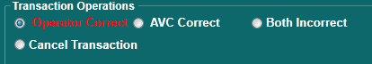

Figure 84 - Transaction Operations, TDAT

**Operator correct**

* The user selects the operator correct option, if result coming from operator’s computer is correct and the result coming from the AVC system is incorrect.
* In this case, operator is not responsible for mismatch condition.

**Both Incorrect**

* The comparison is made between the operator and ARC class.
* If both the classes are results in conflicted transaction, both incorrect option is selected for auditing.

**Cancel transaction**

* If the toll collector selects an incorrect option of vehicle class by mistake, and want to cancel the receipts.
* For this case, the receipt is submitted to supervisor, not used by commuter for transaction.
* For clearance operations supervisor would not use same receipt.

**Dist. Regd. Denied**

* + The fare type of transaction is district registered.
  + The comparison is made between Vehicle registration number specified by toll collector and the vehicle registration number displayed in vehicle image.
  + Both vehicle registration numbers are not matched.
  + The vehicle registration number displayed in vehicle image was not local.
  + The auditor selects **Dist. Regd Denied** option.

The auditor selects this option if fare type of transaction is district but the vehicle registration number is not local.

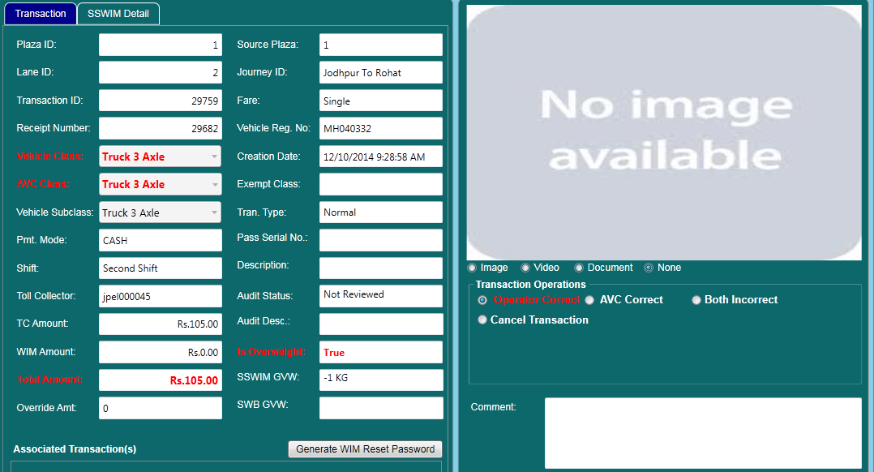

Figure – Dist. Regd. Denied

Auditor can also see the deficit amount.

**Ok**

By default, OK button is disabled. But, it is enabled in the following two cases of filter option:

1. Non-reviewed & mismatched
2. Non-reviewed and exempt

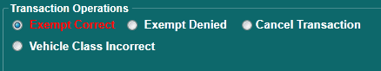

Figure 86 – Exempt transaction operations.

**Exempt Correct**

* A user selects an exempt correct transaction operation, if transaction is visualized by image, video and document.

**Exempt Denied**

* If a toll operator releases a toll paying vehicle from a lane as an exempted vehicle, then it could be audited as exempt denied.
* An exempt transaction shall become cash transaction.

# Real Time Monitoring & Controlling System

toll***M***ax® RTMCS (Real Time Monitoring and Controlling System) is a GUI application generally installed in machines located at plaza offices. The purpose of this module is to display the various hardware status transmitted from all the lanes, so that administrator or supervisor people can monitor all activities of lane. It displays the current transactions happening at a lane with special events in the event section.

The functions performed by ‘RTMCS’ are as follows.

* Display current hardware status of lanes in the plaza office.
* Display vehicle transaction status of the lane.
* Allow supervisor to observe lane activities.

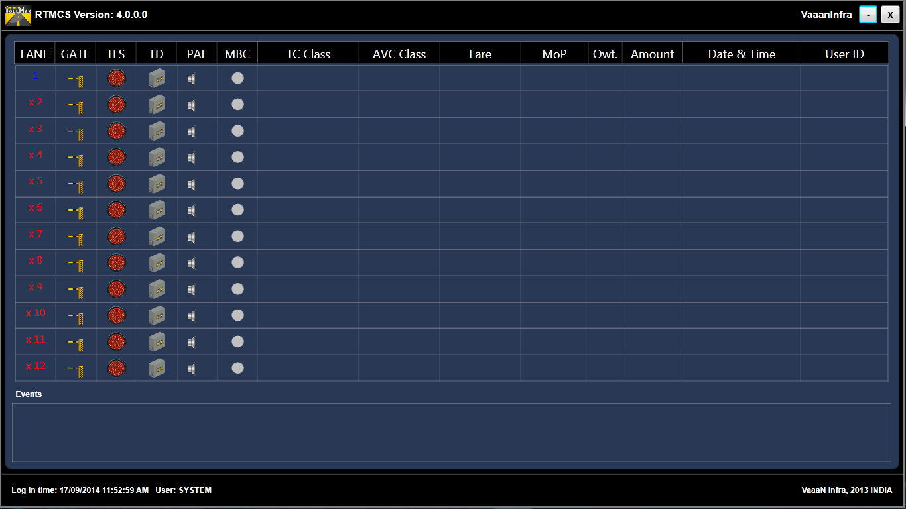

Figure 87 - RTMCS Screen

## 5.1. How RTMCS Works

toll***M***ax® RTMCS is a fully automatic solution, designed to maintain efficient traffic flow that can manage and capture the image/video at real time control of lane equipment. All these network synchronization is done by “EMS (Event Messenger Service)”. This module is window based application that will run on the monitor terminals at plaza location. The main responsibility of this module is to provide a user friendly graphical interface for viewing the current status of various hardware equipment attached with any specific lane/s.

GUI is displayed as follows:

To describe the status of the lane the different items can be explained. Each row represents a different lane. The columns in the screen are explained from left to right. For the proper perceptive of RTMCS, screen can be categorized into parts mentioned as follows:





Figure 88 - RTMCS Column to display Real Time Events



## Lane

* It is utilized to indicate the state of a lane i.e. if the lane is open or closed.
* The “**LANE**” represents the lane number of a particular plaza. If lane is working or synchronize with network, it will green in color. If lane is close or not synchronize with network, it will display the red color “**X**” sign before the lane no.

## Barrier Gate

* The “GATE” is used at Toll plazas to control traffic for paying toll of all vehicles.
* It shows the status of gate is ‘Up’ or ‘Down’. If the gate is ‘Up’, sign will be ‘green’ or if the gate is ‘Down’, sign will be red.

## TLS

* The traffic light is used to control the flow of vehicles through the toll lane before and after toll has been collected.
* The traffic light shall display a red or green light to the commuter indicating the status of their transaction and indicating either to stop or proceed.
* The “Red” light signifies for stop and “Green” light signifies for proceed.
* TLS is synchronizing with automatic barrier gate.

## PRESENCE LOOP

* Loop detector is used for detecting presence of the vehicle over the Loop Sensor.
* If the loop detects vehicle, the loop indicator will green else it remains red.

## EXIT LOOP

* The exit loop determines the exit of a vehicle from a toll lane
* If the loop detects the vehicle, the exit loop indicator changes its color to green else remains red

## TLC DOOR

* The TLC (Toll Lane Controller) System includes the software and hardware components which is required for the toll collection and for reliable counting and classification of vehicles in toll lanes.
* If the TLC Door is open, the sign will ‘Red’ or if it is closed the sign will ‘Green’.

## Transaction no

* This parameter defines the authentication number of any transaction takes place at lane.

## TC Class

* This parameter defines the vehicle class name selected by lane operator.

## Fare

* This parameter defines the type of fare single/return/daily pass.

## Journey

* Journey is defined as the portion of the toll road that the commuter want to use.

## Pmt. Mode

* This parameter defines, the payment method used for specific transaction. It can be cash or exempt.

## Amount

* This parameter defines, amount paid by the commuter to the operator for this transaction.

## Date & Time

* This parameter defines the exact date and time of particular transaction takes place at lane.

## User ID

* This parameter defines the identification number of user or operator.

## Events



Figure 89 - Events Space

The list of messages on the monitor machines at plaza office to define transaction processed on lane. Some of the e.g. are given below.

* Operator logged in
* Operator logged out
* TLC door open
* Violation

# 6. Smart Card Operations

Prepaid operation is a module, through which customer can purchase, refund or recharge smart cards. All operations shall be performed on PoS terminals generally located at Plaza office. The number of users may differ and are client specific.

Major operations performed by prepaid operation module for smartcard and ETC tag are as follows:

* Sale, along with valid documents (if any)
* Recharge with a particular amount
* Refunding smart card or ETC tag
* Blacklisting a smart card or ETC tag
* Replacement of a smart card or ETC tag
* Editing vehicle registration number of a smart card or ETC tag
* Add depot details
* Customer notification by SMS when a card or tag is sold/recharged



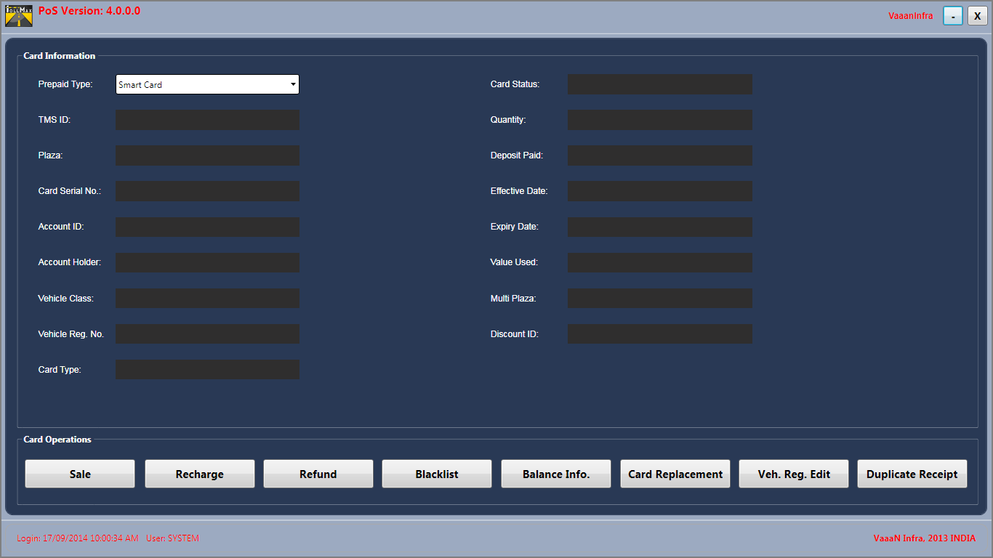

Figure 90 - Prepaid Operation Screen

## Smart Card

Smart card is fast, secure, convenient and cost effective method of toll payment. The smart card issued to the customers contains information such as customer id, vehicle number, card type, amount, expiry date etc. The smart card can be reused many times depending upon the utilization by a particular commuter. The different operations of smart card are mentioned as:

* Sale
* Recharge
  + Refund
  + Blacklist
  + Balance Info
  + Vehicle registration number edit
  + Card replacement

## POS-Lane operations

**Smart Card**

* A commuter with smart card approaches to the toll lane
* The lane operator selects the vehicle class via TCA
* The commuter or toll collector punches the smart card on smart card reader mounted on the toll lane
* If the smart card is valid, a transaction is successful and if invalid, error message will be displayed on TCA screen
* On successful transaction, TLS turns green and barrier gate is in up-state
* The transaction generated for smart card is separately maintained in database which can be viewed using Reporting module

**ETC Tag**

* A commuter with an ETC tag approaches a toll lane
* An ETC reader installed in lane reads a tag
* If a tag is valid, a transaction is successful and if invalid, error message will be displayed on TCA screen
* On successful transaction, TLS turns green and barrier gate is in up-state
* The transaction generated for ETC is separately maintained in database which can be viewed using Reporting module



## Information

The information that the card contains, is reflected on the master screen of prepaid operation module.

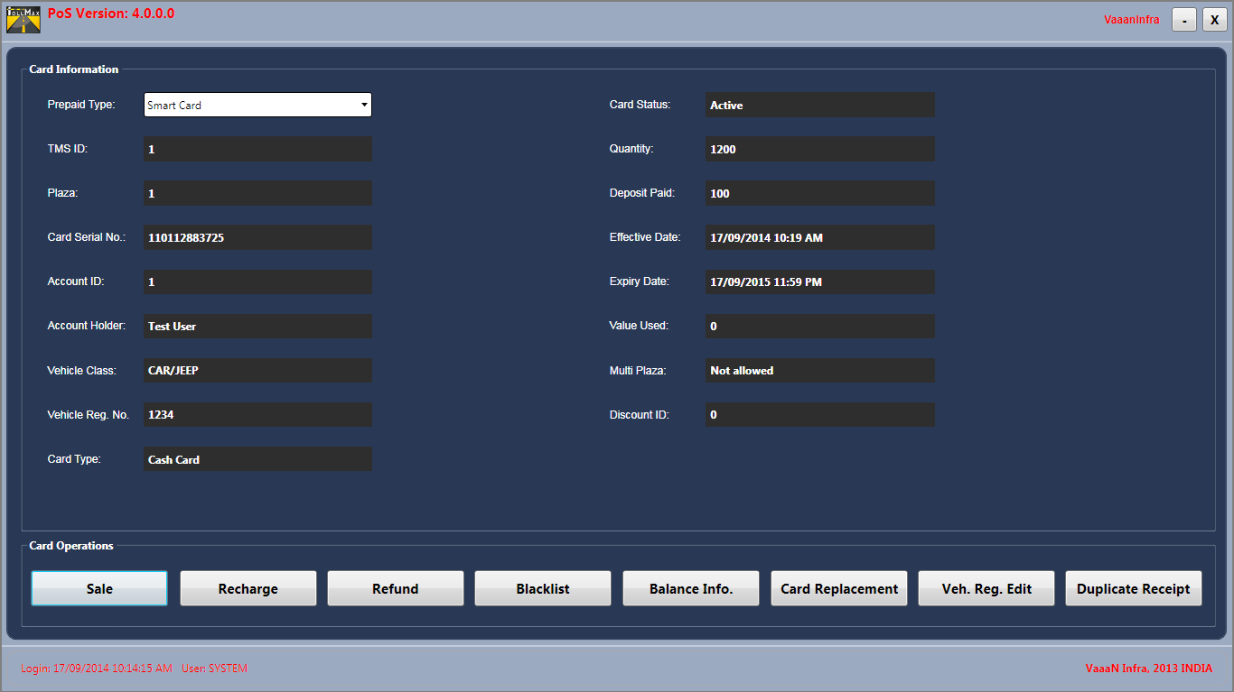

Figure 91 - Information in a card

The card information is described below:

|  |  |
| --- | --- |
| **Terms** | **Description** |
| TMS ID | The identification number for Toll Management System. |
| Plaza | The unique identification number for a specific plaza class. |
| Card Serial No. | The unique number for a specific smart card. |
| Account ID | The unique identification for specific Account. |
| Account Holder | The name of authorized person for specific account. |
| Vehicle Class | The type of vehicle class for which the card will be issued. |
| Vehicle reg. no. | It defines the register no of vehicle. |
| Card Type | It defines the nature of smart card. It can be a time cardor exempt card. |
| Card Status | The status of card weather it is active state or refund card. |
| Quantity | The amount of money paid if it is cash card. |
| Deposit Paid | The deposit amount of money paid by commuter for card with respect to specific account Id. |
| Effective Date | The date on which smartcard is considered to be effective in the toll lanes for operations. |
| Expiry Date | The date on which the card is going to be inactive. |
| Value Used | It defines how much amount is used i.e.amount of cash in cash card. |
| Multi Plaza | This parametere defines weather the smart card is valid for more than one plaza road. |
| Discount Id | This parametere defines weather the smart card isdiscounted or not.If value is 1 then it is discounted card used by local customer. Otherwise used by commercial commuter. |

**Important point**

*Before the sale operation, card should be intialized with a unique key. If the card is not* *initilized with the value which card reader contains, then it is not possible to access any information that a card is equipped with.*

## Card operations

Depending upon the status of a card, various operations can be performed using prepaid operations module.



Figure 92 - Card Operations



## Sale

The sale operation can be processed if card status is refund. The sale button is used to sale a card to commuter. To sale a smart card to the new commuter, an account is created using customer account screen which can be accessed through a FIND button exists on sale operation screen. If an account is already created, selection of desired tabs allows a card to be sold. This operation is performed by POS operator.

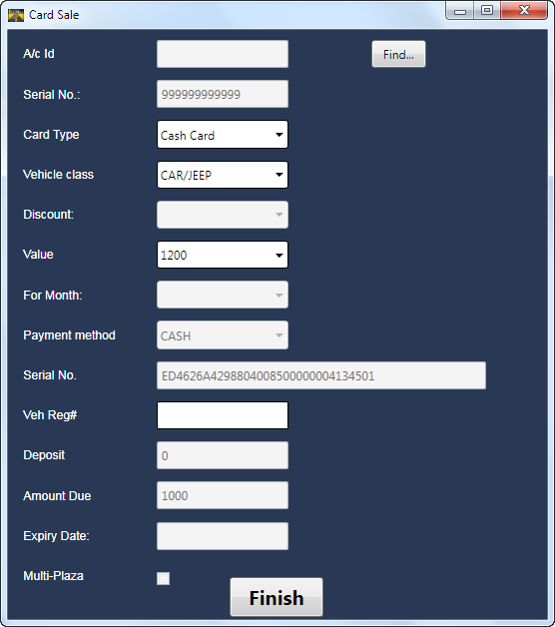

Figure 93 - Smart Card Sale Screen

The available tabs in smart card sale screen are described as follows:

**A/C Id:** This parameter defines the unique identification number for a specific account. On selection of a particular account, a specific account id appears on the smart card sale screen in A/C Id tab.

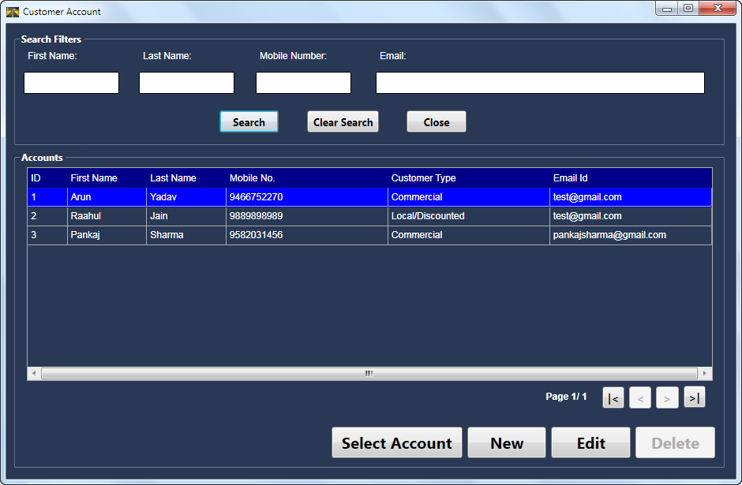

Figure 94 - Customer Account Screen

The screen layout for Customer Account is given as below.

* “Search” is used for seaching detailed information of already registere account on the basis of first name or last name or mobile number or email id
* “Clear search” is used to clear all information from the tabs
* “Close” is used to exit from the account screen
* Page navigation buttons are used for togglingdifferent pages
* “Select account” is used to select an account from the list of created users
* “New” button is used for creating a new commuter account

The new account creation takes place as described below:

* Enter first, last name, mobile number (restricted to ten digits only), email id, address
* The account type selection as single
* The customer type could be selected as commercial or local depending upon the type of documents provided by a commuter
* For local commuter, the documents are verified by plaza manager and after verification, the smart card can be sold to a particular commuter
* Upload a scanned copy of snap and a valid document(if any)
* Click on save button to complete the creation of a particular account otherwise click on cancel button to restrict account creation

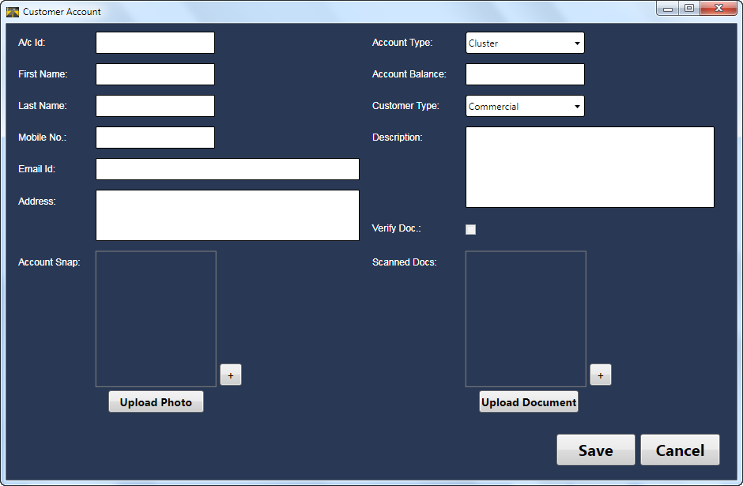

Figure 95 - Account Creation Screen

**How to add a new account**

1. Click on Sale button.

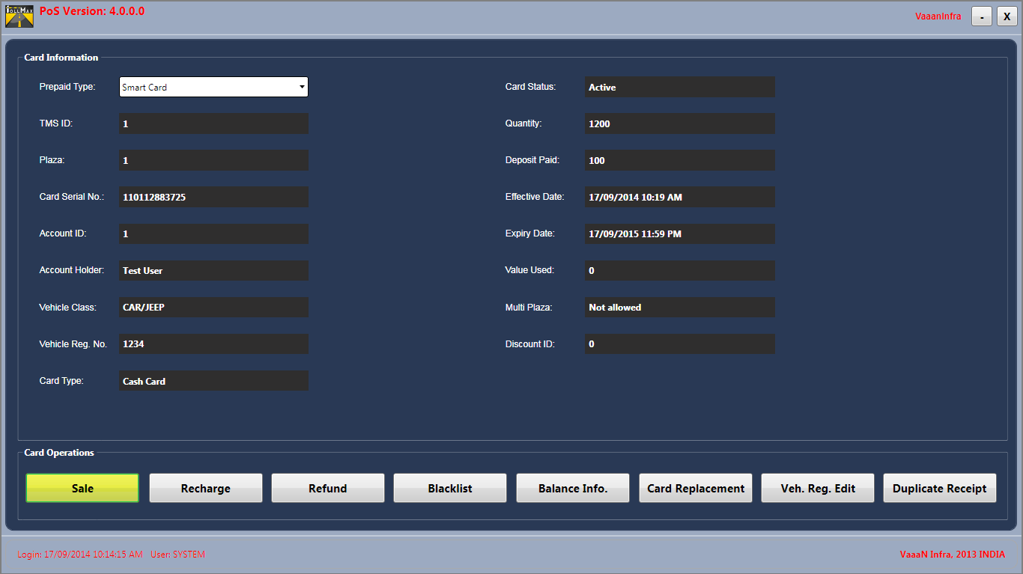

Figure 96

1. From the smart card sale screen, click on find button to open account creation screen.

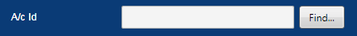

Figure 97

1. To proceed with the new account creation, click on new button.

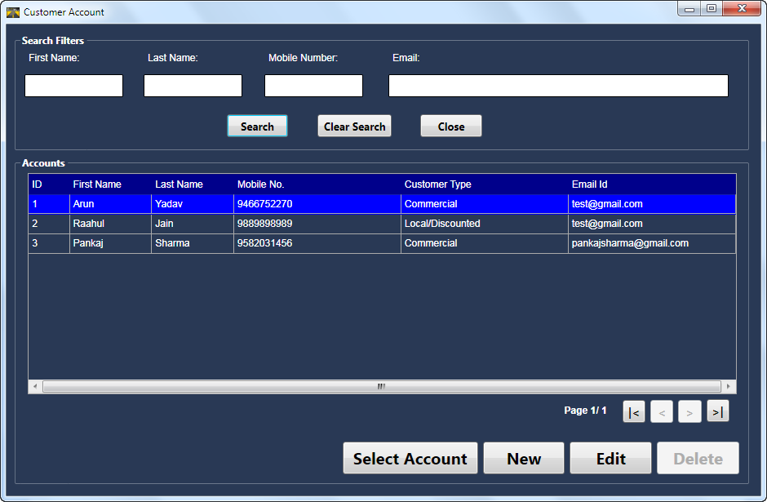

Figure 98

1. In customer account screen, enter details of a commuter along with snap and document(if any). Click on save button for successful creation of a commuter.

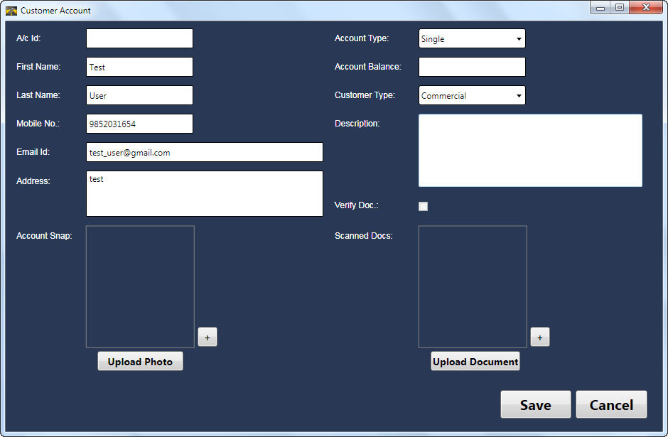

Figure 99

1. The edit button is used to update the information of a commuter except customer type.

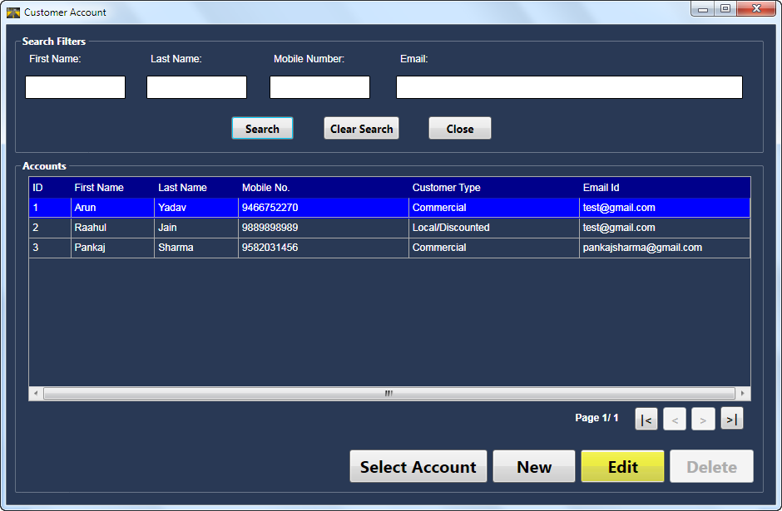

Figure 100

1. The account information can be edited as shown below:

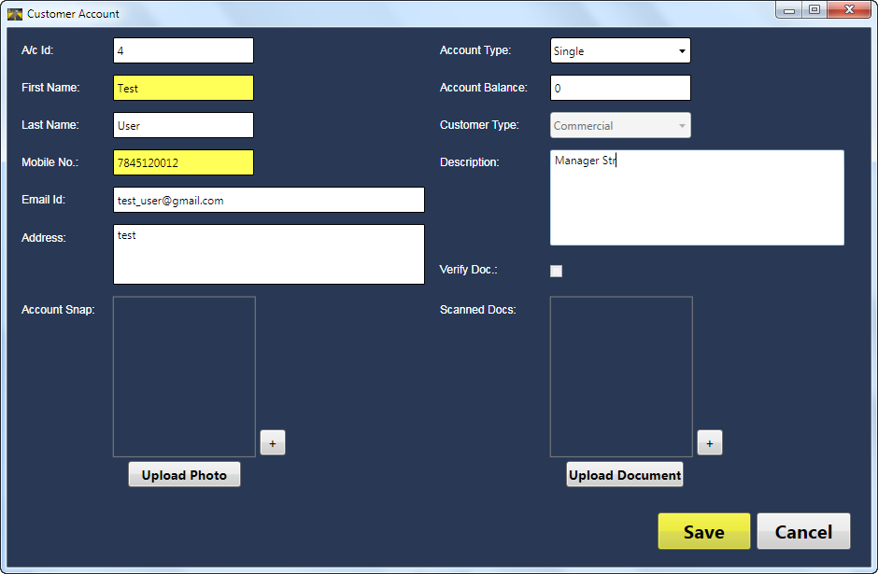

Figure 101

**Card type**

There are three types of cards, categorized as:

* Time card
* Cash card
* Exempt card

Depending upon the customer type selected at the time of accoutn creation, seprate cards are provided. The cash card is meant for commercial type customers, the time card is meant for local customers with a valid document as an id proof and exempt cards are issued by a plaza manager’s approval.

**Vehicle class**

The selection of vehicle class depends upon the type of account selected. The time card could only be sold to car/jeep vehicle class. The cash card and exempt card could be issued for any type of available vehicle class.

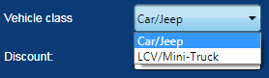

Figure 102

**Discount**

Discount is valid for only local customer type.For local customer, discount tab automatically selects the amount configured in MCM and is displayed here.



Figure 103

**Time**

This parameter defines the number of months a time card is going to sold. The maximum limit for a time card to be sold is one month.



Figure 104

**For Month**

This parameter defines the current and next mopnth. The card will become active as per selection of month. If current month is selected, the card is activated and if sold for next month, card will be active for next coming month.

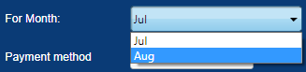

Figure 105

**Payment Method**

The payment method for prepaid operations is by default cash.



Figure 106

**Serial No**

This parameter display the serial number of a card.



Figure 107

**Veh Reg#**

This is the tab for entering vehicle registration number.



Figure 108

**Deposit**

The amount of money that is charged from commuter as a card securtity is displayed here and can’t be modified from the smart card screen.



Figure 109

**Amount due**

It is the sum of deposit amount and prepaid toll rate amount for specific vehicle depending on card type and plaza usage.



Figure 110

**Expiry Date**

The expiry date defines the last date for card usage on toll plaza.



Figure 111

**Multi Plaza**

It defines whether the card can be used on multi plaza or single plaza.



Figure 112

**Finish**

To complete the sale operation, click on finish button. If the mandatory details entered are not correct, the sale operation will be restricted and produces some informative message to re-enter details again.



Figure 113

* A message appears on screen for confirmation of sale operation. Clicking on OK button, successfully completes the sale transaction.

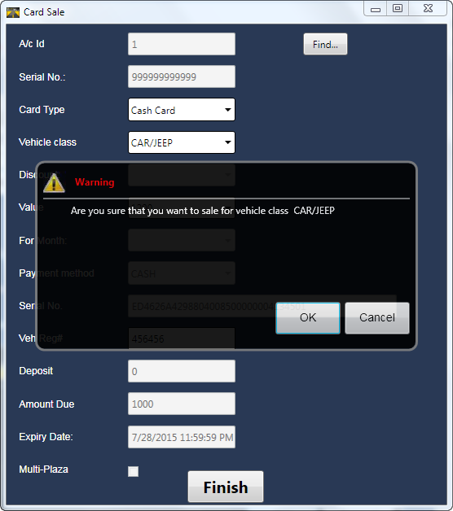

Figure 114 - Sale Operation, Warning message

* Clicking on OK button, successfully completes the sale transaction.

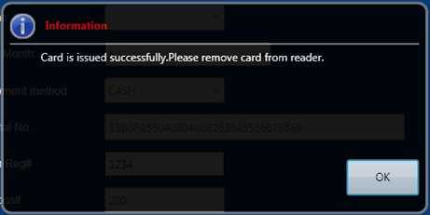

Figure 115 - Sale operation successful

**Important point**

*Expiry date of card will be set automatically as the last day of current month for time card. For cash and exempt cards, the expiry date will be of next one year from the date of purchase.*

## Recharge

Recharge is an operation to renew a card for lane transactions. The recharge is possible on the plaza, from where it is issued. For time card, one month is added as an expiry date of a card. The cash card requires to get recharged according to need i.e. if the card balance is low; amount is required to be inserted to make further transactions on lane.

The POS operator has to follow the steps described below:

* Punch the card on card reader and the information in the card appears on the master screen of the prepaid operation module
* Clicking on recharge button, smart card recharge screen pops out.

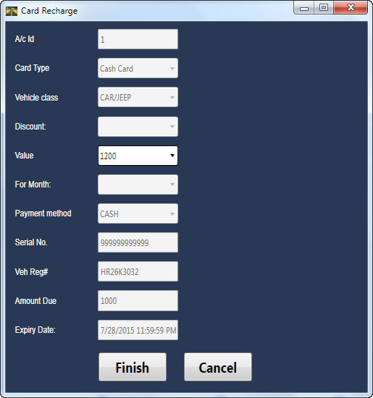

Figure 116 - Recharge Screen

* Click on the finish button and a card get recharged successfully

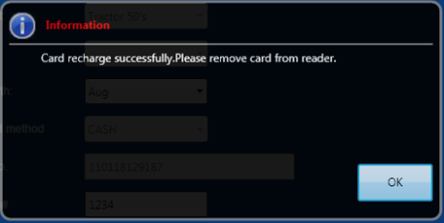

Figure 117 - Recharge Successful

* After recharging a card, verify the information inserted in a card.



Figure 118 - Recharge verification

**Important point**

*At the time of recharge, the vehicle registration number can be changed as desired by the commuter.*

## Refund

The refund operation is used to return a card back to plaza. The deposit amount charged for the card sale is refunded back to commuter in case of time card. For cash card, addition of deposit and remaining balance is offered back to commuter.

* Punch the card on card reader and the information is displayed on master screen of prepaid operation module



Figure 119

* Clicking on refund button, smart card refund screen pops out

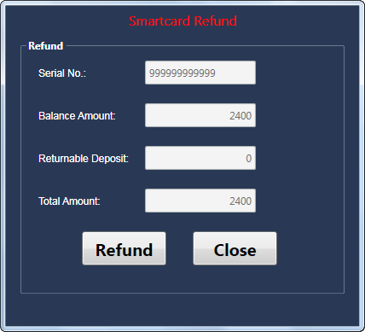

Figure 120 - Refund Screen

* Click on the refund button and a card gets recharged successfully

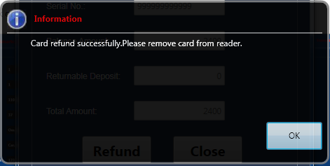

Figure 121 - Refund Successful

* After refunding a card, verify the information appearing on the master screen. The status changes from active to refund

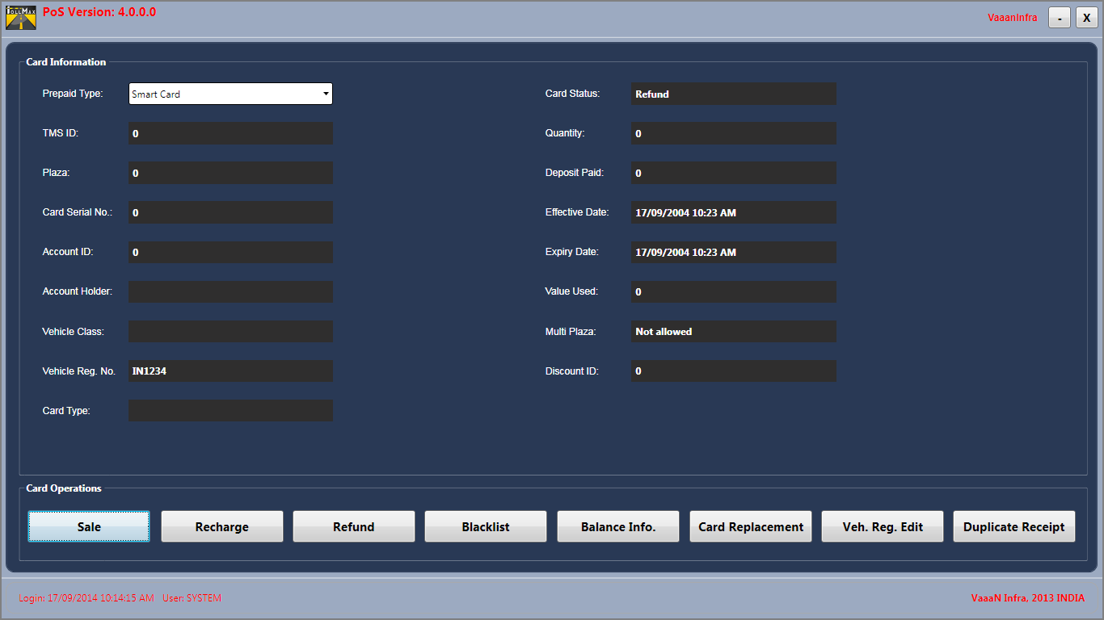

Figure 122 - Refund Verification

## Blacklist

The blacklist operation is used to restrict a card to be used on toll lanes. This operation is performed when there is come conflicts arises, card lost or damaged etc.

**Blacklist**

A card is declared as a blacklist in case of following reasons:

* If a card is lost/ stolen/ damaged by customer
* If any administrative reasons or account suspension
* In case of any violation - any discrepancy found during the time of recharge, (like damaged) refund, usage of card on toll lanes

The steps for making a card blacklisted are described below:

* Click on blacklist button and a smart card blacklist screen pops out

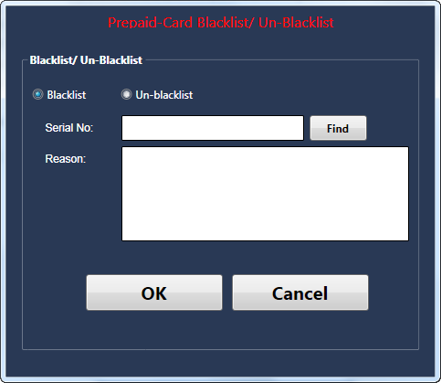

Figure 123 - Blacklist Screen

* Select blacklist radio button and find a particular commuter to get blacklisted using search screen
* After searching a commuter, double click on the user information from search grid

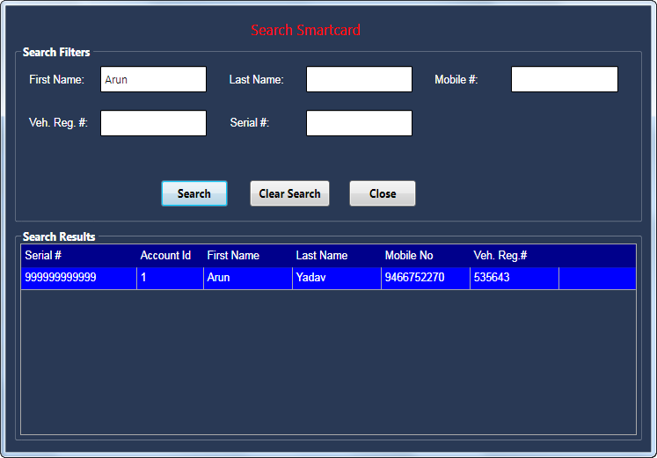

Figure 124 – Search Smart Card Screen

* The serial number is now displayed on the smart card blacklist screen
* Clicking on OK button makes a card blacklisted and a successful message appears on a screen
* To blacklist or un-blacklist a card, a valid reason is required and if not mentioned, a message screen will appear as shown below:

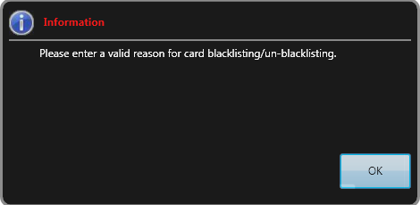

Figure 125 – Search Smart Card Screen

* After entering a valid reason, a successful message will appear

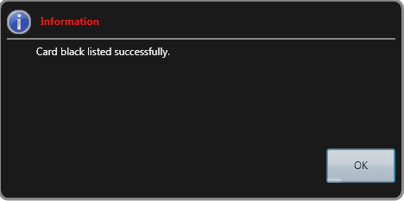

Figure 126 - Blacklist operation successful

**Un-Blacklist**

The operation for un-blacklisting a card is exactly same as it is in blacklisting operation. The difference is in selection of radio button exists on smart card blacklist screen. POS operator can Un blacklist any smartcard by selecting particular record from the list customer names. After selecting, the record user has to click on the Un-Blacklist option.

The steps for un-blacklisting a card is described below:

* Click on un-blacklist button and a smart card blacklist screen pops out
* Select un-blacklist radio button and find a particular commuter to get un-blacklisted using search screen
* After searching a commuter, double click on it
* The serial number is displayed on the smart card blacklist screen after commuter selection
* Clicking on OK button makes a card un-blacklisted and a successful message appears on a screen

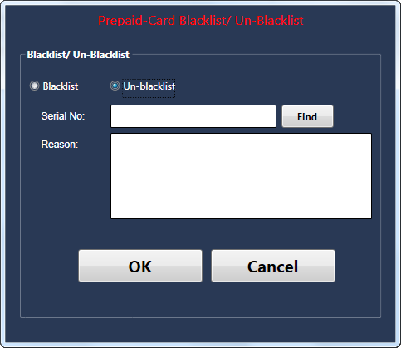

Figure 127 – Un-Blacklist Operation

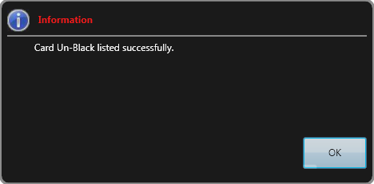

Figure 128 - Un-Blacklist Successful

## Balance Info

A user can see all the information related with a card by clicking on “Balance Info” button**.**



Figure 129

A “Smart card Information” screen will be displayed on the screen, which can be categorized as:

* **Search Criteria**

Search smartcard on the criteria of ‘First Name’ or ‘Last Name’ or ‘Mobile #’ or ‘Veh. Reg #’ or ‘Serial #’Here we search Smart card on the criteria of “Veh. Reg.#”.

* **Search Result**

Detail of specific smart card appears on the screen by entering a related search for a specific user.

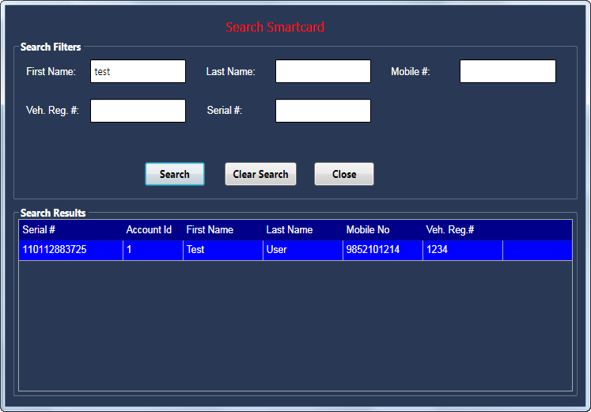

Figure 130 - Search Smart Card Screen

#### Smart card Balance Information” window will be displayed by clicking on selected record.

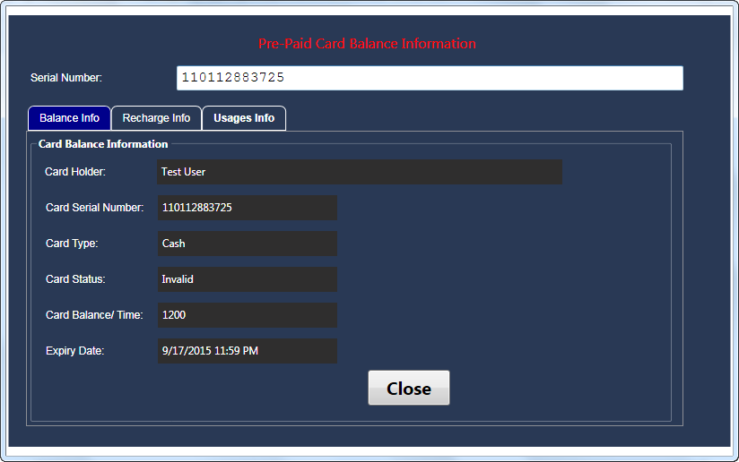

Figure 131 - Balance Info. Screen

## Card Replacement

A customer can request for card replacement in case of lost/damage. Customer can request for card replacement from the plaza. The steps for card replacement are described below:

#### Click on the Card Replacement button

Figure 132

#### Smart Card Replace window pops out

#### Find the details of the lost/damage card using search screen. On selection of a particular account, the details are automatically generated on the smart card replace screen

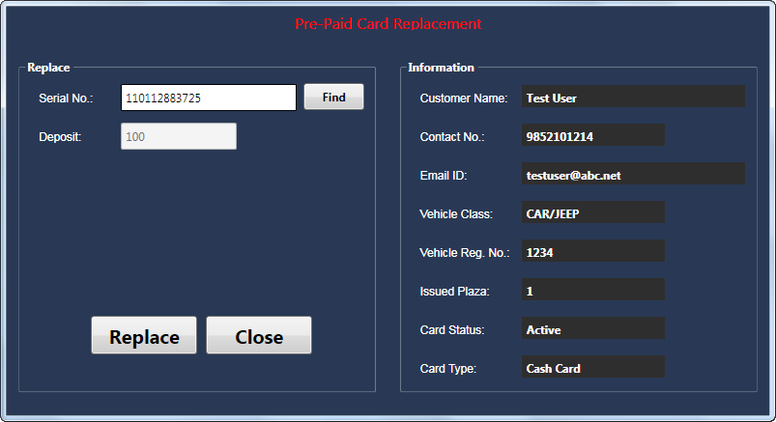

Figure 133 - Card Replacement Screen

#### Click on Replace button and a new dialogue box pops out informing to swipe a new card on card reader

* Clicking on OK button, completes the process of card replacement and the information present on the card used earlier are transferred to new card
* Click on OK button to clear the screen and verify the details inserted in a new card

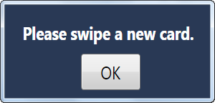

Figure 134 - Card Replacement Successful

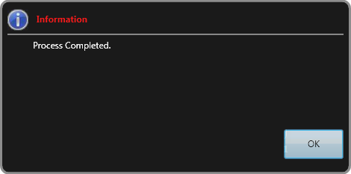

Figure 135 - Replacement process completed

## Veh. Reg. Edit

A customer can request to change the vehicle registration number on the card, so that he can use old smart card for a new vehicle. The steps given as follows:

#### Click on “Veh. Reg. Edit” button



Figure 136

#### “Veh. Reg. Edit” window will be displayed

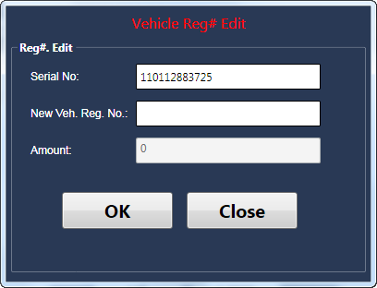

Figure 137 - Veh. Reg. Edit Screen

#### Flash the card using the card reader. The card information will be displayed on the “Veh. Reg. Edit” screen

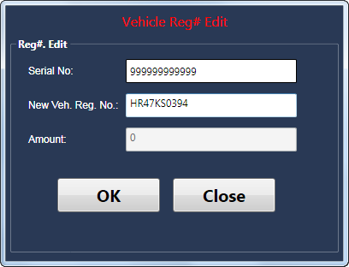

Figure 138

#### Enter the new vehicle registration number and click on “Ok”. “Vehicle Reg. No. changed successfully” pop up will be displayed

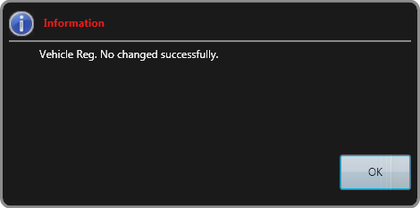

Figure 139 - Veh. Reg. Successfully Changed

## Duplicate Receipt

A new duplicate receipt can be generated for particular transaction. The steps are given as:



Figure 140

#### Click on the “Duplicate receipt” button. Following screen will be displayed.

#### A specific record can be search on the basis of “First Name” or “Last Name” or “Mobile #” or “Veh. Reg. #” or “Serial No”.

#### In the following screen, we search based on “Last Name”.

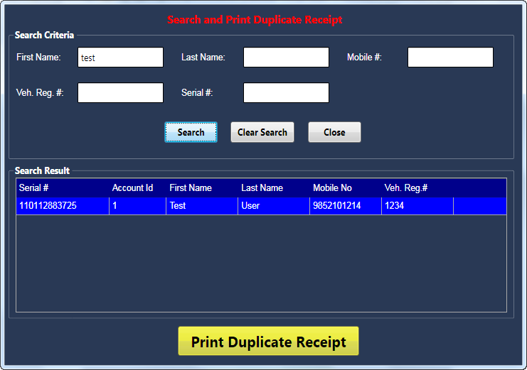

Figure 141 - Duplicate Receipt Screen

* Click on “Print Duplicate Receipt”. The receipt will be printed

## Depot Details

Depot is the group account in which multiple vehicles of one customer are registered for specific month. The customer needs to pay the entire amount in advance for registered vehicles. The depot account of the customer contains information such as depot name, vehicle class, vehicle registration number, payment method and so on.

Note: Expiry date of account will be set automatically set as the last day of selected month.

**POS-Lane Operations**

**Depot**

* A commuter with depot account approaches to the toll lane
* The lane operator selects the vehicle class
* The lane operator selects payment method as Depot
* If the depot account is valid, a transaction is successful and if invalid, error message will be displayed on TCA screen as **Invalid depot registered vehcile number**
* On successful transaction, TLS turns green and barrier gate is in up-state
* Error message will be displayed in following scenarios:
  + If depot account is expired and its grace time is also over
  + If vehicle class do not match with the class mentioned in Depot account
  + If vehicle registration number do not match

To add and see the depot details, click on **Depot Details** button, as below.

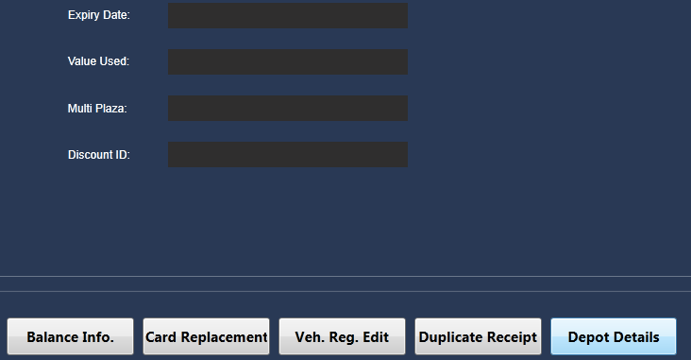

Figure 142 – Depot Details

The **Depot Information** window appears as below.

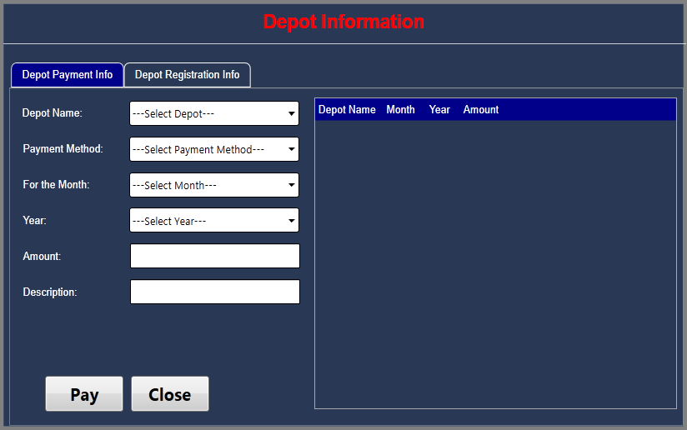

Figure 143 – Depot Information Main

This window is categorized into two sections that are:

* **Left side section**: In this section, you can see **Depot Payment Info** and **Depot Registration Info** tabs. Use these tabs to add and see the depot details. (Please see **add depot details** and **see depot details** sections for detailed instructions.)
* **Right Side section**: This section shows the search results depending on the details you specify in left side section.

**Add Depot Details**

You need to add depot account before adding one’s payment and registration details. (Please see **add new depot** section in **MCM module** for detailed instructions.)

**Add Depot Account Customer Payment Information**

When customer makes the payment, the POS user needs to add the following details:

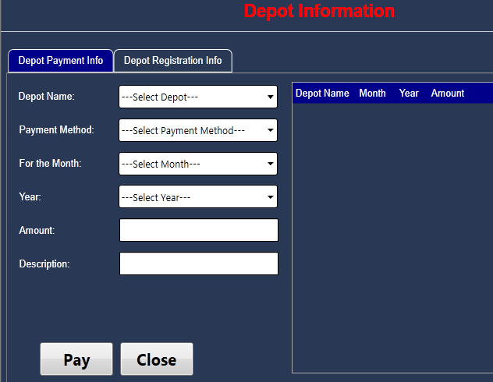

Figure 144 – Add Depot Info Main

* In **Depot Name** drop-down list, select the depot name
* In **Payment Method** drop-down list, select the payment method that customer has used.
* In **For the Month** drop-down list, select the month and the depot account is activated for selected month. This means registered vehicles will be active only for selected month.
* In **Year** drop-down list, select a year for which customer has registered the vehicles.
* In **Amount**, specify the total amount that POS has charged from customer for all registered vehicles
* In **Description**, write a brief description about depot payment info.

Click on **Pay** button. The printed receipt comes out from printer.

**Add Depot Registration Information**

You need to click on **Depot Registration Info** tab. To register a new vehicle, the POS needs to add following registration details:

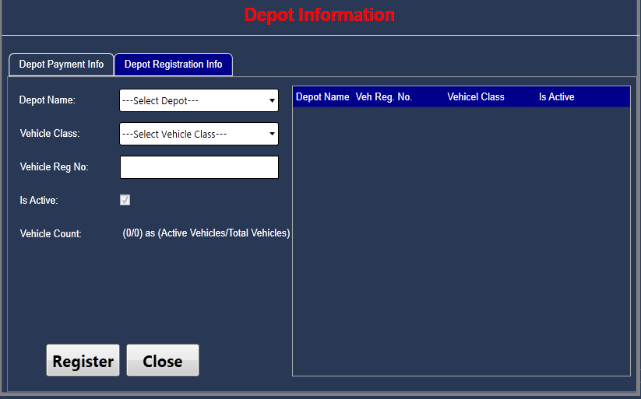

Figure 145 – Add Depot Registration Info

* In **Depot Name** drop-down list, select the depot name
* In **Vehicle Class** drop-down list, select the vehicle class that customer wants to register
* In **Vehicle Reg No**, specify the registration number of vehicle
* **Is Active:** Select this checkbox, if the vehicle is allowed to cross the lane
* In **Vehicle Count,** you can see the total number of vehicles active out of total number of vehicles registered.

Click on **Register** button and the new vehicle is registered.

With the same above process, you can register one or more vehicles.

**See Depot Details**

**See Depot Payment Details**

By default, the **Depot Payment Info** tab is selected. In **Depot Name** drop-down list, select the name of depot account whose details you want to see.

In the right side section, the payment details of the depot are displayed in following columns:

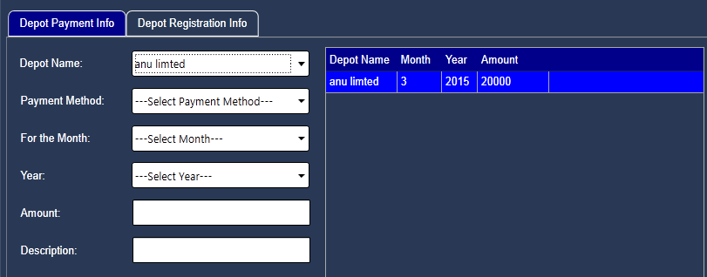

Figure 146 – See Depot Payment Info

* **Depot Name**: The name of depot account
* **Month**: The month for which vehicles are registered
* **Year**: The year of the specified month
* **Amount**: The total amount paid by depot account customer

**See Depot Registration Details**

To see the depot registration details, click on **Depot Registration Info** tab as below.

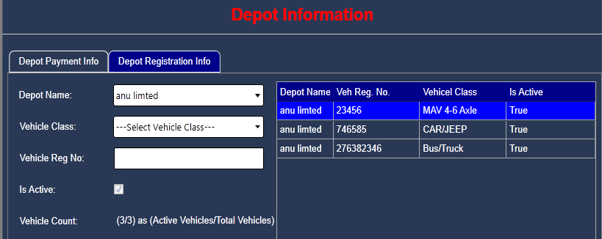

Figure 147 – See Depot Registration Info

In **Depot Name** drop-down list, select the depot whose registration details you want to see. For each registered vehicle under selected depot, you can see following details.

* **Depot Name**: The depot account name under which vehicle is registered
* **Veh Reg No**.: The registration number of vehicle
* **Vehicle Class**: The class of vehicle that can be car/jeep, truck and so on
* **Is Active**: You can see either True or False. The True value shows that the corresponding vehicle can cross the lane. The False value shows that the corresponding vehicle cannot cross the lane.

# Reporting

Report Module is a GUI based application. The main purpose of this module is to present data in a desired manner, which can access from database using some user given credentials. A report is a combination of three kinds of information:

* **Data:** This parameter defines the data, which is to be fetched from database to be presented.
* **Layout:** This parameter defines the formatting/ orientation of data how it will be presented.
* **Parameters:** It defines some data selection criteria, which is generally provided by the user through the input controls of the GUI of the Report Module.

The functions performed by ‘RM’ are as follows:

* Reports can be categorized by applying different filters based on report category start/ end date, lane, vehicle class etc.
* It provides necessary parameter to generate reports in PDF format.
* Reports can be saved or print for later use.

When valid user is logged on, the GUI is displayed as follows.

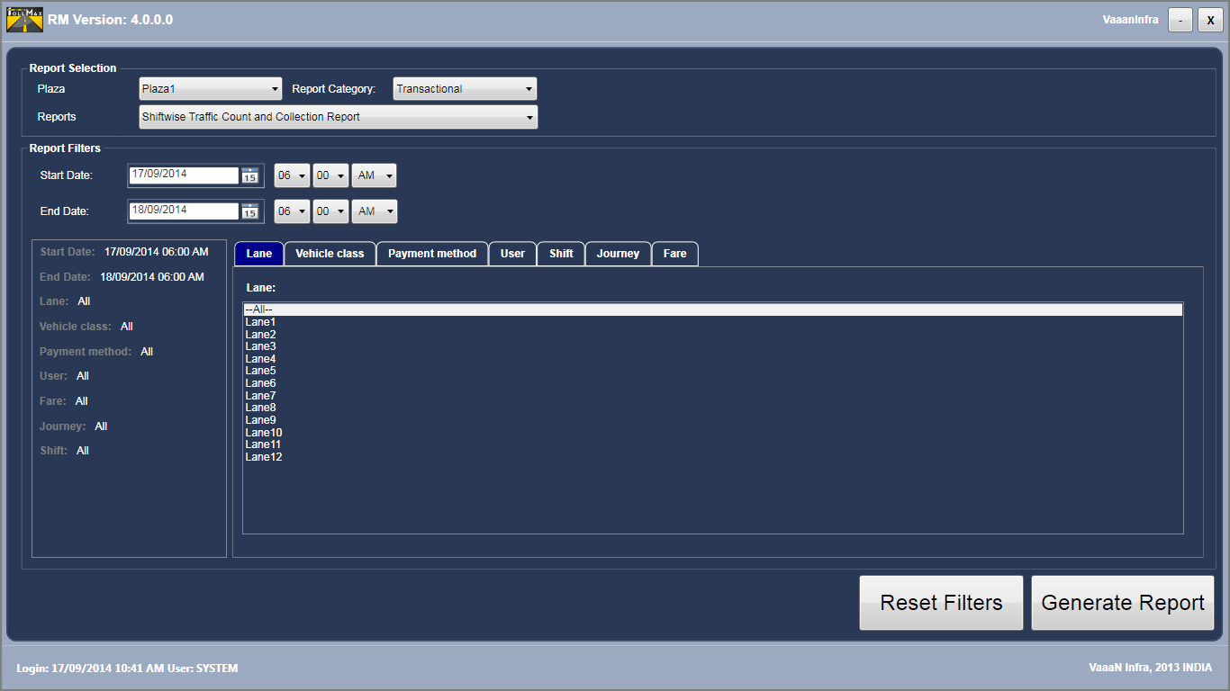

Figure 148 - Reporting Module Screen

The screen layout explanations are as follows:

* Product name and application name
* Current logged in user login id and login in time
* Reporting screen divided in different items
* Reset and Generate Report Button
* Company name (Configurable)

## Report Selection

Report selection defines the hierarchy structure of the reports.

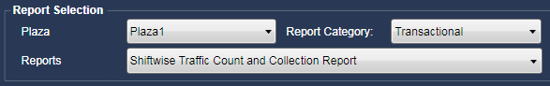

Figure 149 - Report Selection

It is categorized as:

* In **Report Category** drop-down list, the list of all report categories available in the system is displayed. Each category has different types of reports.
* In **Report** drop-down list, the list of reports appears depending on the report category selected in **Report Category** drop-down list.



## Report Category

The different categories are given as below:

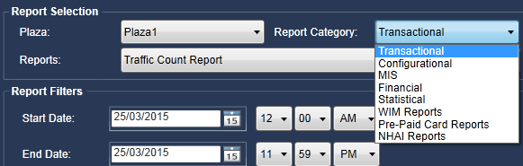

Figure 150 - Report Category



## 7.2.1. Transactional Reports

It displays all the transactional reports available in the system. Following are the steps to generate this report:

* In **Report Category** drop-down list, select **Transactional** option.
* In **Reports** drop-down list, the list of all transactional reports is populated.

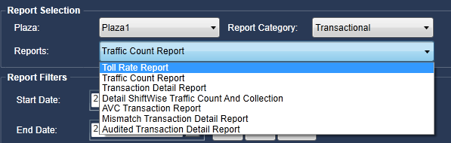

Figure 151 – Transactional Reports

**Common Filters**

**Start Date** and **End Date** filters are always available for following types of transactional reports.

* Toll Count Report
* Transaction Detail Report
* Detail Shiftwise Traffic Count and Collection
* AVC Transaction Report
* Mismatch Transaction Detail Report
* Audited Transaction Detail Report
* Exemption Report

Select the date range for which you want to generate the report.

* **Start Date**: Click on calendar icon available corresponding to the **Start Date** and select the required date. You can also select the specific time of selected date.
* **End Date**: Click on calendar icon available corresponding to the **End Date** and select the required date. You can also select the specific time of selected date.

### Toll Rate Report

Select this option to generate the rate details report of the toll for each vehicle class. For every journey name, you can see the toll rate of specific fare type (single, return and district registered). This report shows the amount charged by commuter for specific vehicle, the date and time from which this amount is started charging, and the date and time when this amount was fixed to charge. You can generate this report based on **Vehicle Class** filter.

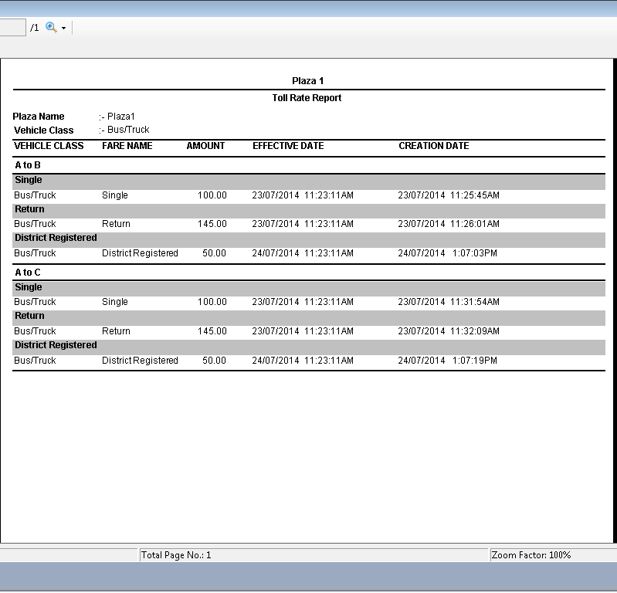

Figure 152 – Toll Rate Report

### Traffic Count Report

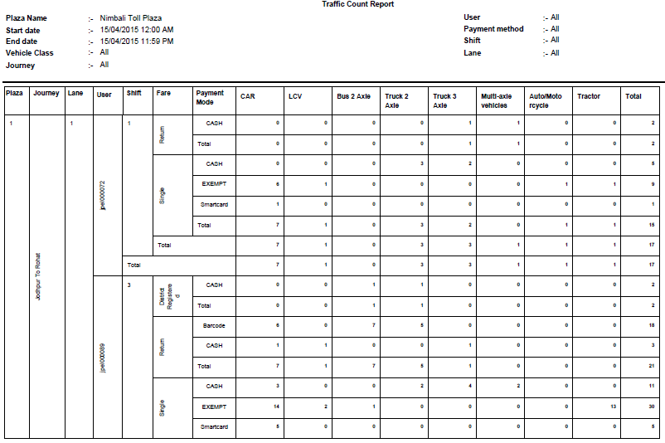

Figure 153 - Traffic Count Report

### Transaction Detail Report

Select this option to generate the details report of the transaction. For each transaction, you can see its corresponding details such as date and time when transaction was created, the plaza number in which transaction was created, the vehicle class for which transaction was created, the payment method that was used for transaction, and the fare name for which transaction was created. You can generate this report based on following filters:

* Lane
* Vehicle class
* Payment method
* User
* Shift
* Vehicle registration number
* Fare

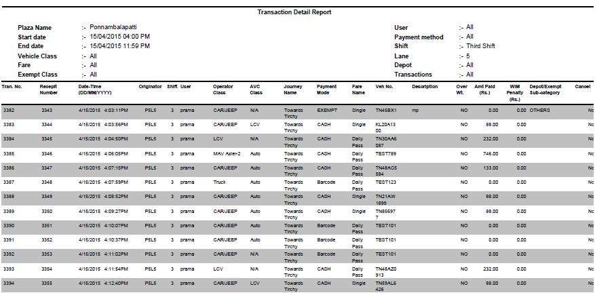

Figure 154 - Transaction Detail Report

### AVC Transaction Report:

Select this option, to generate the transaction details report of the AVC. For each AVC transaction, you can see its corresponding details such as date and time when transaction was created, the vehicle class for which transaction was created, the payment method that was used for transaction, the vehicle class for which transaction was created. You can generate this report based on following filters:

* Lane
* Vehicle class
* Payment method
* User
* Shift
* Fare

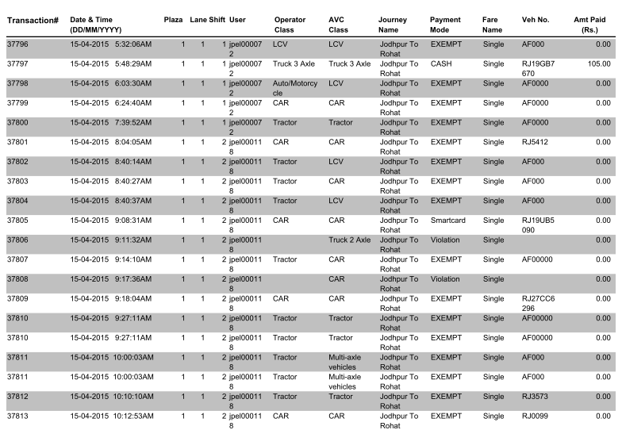

Figure 155 - AVC Transaction Report

### Mismatch Transaction Detail Report

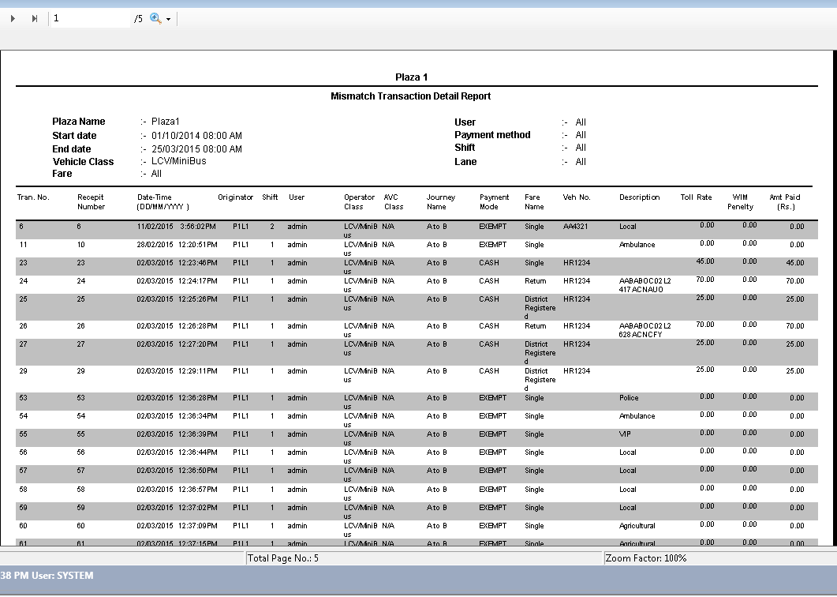

Figure 156 - Mismatch Transaction Detail Report

### Audited Transaction Detail Report

Select this option to generate the details report of audited transactions. For each audited transaction, you can see the details such as date and time when transaction was created, the payment method of transaction before audit, the payment method after audit, the vehicle class before audit, and the vehicle class after audit. You can generate this report based on following filters:

* Lane
* Vehicle class
* Payment method
* User
* Shift

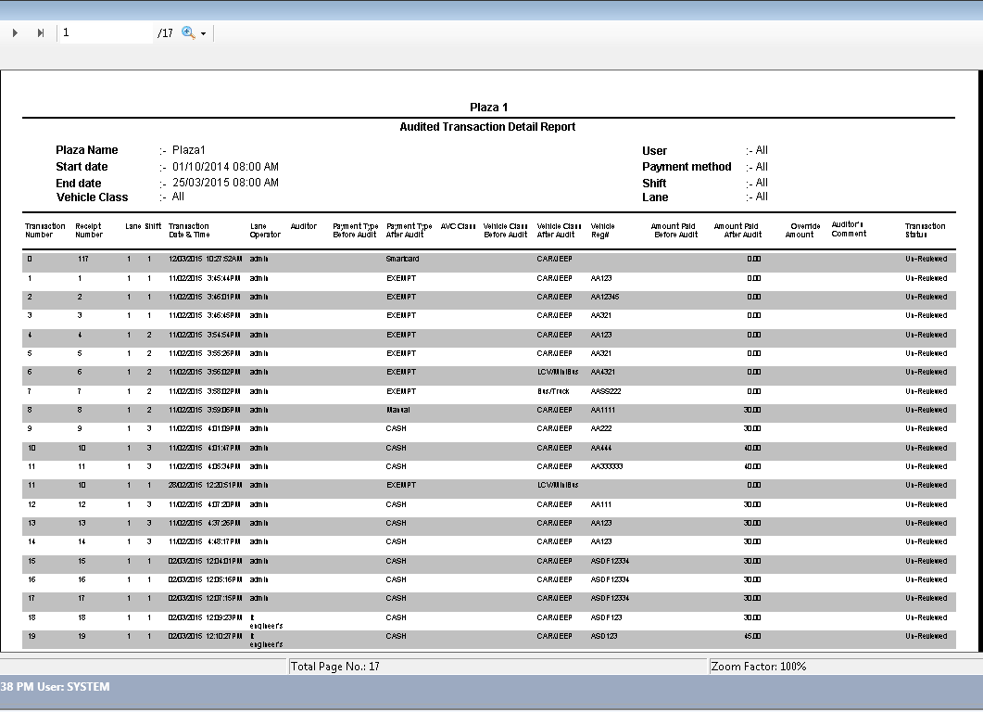

Figure 157 - Audited Transaction Detail Report

## Configurational Reports

It displays all the Configurational reports available in the system. Following are the steps to generate this report.

* In **Report Category** drop-down list, select **Configurational** option.
* In **Reports** drop-down list, the report type is populated.

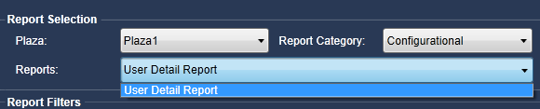

Figure 158 – Configurational Report

### User Detail Report

Select this option to generate the user details report based on different roles. For example, you can see the user details whose role is admin.

If there are multiple users who have admin role, you can see the list of all users. For each user, you can see its corresponding details such as unique user ID, login name, first and last name, and the date when account will be expired.

Select the role and click on **Generate** button as below.

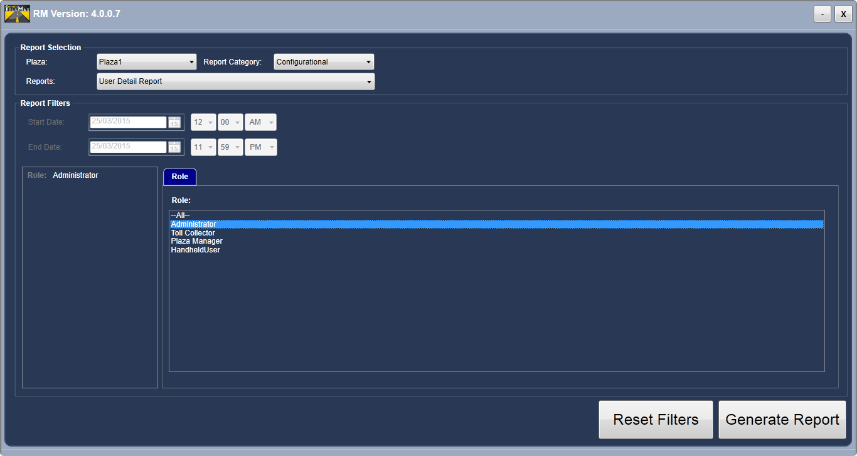

Figure 159 – User Details Report Filters

The report is opened in PDF format as below.

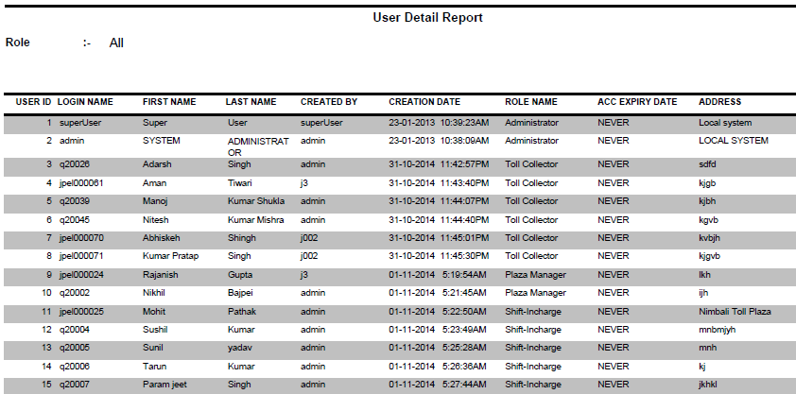

Figure 160 – User Details Report

## MIS Reports

It displays all the “MIS Reports” available in the system. Following are the steps to generate the MIS report.

* In **Report Category** drop-down list, select **MIS** option.
* In **Reports** drop-down list, the list of all available MIS reports is populated.

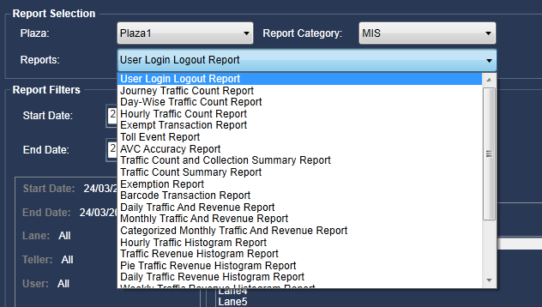

Figure 161 - MIS Reports

**Common Filters**

**Start Date** and **End Date** filters are always available when you select the following types of MIS report.

* User Login Logout Report
* Journey Traffic Count Report
* Day wise Traffic Count Report
* Hourly Traffic Count Report
* Exempt Transaction Report
* Toll Event Report
* AVC Accuracy Report
* Traffic Count and Collection Summary Report
* Traffic Count Summary Report
* Exemption Report
* Barcode Transaction Report
* Daily Traffic and Revenue Report
* Hourly Traffic Histogram Report
* Traffic Revenue Histogram Report
* Pie Traffic Revenue Histogram Report
* Weekly Traffic Revenue Histogram Report
* Shift Clearance Report
* AVC Accuracy Class Wise Comparison
* User Login Report
* Manual Ticket Count Report
* Lane Wise Revenue Report

Select the date range for which you want to generate the report.

* **Start Date**: Click on calendar icon available corresponding to the **Start Date** and select the required date. You can also select the specific time of selected date.
* **End Date**: Click on calendar icon available corresponding to the **End Date** and select the required date. You can also select the specific time of selected date.

Figure -

**Types of Reports**

### User Login-Logout Report

Select this option to generate the login-logout details report of the operator or user. For each user, you can see its corresponding details such as operator or user ID, date and time when user logged-in and logged-out, and the name of module. You can generate this report based on following filters.

* Lane
* Teller
* User

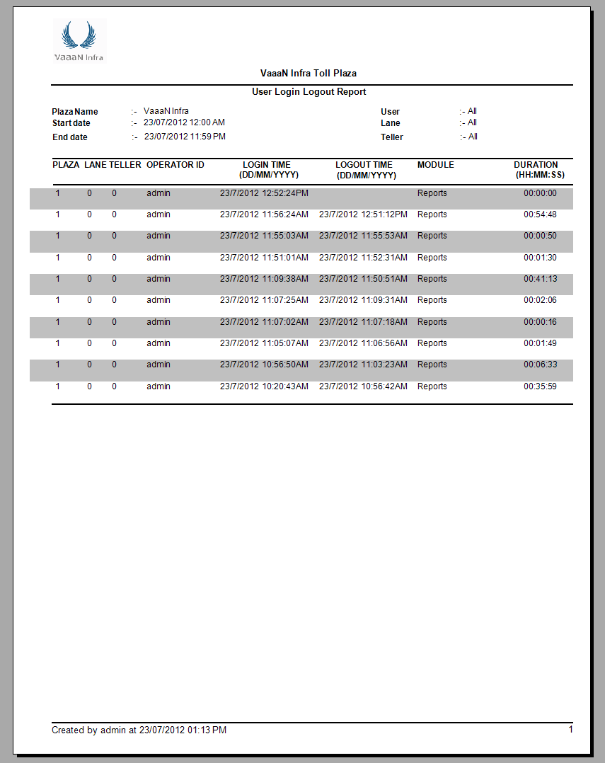

Figure – User Login Logout Report

### Journey Traffic Count

Select this option to generate the traffic count report of the journey. This report is generated based on each payment method. For each payment method, you can see the details such as total number of **Trucks** (vehicle type) used the **Single** fare type, and total number of **Cars** (vehicle type) used the **Return** fare type. You can generate this report based on following filters.

* Lane
* Vehicle class
* Payment method
* User
* Shift
* Fare

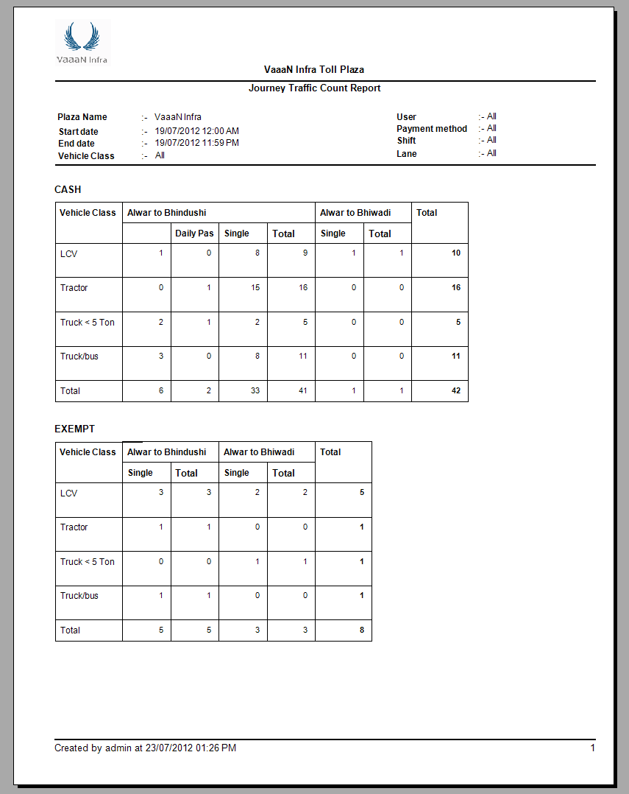

Figure 163 – Journey Traffic Count Report

### Day-Wise Traffic Count Report

Select this option to generate the traffic count report for specific date or for multiple dates. This report shows the number of trucks (vehicle class) crossed on specific date in particular shift. You can generate this report based on following filters.

* Lane
* Payment Method: You can see the total number of cars crossed on particular date by paying cash.
* User

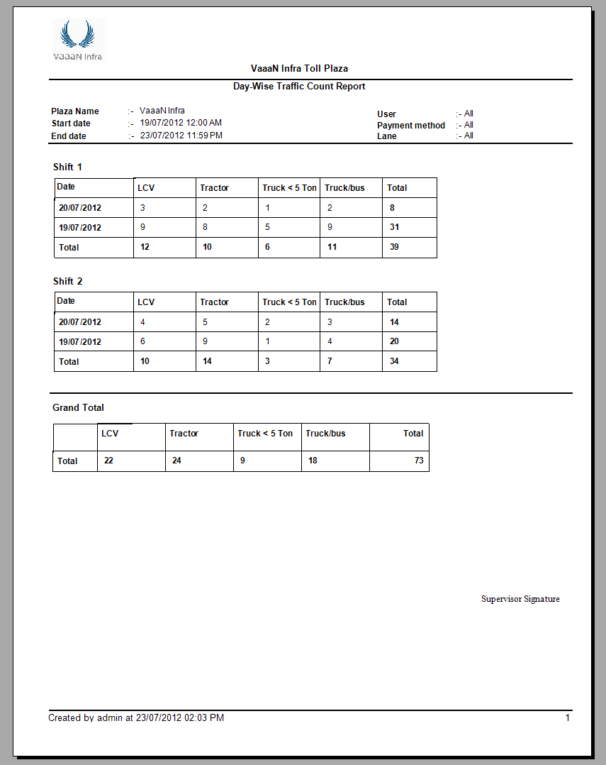

Figure 164 - Day-Wise Traffic Count Report

### Hourly Traffic Count Report

Select this option to generate the traffic count report on hourly basis. This report shows the total number of cars crossed in every hour of the day. You can generate this report based on following filters.

* Lane
* Vehicle class
* Payment method
* User
* Shift

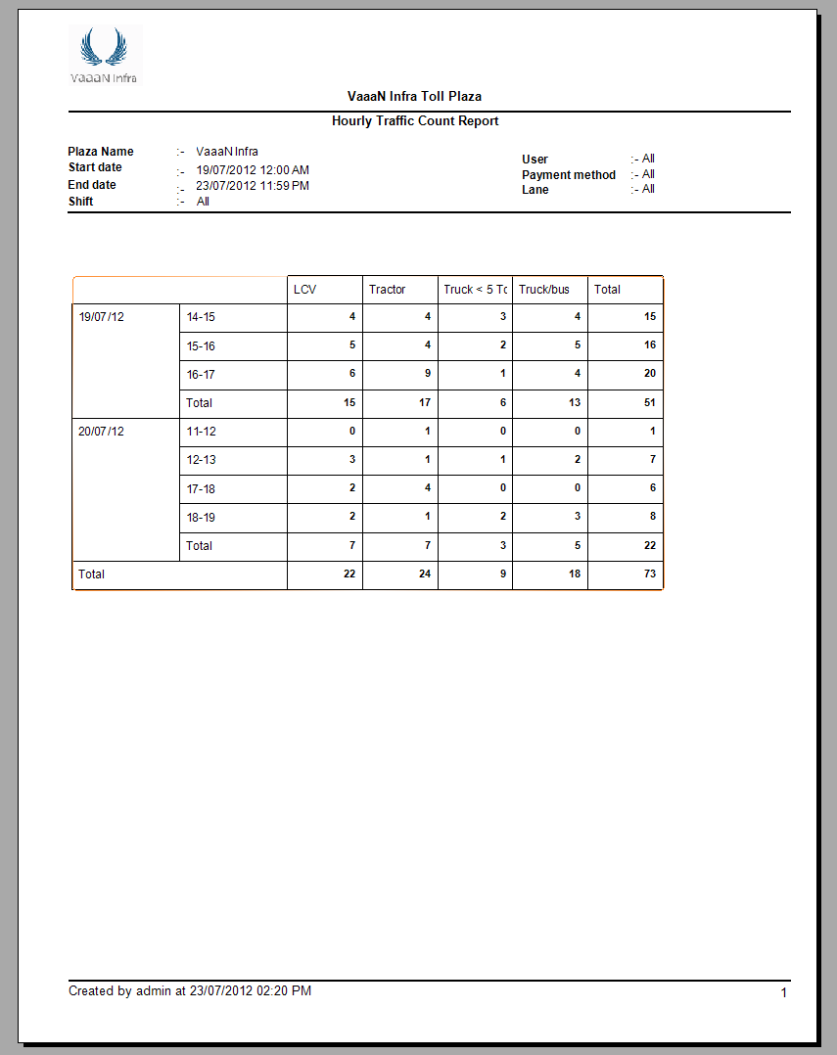

Figure 165 - Hourly Traffic Count Report

### Exempt Transaction Report

Select this option to generate the transaction details report of the exempt payment method. For each exempt type of transaction, you can see the details, such as which exempt class was used for transaction, for which vehicle class the exempt transaction was created, the vehicle registration number for which exempt transaction was created, and the date and time when exempt transaction was created. You can generate this report based on following filters.

* Lane
* Vehicle Class
* User
* Shift

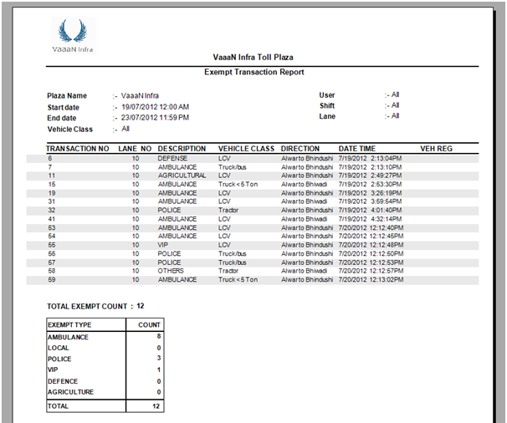

Figure 166 - Exempt Transaction Report

### Toll Event Report

Select this option to generate the event log details report of the toll. For each event, you can see its corresponding details such as date and time when event was occurred, the description of an event, the lane number where event was occurred, and the serial number of an event.

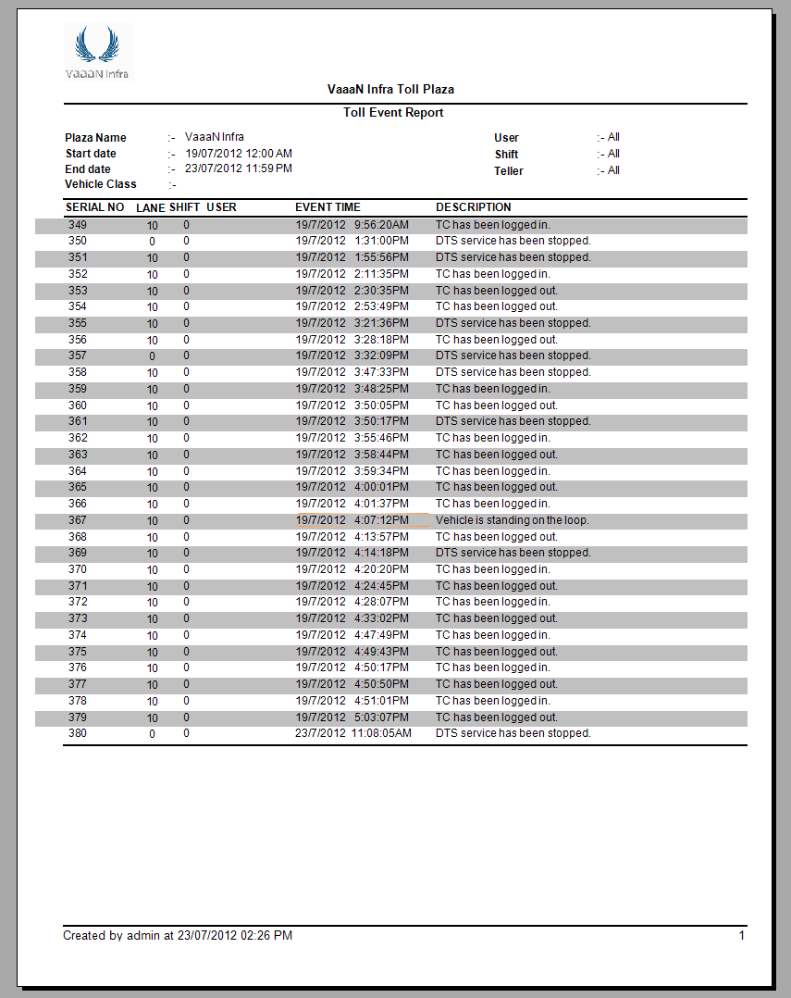

Figure 167 – Toll Event Report

### AVC Accuracy Report

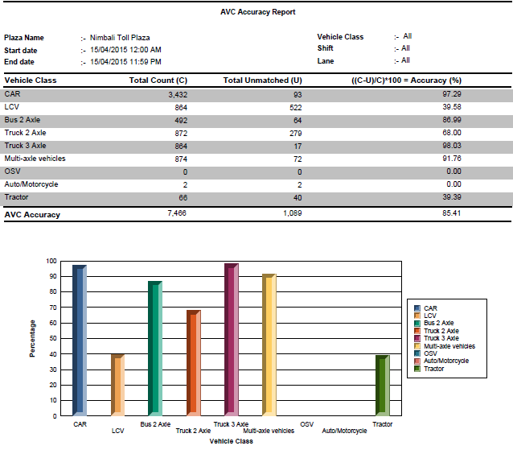

Figure 168 – AVC Accuracy Report

### Traffic Count and Collection Summary Report

### Traffic Count Summary Report

### Exemption Report

This report shows the number of times, each vehicle class used the exemption class such as agriculture, ambulance, auto, defense and local on specific date or selected dates.

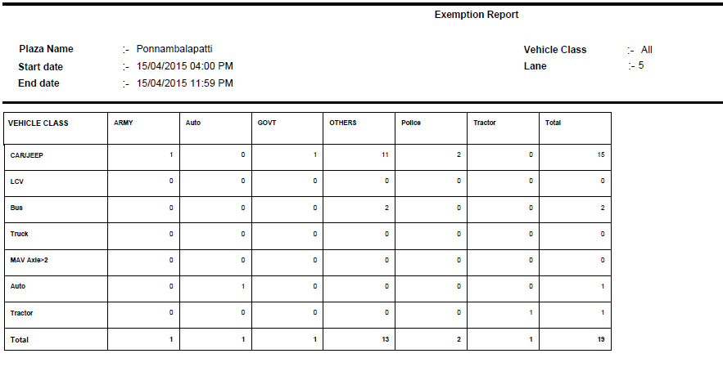Figure 169 – Exemption Report

### Pass Multi Read Detail Report

Select this option to generate the transaction details of barcode payment method. For each barcode transaction, you can its corresponding details such as pass serial number, receipt number, date and time when transaction was created, the lane and shift number for which transaction was created, the username who created the transaction, the vehicle class for which transaction created, journey name, payment method used in transaction, and the amount paid by commuter for transaction. You can generate this report based on following filters.

* Lane
* Vehicle class
* User
* Shift

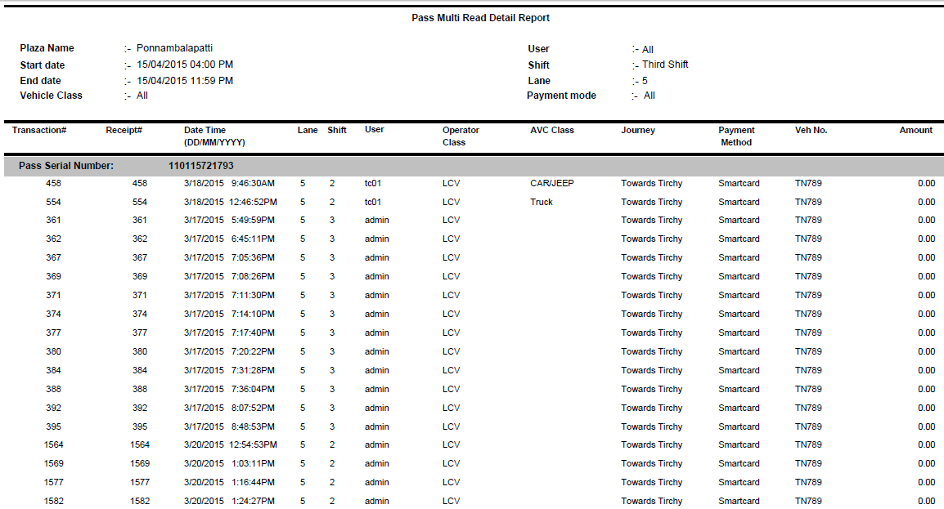

Figure 170 – Pass Multi Read Detail Report

### Daily Traffic and Revenue Report

Select this option to generate the revenue details report of traffic on daily basis. For each fare type, you can see its corresponding details such as how much revenue are generated by each vehicle class in different shifts. You can generate this report based on following filters.

* Lane
* User

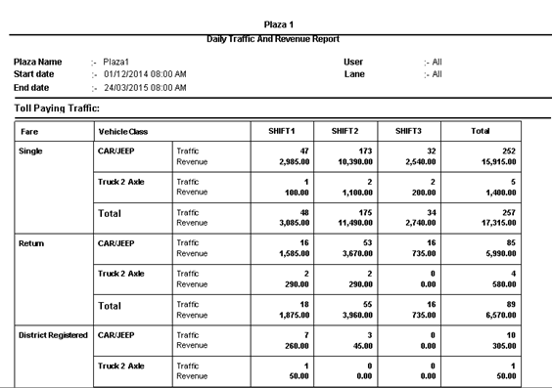

Figure 171 – Daily Traffic and Revenue Report

### Monthly Traffic and Revenue Report

Select this option to generate the revenue details report of traffic on monthly basis. You can see the total revenue generated in selected month. You can generate this report based on following filter.

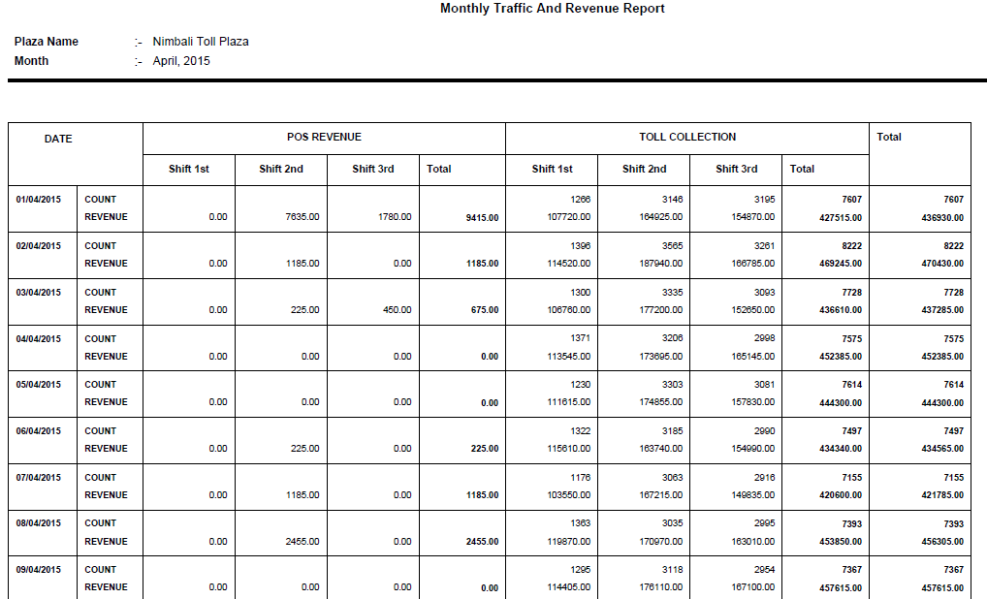

Figure 172 – Monthly Traffic and Revenue Report

* + - 1. **Hourly Traffic Histogram Report**

Select this option, if you want to graphically summarize the distribution of a data.

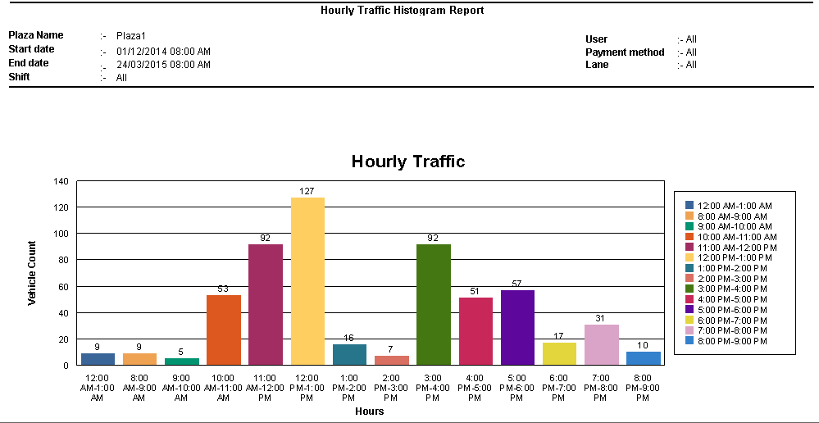

Figure 173 – Hourly Traffic Histogram Report

The horizontal axis of the bar graph represents the hour range. The vertical axis represents the total count of vehicle. This bar graph shows the total count of vehicles crossed in each hour range. You can generate this report based on following filters.

* Lane
* Vehicle Class
* Payment method
* User
* Shift

### Traffic Revenue Histogram Report

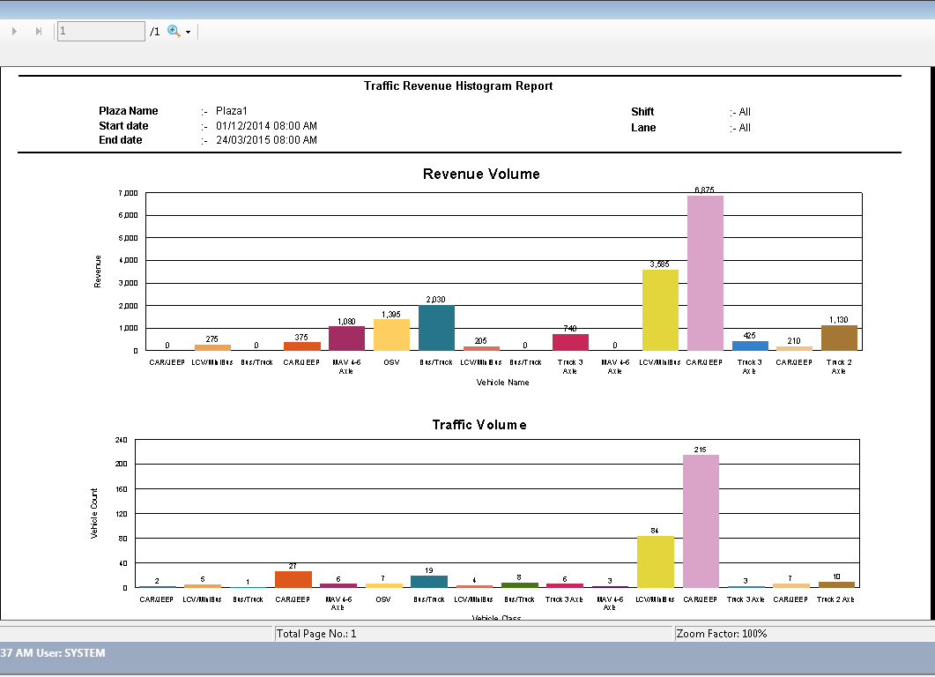Figure 174 – Traffic Revenue Histogram Report

### Pie Traffic Revenue Histogram Report

Select this option to generate the revenue details of traffic in pie chart. You can generate this report based on following filters.

* Lane
* Shift

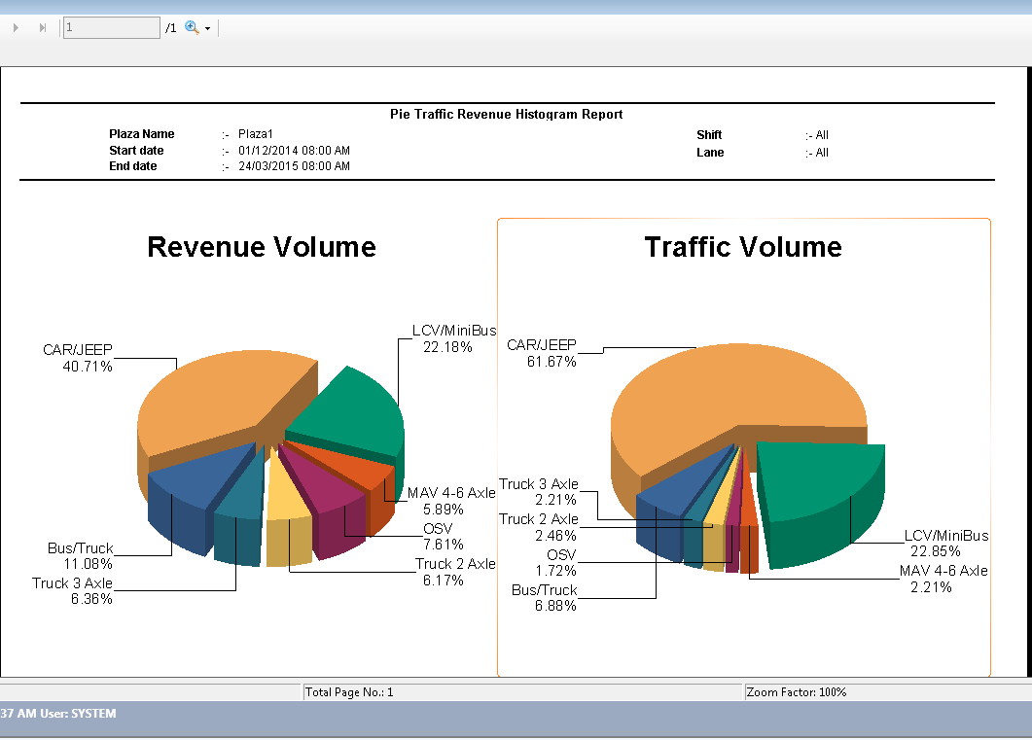

Figure 175 – Pie Traffic Revenue Histogram Report

### Daily Traffic Revenue Histogram Report

### Weekly Traffic Revenue Histogram Report

### Shift Clearance Report

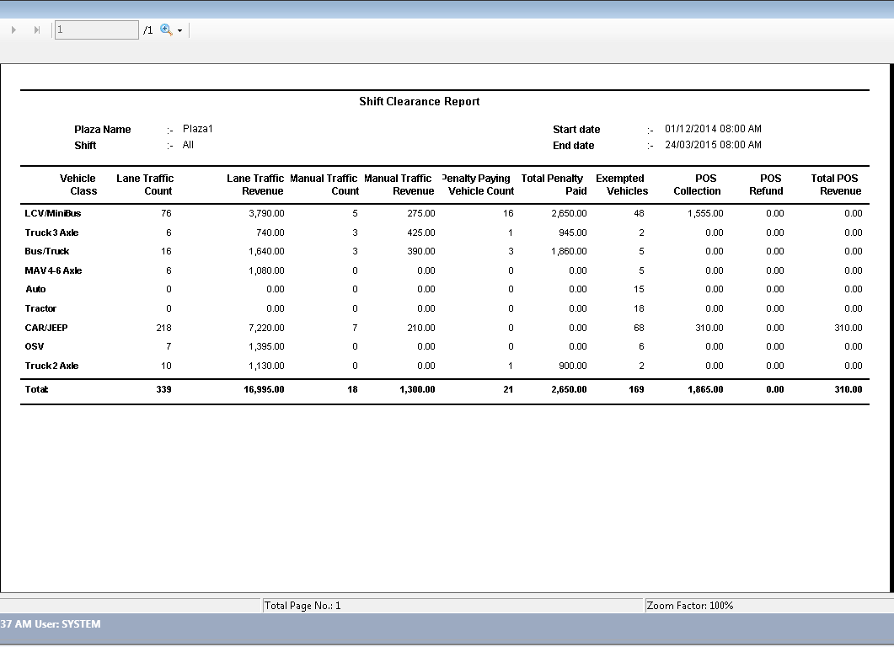

Figure 176 – Shift Clearance Report

### AVC Accuracy Class wise Comparison

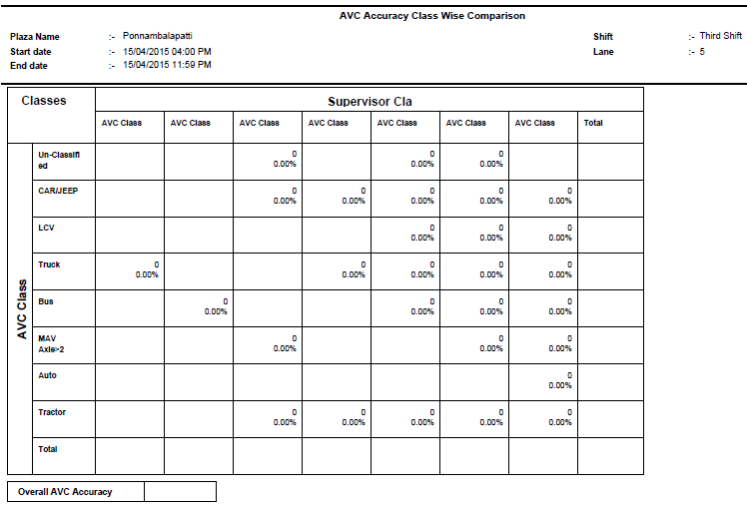

* + - 1. **AVC Accuracy Class-wise Lane-wise Report**

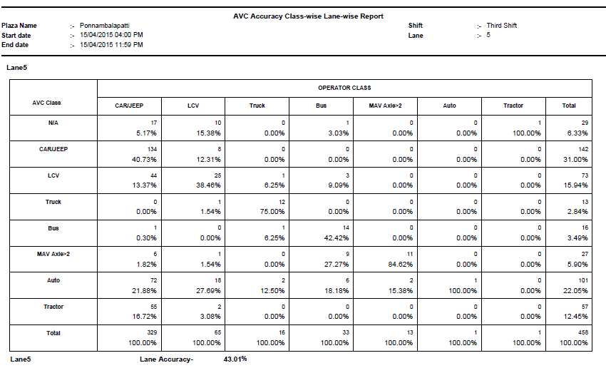

* + - 1. **AVC Traffic Count Report**

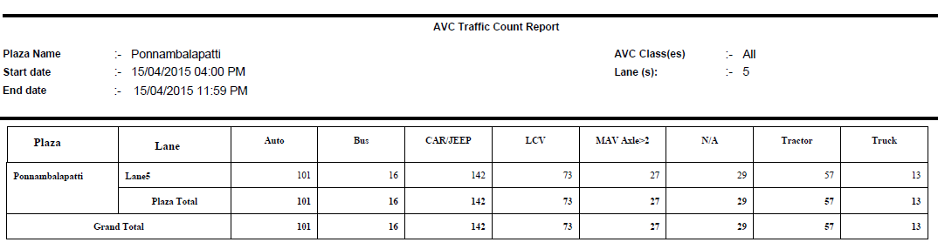

### User Login Report

Select this option to generate the login details report of a user. For each user, you can see its corresponding details such as the lane number in which user logged-in, shift number, the user ID, the username and the login name. You can generate this report based on following filters.

* Lane
* User
* Shift

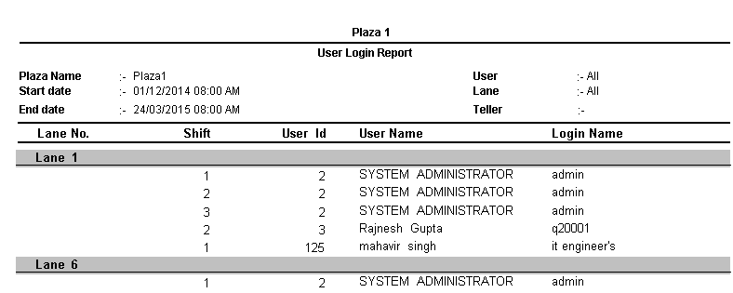

Figure 177 – User Login Report

### Daily Shift Wise MIS Report

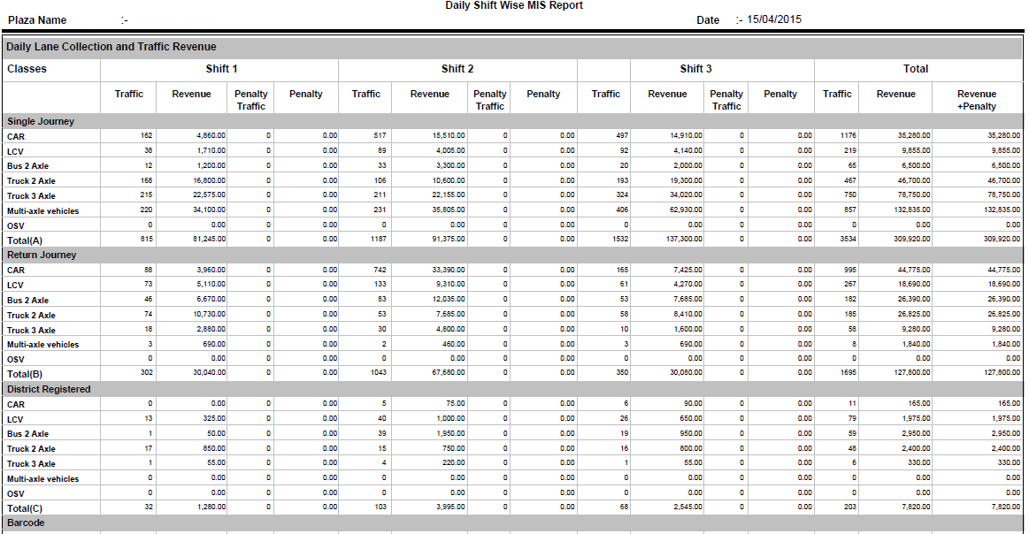

Figure 178 – Daily Shift Wise MIS Report

### Manual Ticket Count Report

### Lane Wise Revenue Report

## Financial Reports

It displays all the “Financial” reports available in the system. Following are the steps to generate financial report.

* In **Report Category** drop-down list, select **Financial** option.
* In **Reports** drop-down list, the list of all available financial reports is populated.

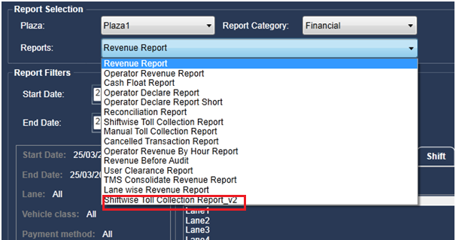

Figure 179 - Financial Report

### Revenue Report

Select this option, if you want to generate the revenue details report. This report shows the total revenue earned by specific type of vehicle in particular shift. For each shift of a day, you can see the total revenue generated by each vehicle type.

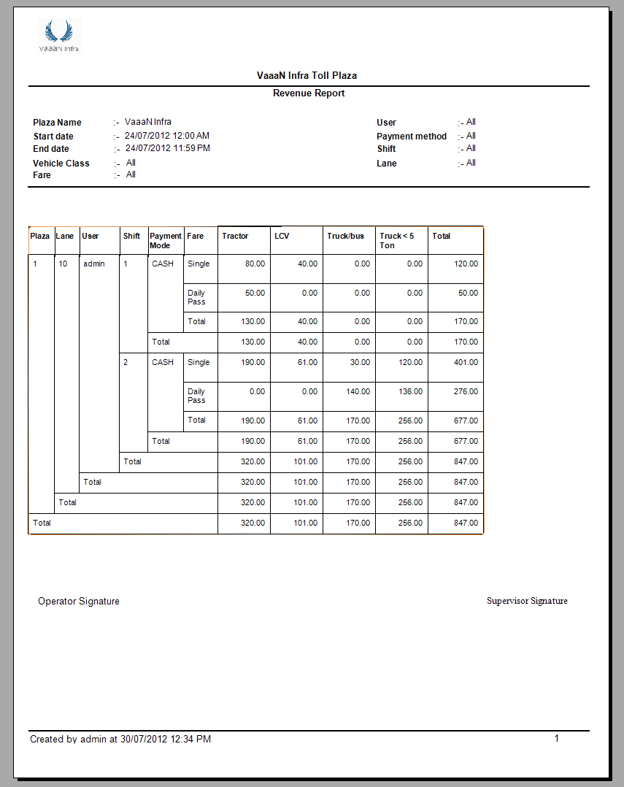

Figure 180 - Revenue Report

### Operator Revenue Report

Select this option, to generate the revenue details report of the operator. This report shows the revenue generated by operator from specific vehicle type.

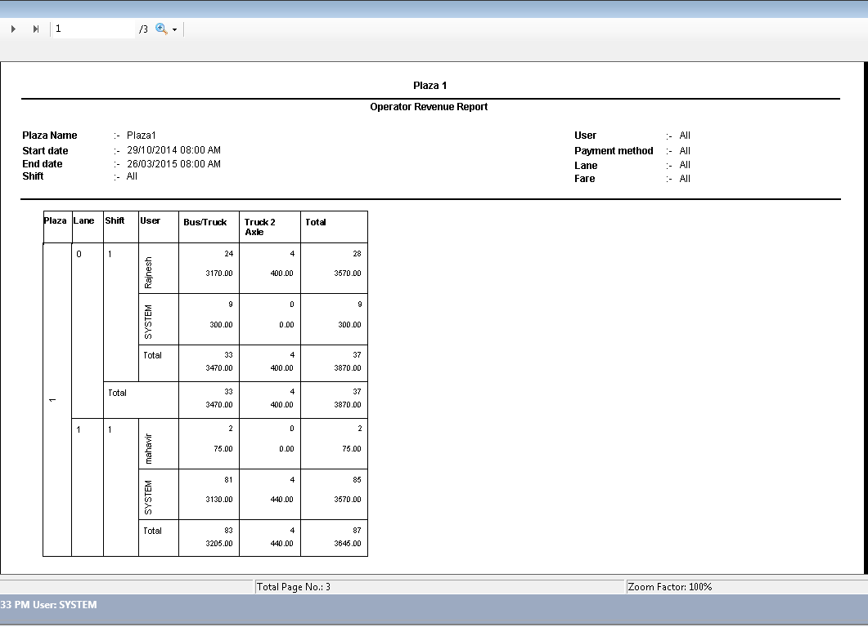Figure 181 - Operator Revenue Report

### Cash Float Report

Select this option, to generate the report for amount given by supervisor to the toll operator in the beginning of the shift. For each lane of the plaza, you can its corresponding details such as the lane number, for which cash was given, the operator name to whom the cash was given, the supervisor name who gave the cash, the total amount, and the date and time when cash was given.

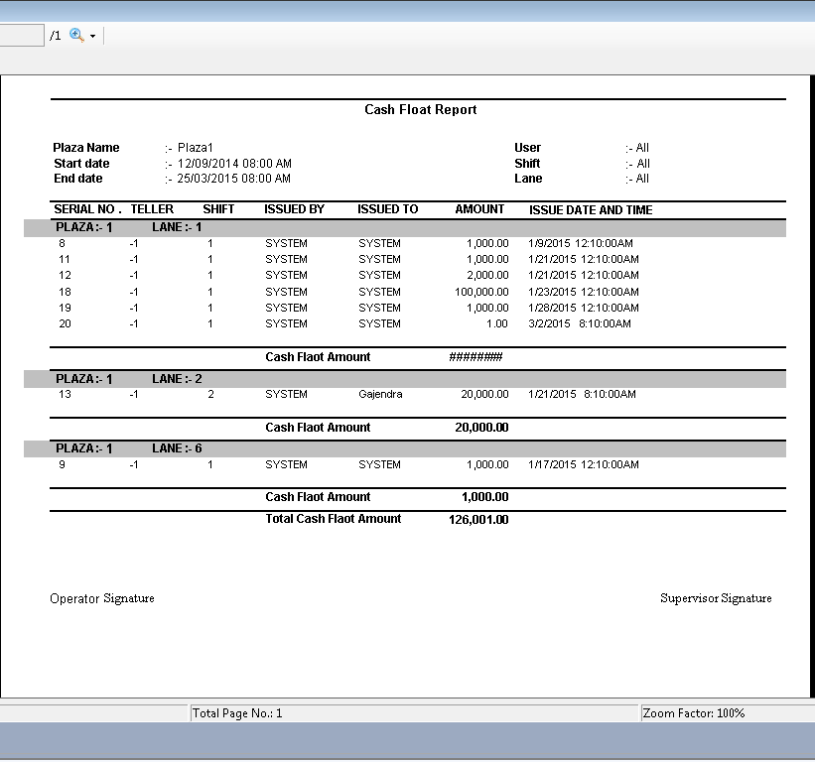

Figure 182 – Cash Float Report

### Reconciliation Report

### Shift wise Toll Collection Report

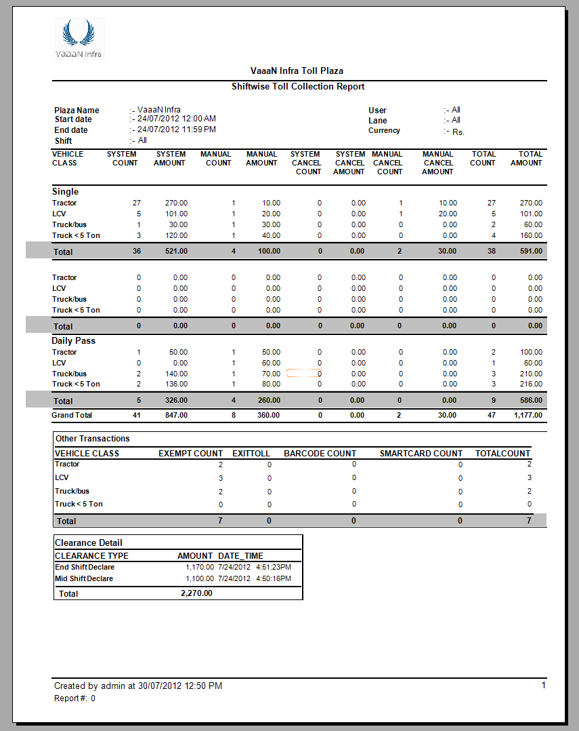

Figure 183 - Shift-wise Toll Collection Report

### Manual Toll Collection Report

Select this option to generate the report for toll amount collected manually. For each vehicle type, you can see its corresponding details such as fare type used, number of vehicles crossed, and the total amount collected.

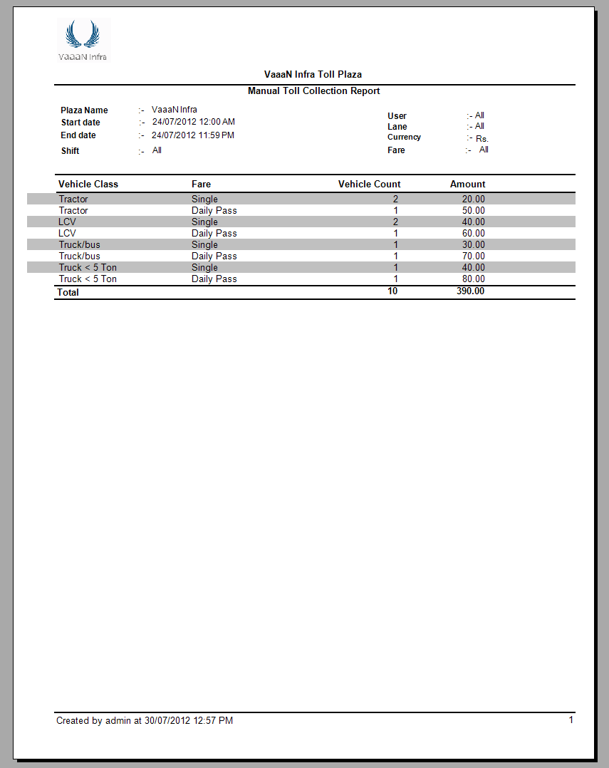

Figure 184 – Manual Toll Collection Report

### Cancelled Transaction Report

Select this option to generate the report for cancelled transactions. This report shows the transaction number that was cancelled, vehicle class for which transaction was cancelled, the date and time when transaction was created.

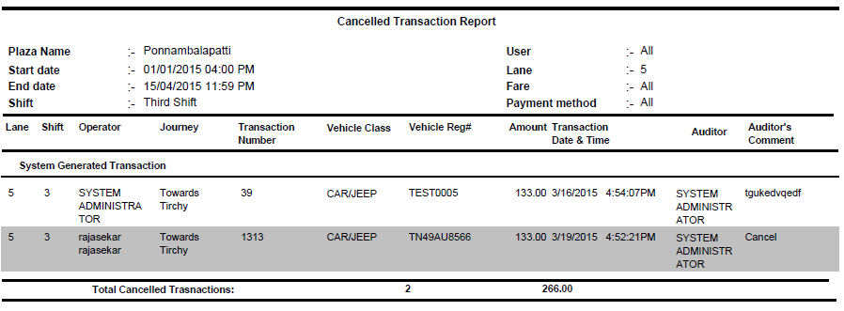

### Operator Revenue by Hour Report

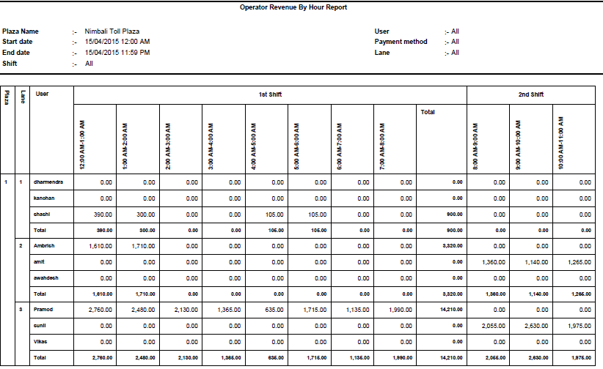

### Revenue before Audit

Select this option to generate the revenue details report before audit. This report shows the amount collected by specific lane operator when different vehicle types crossed the lane.

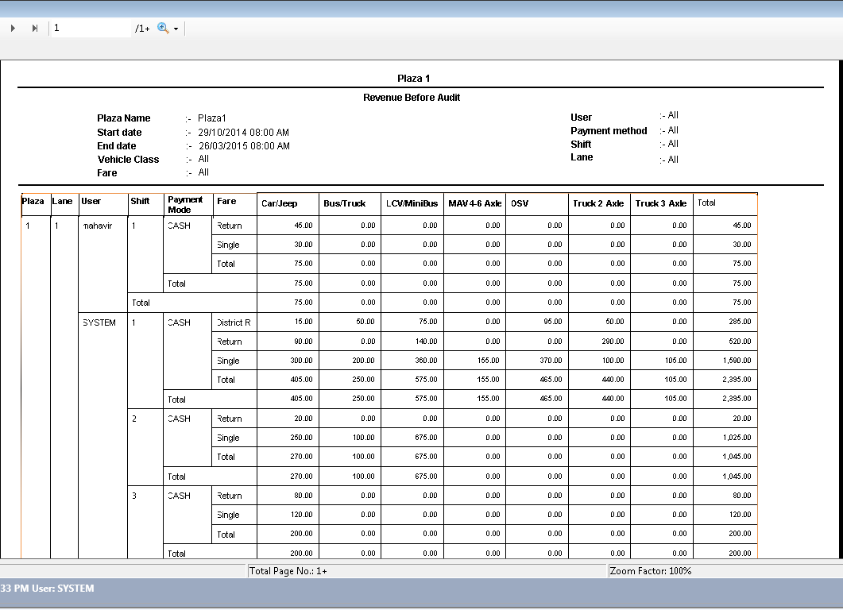Figure 185 – Revenue Before Audit

### User Clearance Report

Select this option to generate the clearance details report of the user. For each user, you can see its corresponding details such as the date and time when user logged in to the system, the amount that was given by supervisor to the operator in the beginning of shift, the amount that was collected by operator during mid of shift, the amount that was declared by operator, and status of declaration whether declared or not.

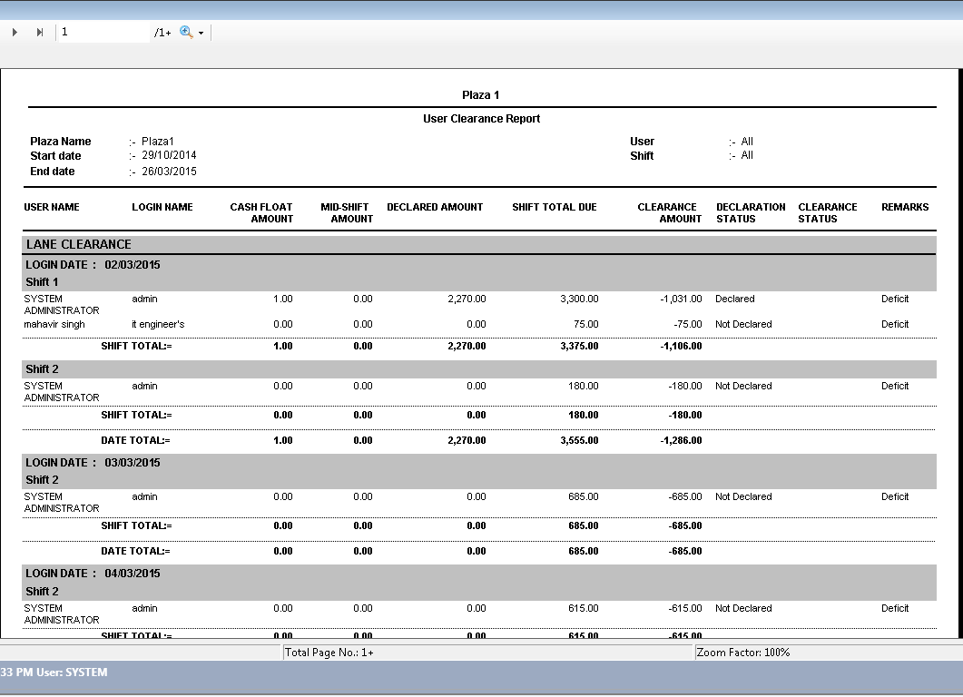Figure 186 – User Clearance Report

### TMS Consolidate Revenue Report

### Lane Wise Revenue Report



## Statistical Reports

It displays all the statistical reports available in the system. Following are the steps to generate the statistical report.

* In **Report Category** drop-down list, select **Statistical** option.
* In **Report** drop-down list, the list of all available statistical reports is populated.

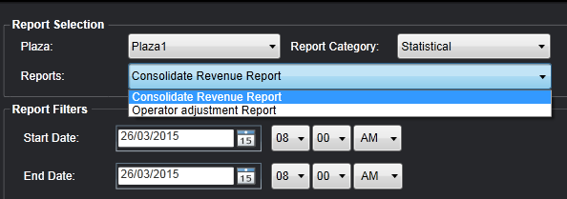

Figure 187 – Statistical Report Options

* + - 1. **Consolidate Revenue Report**

For every journey name and all its payment methods, you can see the details such as total number of specific vehicle type crossed and the total amount paid by that vehicle. For example, the total number of tractors crossed by paying toll in cash for journey A to B.

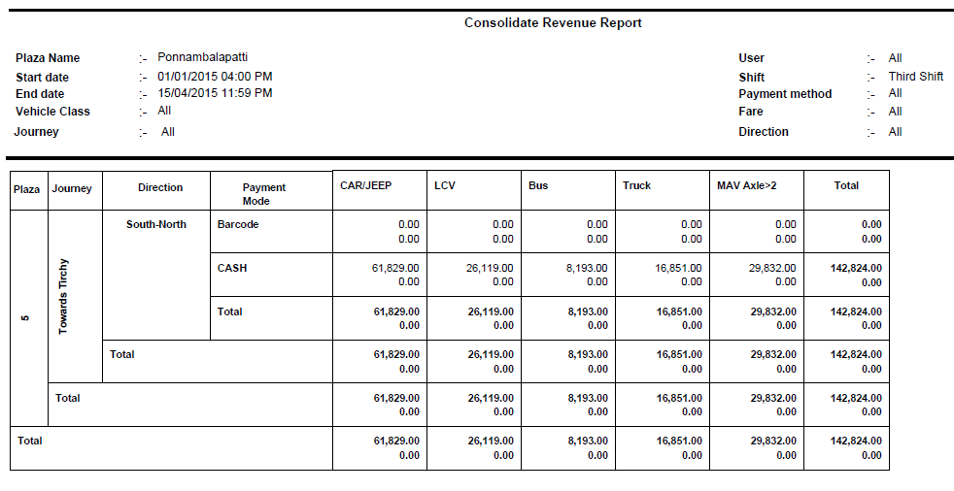

Figure 188 - Consolidate Revenue Report

## Pre-Paid Card Reports

It displays all pre-paid card type of toll payment reports. Pre-Paid card payment method involves two types of cards that are Smartcard Card and Electronic Toll Collection.

Following are the steps to generate the report of Pre-Paid Card.

In **Report Category** drop-down list, select **Pre-Paid Card Reports** option.

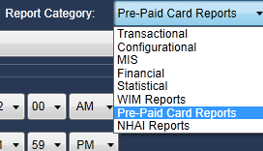

Figure 189 – Pre-Paid Card Reports Category

In **Reports** drop-down list, the list of all available **Pre-Paid Card** report is populated. Following are the types of report.

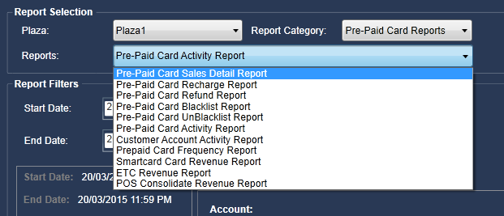

Figure 190 – Prepaid Card Report Options

### Pre-Paid Card Sales Details Report

Select this option, if you want to generate the sales details report of the pre-paid card. For each card type, you can see its sales details such as date when card was sold, the expiry date of card, vehicle class for which card was sold, vehicle registration number and so on.

### Pre-Paid Card Recharge Report

Select this option, if you want to generate the recharge details report of the pre-paid card. For each card type, you can see its recharge details such as date when the card was recharged, the recharge amount, and the vehicle class for which card was recharged and so on.

### Pre-Paid Card Refund Report

Select this option, if you want to generate the refund details report of the pre-paid card. For each commuter account, you can see its corresponding details such as vehicle class for which the card was refunded, the vehicle registration number for which card was refunded, the amount paid for card, the date when card was refunded, the expiry date of card and so on.

### Pre-Paid Card Blacklist Report

Select this option, if you want to generate the blacklist report of the pre-paid card based on type of pre-paid card, user, and vehicle class. You can see the details such as account holder whose card was blacklisted, the date when card was blacklisted, the vehicle class for which card was blacklisted.

### Pre-Paid Card UnBlacklist Report

Select this option, if you want to generate the unblacklist report of the pre-paid card based on type of pre-paid card, user, and vehicle class and so on. For each accountholder or commuter, you can see its corresponding details such as vehicle class for which card was unblacklisted, the vehicle registration number for which card was unblacklisted, the date when card was unblacklisted, and the expiry date of the card.

### Pre-Paid Card Activity Report

Select this option, if you want to generate the report for all activities that are placed for each prepaid card.

### Customer Account Activity Report

Select this option, if you want to generate the report for all activities that are placed on each customer account by POS operator. For each customer, you can see its corresponding details such as the date when account was first created or when pre-paid card was first purchased, amount with which the pre-paid card was recharged.

### Pre-Paid Card Frequency Report

Select this option, if you want to generate the report to see how many times the card was used by commuter. You can see the details such as name of commuter who used the card, the lane number on which card was used, the type of vehicle for which card was used, and the shift number on which card was used.

### Smartcard Card Revenue Report

Select this option, if you want to generate the report to see how much revenue was generated from smartcard. You can generate the report based on users or commuters, and shifts. You can see the total smartcard revenue earned by specific user or commuter, such as the vehicle number for which smartcard was issued by commuter, the deposit amount that was taken by POS from commuter as a security, the date and time when smartcard was taken by commuter, the vehicle class for which smartcard was taken.

### ETC Revenue Report

Select this option, if you want to generate the report to see how much revenue is generated from electronic toll collection payment method. You can generate the report based on users or commuters, and shifts. You can see the total ETC revenue earned by specific user or commuter, such as the vehicle number for which smartcard was taken by commuter, the deposit that was taken by POS from commuter as a security, the date and time when smartcard was taken by commuter, the vehicle class for which smartcard was taken.

You can categorize the report by using following filters.

**Common Filters**: **Start Date** and **End Date** filters are always available when you select any of the pre-paid card report.

Select the date range for which you want to generate the report.

* **Start Date**: Click on calendar icon available corresponding to the **Start Date** and select the required date. You can also select the specific time of selected date.
* **End Date**: Click on calendar icon available corresponding to the **End Date** and select the required date. You can also select the specific time of selected date.

**Note**: If you want to see the report of specific date, you need to select that date in both the **StartDate** and **End Date** fields.

There are some filters that are displayed depending on the type of report that you have selected.

Generate **Pre-Paid Card Sales Detail, Pre-Paid Card Recharge, Pre-Paid Card Refund, Pre-Paid Card Blacklist** and **Pre-Paid Card UnBlacklist** reports based on following filters:

* Teller
* Vehicle Class
* User
* Shift
* Pre-Paid Type

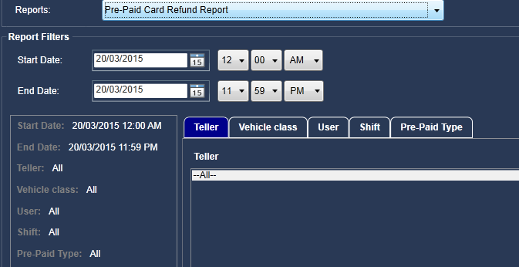

Figure 191 – Prepaid Card Refund Report Filters

Generate **Pre-Paid Card Activity** based on following filters:

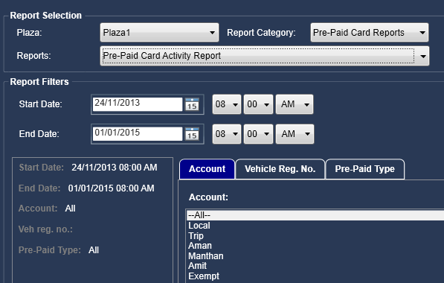

Figure 192 – Prepaid Card Activity Report Filters

* Account
* Vehicle registration number
* Pre-paid type

Generate **Customer Account Activity Report** based on following filters:

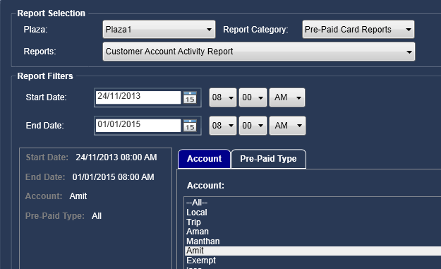

Figure 193 – Customer Account Activity Report Filters

* Account
* Pre-paid type

Generate **Prepaid card frequency** based on following filters:

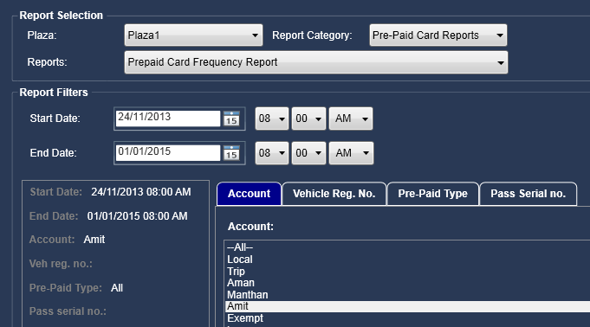

Figure 194 – Prepaid Card Frequency Report Filters

* Account
* Vehicle registration number
* Pre-paid type
* Pass serial number

Generate **SmartCard card Revenue Report** and **ETC Revenue Report** based on following filters:

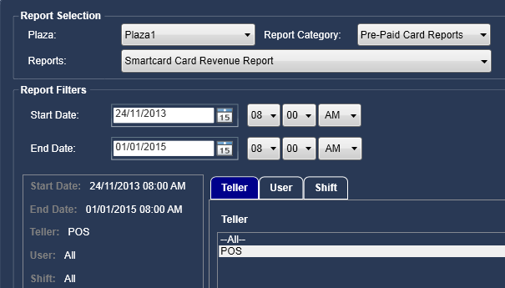

Figure 195 – Smart Card Revenue Report Filters

* Teller
* User
* Shift

Generate **POS Consolidate Revenue** report based on following filters:

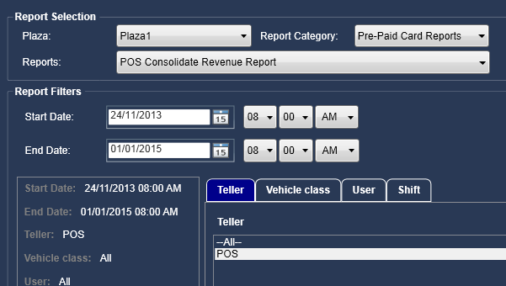

Figure 196 – POS Consolidate Revenue Report

* Teller
* Vehicle class
* User
* Shift

**Generate the Report**

Click on **Generate** button. The report is opened in PDF format, depending on the type of report and the filters you have selected to generate the report.

**Pre-Paid Card Sales Detail Report**

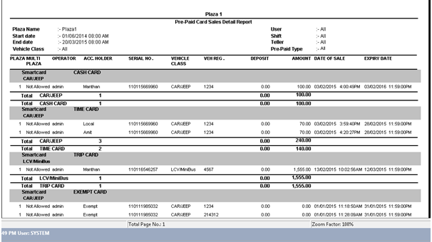

Figure 197 – Prepaid Card Sales Detail Report

**Pre-Paid Card Recharge Report**

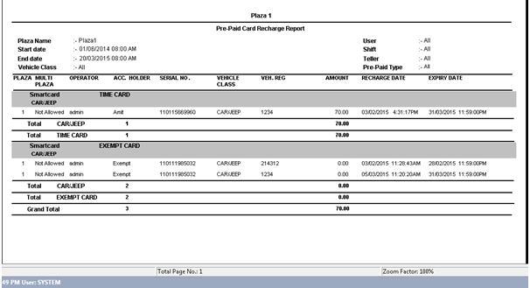

Figure 198 – Prepaid Card Recharge Report

**Pre-Paid Card Refund Report**

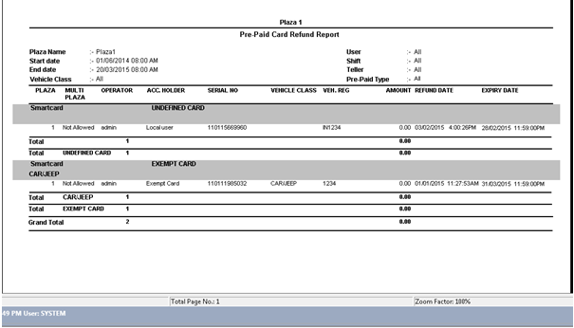

Figure 199 – Prepaid Card Refund Report

**Pre-Paid Card Blacklist Report**

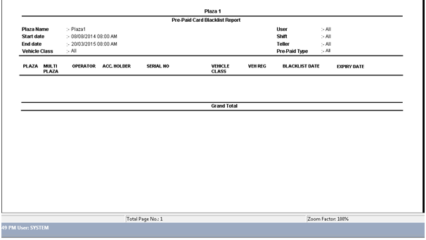

Figure 200 – Prepaid Card Blacklist Report

**Pre-Paid Card Frequency Report**

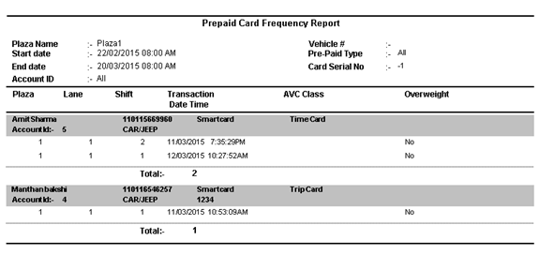

Figure 201 – Prepaid Card Frequency Report

**Smartcard Card Revenue Report**

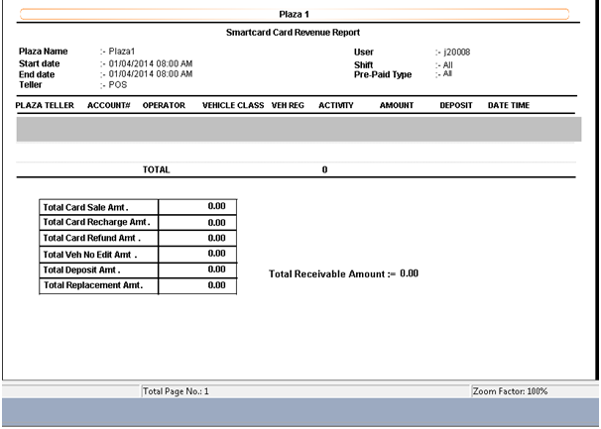

Figure 202 – Smartcard Card Revenue Report

**ETC Revenue Report**

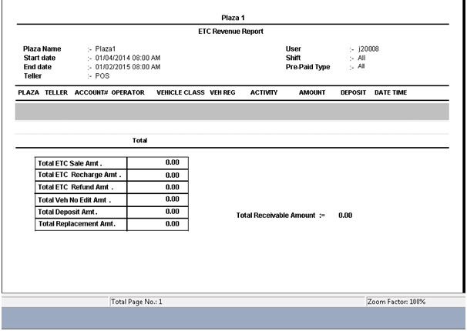

Figure 203 – ETC Revenue Report

**POS Consolidate Revenue Report**

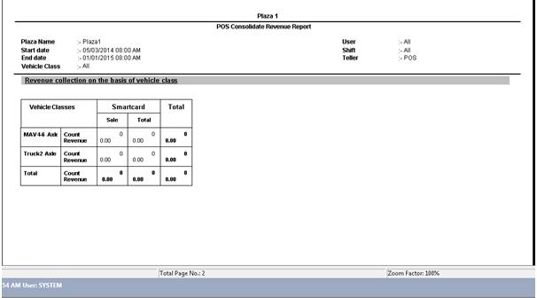

Figure 204 – POS Consolidate Revenue Report

You can either save the report or take the print of report for later user.

**Depot Vehicle Report**

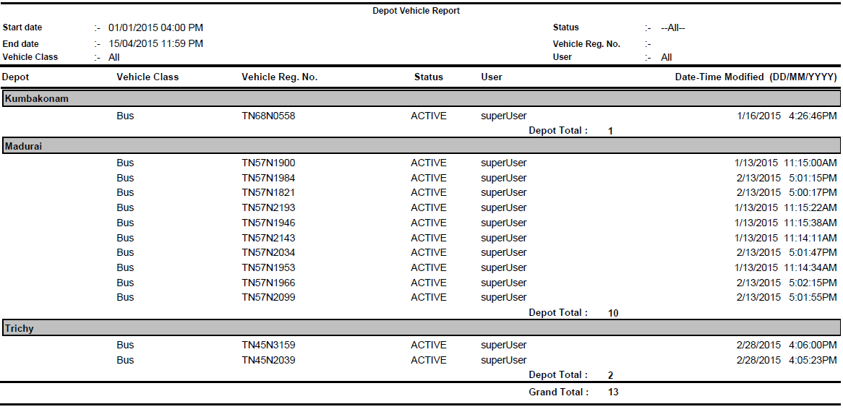

**Customer Account Activity**

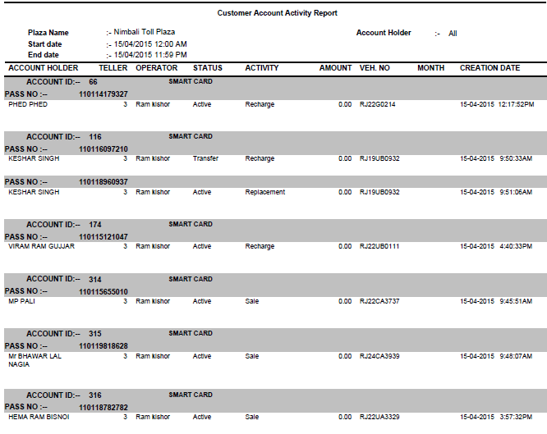

## WIM Reports

It displays all WIM reports available in the system. Following are the steps to generate WIM reports:

In **Report Category** drop-down list, select **WIM Reports** option.

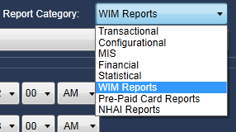

Figure 205 – WIM Reports Category

In **Reports** drop-down list, the list of all available WIM reports is populated. Following are the types of report.

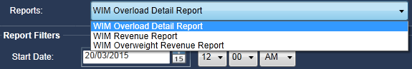

Figure 206 – WIM Report Options

### WIM Overload Detail Report

Select this option, if you want to generate the overload details report of the WIM. For each transaction, you can see its corresponding WIM details such as vehicle class, fare type, payment method, actual measured weight of vehicle, weight allowed for vehicle, penalty amount, if overweight, whether penalty was paid or not, whether vehicle was overloaded or not and so on.

### WIM Revenue Report

Select this option, if you want to generate the revenue details report of the WIM. This revenue is generated by the penalty that toll collector had charged from commuter due to the overweight of vehicle.

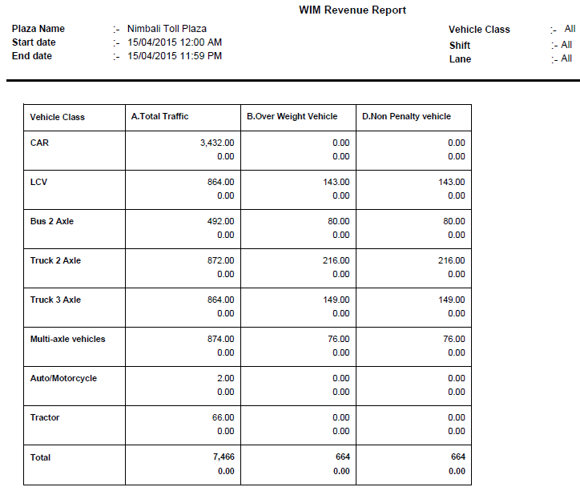

### WIM Overweight Revenue Report

Select this option, if you want to generate the report of earned revenue because of the overweight vehicle.

* + - 1. **WIM Transaction Detail Report**

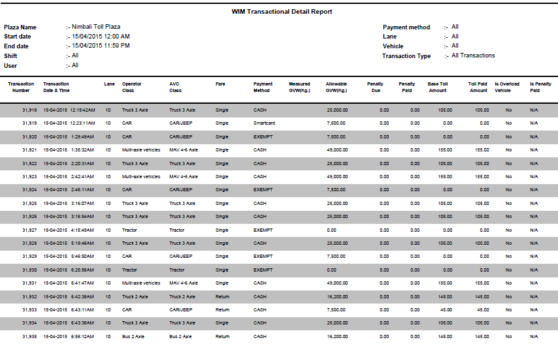

**Using Filters**

You can categorize the report by using following filters.

**Common Filters**: **Start Date** and **End Date** filters are always available when you select any of the WIM report type.

Select the date range for which you want to generate the report.

* **Start Date**: Click on calendar icon available corresponding to the **Start Date** and select the required date. You can also select the specific time of selected date.
* **End Date**: Click on calendar icon available corresponding to the **End Date** and select the required date. You can also select the specific time of selected date.

**Note**: If you want to see the report of specific date, you need to select that date in both the **StartDate** and **End Date** fields. Start and End Dates fields are mandatory to select to generate the report.

There are some filters that are displayed depending on the type of report that you have selected.

**WIM Overload Detail Report**

When you select **WIM Overload Detail Report** option, the additional filters are displayed as a separate tab, as below.

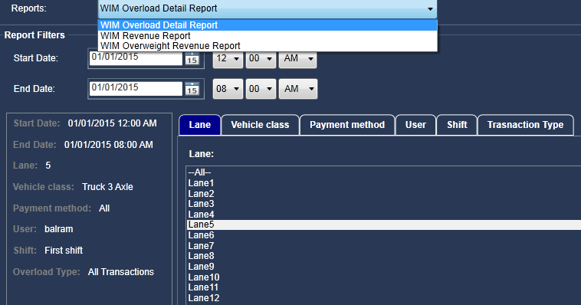

Figure 207 – WIM Overload Detail Report Filters

* **Lane**: Select specific lane to see the report based on selected lane. You can also select All option to see the report based on all lanes.
* **Vehicle Class**: Select the required class of vehicle.
* **Payment Method:** Select the required payment method such as cash, smart card and so on.
* **User**: Select the required user or commuter.
* **Shift**: Select the required shift.
* **Transaction Type**: Select the required type of transaction.

The options populated in each tab, depending on the options configured in MCM module.

**WIM Revenue Report**

When you select **WIM Revenue Report** option, the additional filters are displayed as a separate tab, as below.

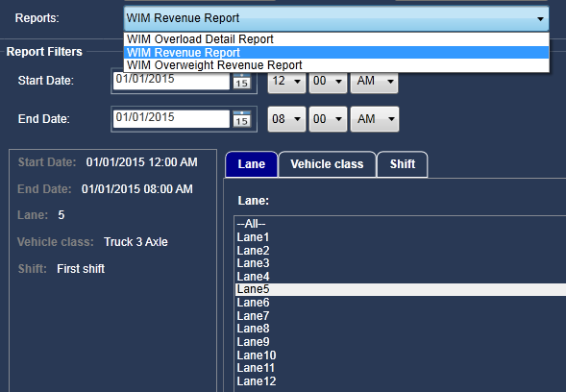

Figure 208 – WIM Revenue Report Filters

* **Lane:** Select **All** option to select all the lanes or specific lane.
* **Vehicle Class:** Select the specific class of vehicle.
* **Shift:** Select the required shift.

**WIM Overweight Revenue Report**

When you select **WIM Overweight Revenue Report** option, the additional filters are displayed as a separate tab, as below.

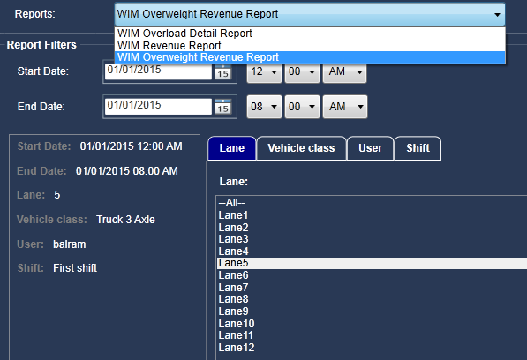

Figure 209 – WIM Overweight Revenue Report Filters

* **Lane:** Select **All** option to select all the lanes or specific lane.
* **Vehicle Class:** Select the specific class of vehicle.
* **User:** Select the required user.
* **Shift:** Select the required shift.

**Note:** For each of the above filter, you can select multiple options. For example, you can select multiple lanes based on which you want to generate the report. Press **Shift** to select multiple options.

You can use one or more of the above filters or all filters together to generate the report.

**See the Applied Filters**

In bottom left side section, you can see all applied filter names with their respective selected options/option that you are using to generate the report.

There are two buttons available at the bottom right side of the screen.

**Reset Filters**

Click on this button, if you want to reset all the filters. You can see that all filters are set to their default option.

**Generate Report**

Click on this button to generate the report based on the options that you have selected on this screen. The report is opened in PDF format as below.

You can either save the report or take the print of report for later use.

## NHAI Reports

It displays all the reports that are related to National Highway Authority of India (NHAI). Following are the steps to generate the report of NHAI.

In **Report Category** drop-down list, select **NHAI Reports** option.

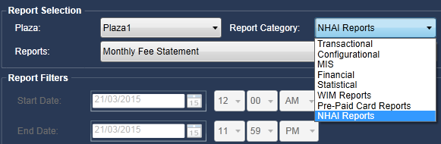

Figure 210 – NHAI Reports Category

In **Reports** drop-down list, the list of all available NHAI reports is populated. Following are the types of report.

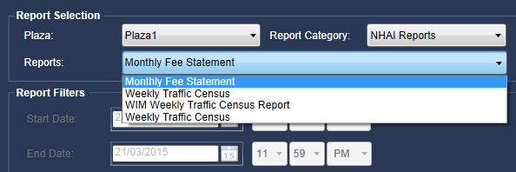

Figure 212 – NHAI Report Options

### Monthly Fee Statement

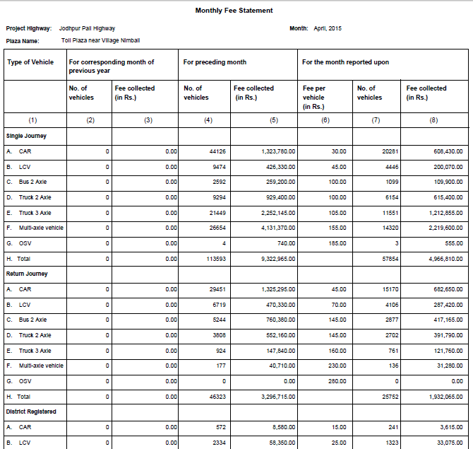

### WIM weekly Traffic Census Report

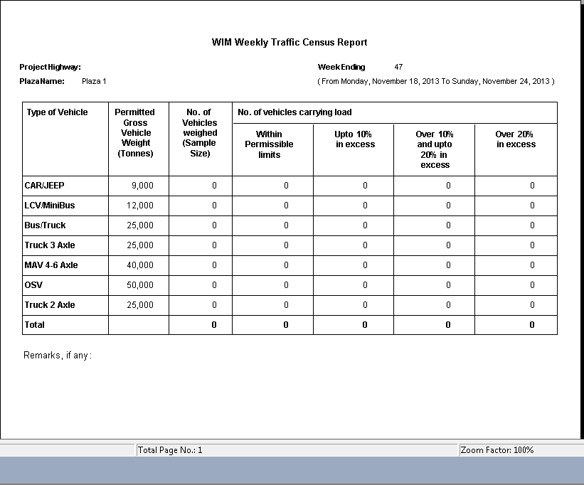

Figure – WIM Weekly Traffic Census Report

### Weekly Traffic Census

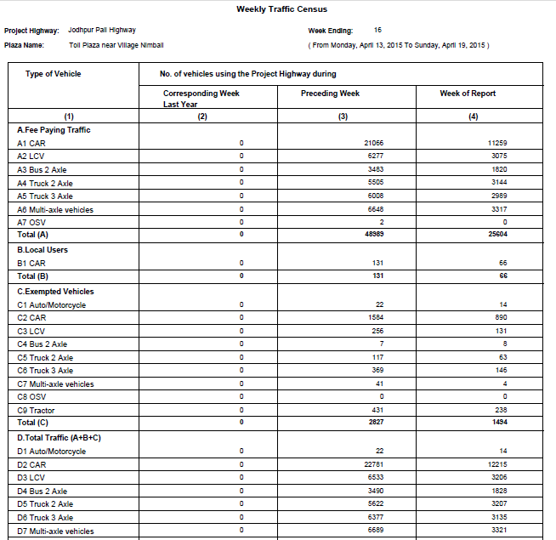

**Using Filters**

**Weekly Traffic Census**: Generate this report based on following filters.

* **Start Date**: Select the date from which the week starts.
* **End Date**: When you select this option, the **End Date** field becomes disabled, as this report type displays weekly report.

**Monthly Fee Statement**: Generate this report based on following filters.

* **Month**: Select one or multiple months for which you want to generate fee statement report.
* **Year**: Select the year of the selected month/months. You can select only one year at a time.

**WIM Weekly Traffic Census Report**: Generate this report based on following filter.

**Start Date**: Select the date from which the week starts.

In the report, you can see following details.

* At top right side, you can see the specific week that you have selected to generate the report.
* At top left side, you can see the plaza number.

For each type of vehicle, you can see its corresponding details such as the gross weight allowed to cross the lane, number of vehicles within limit and so on.

# File\Media Transfer Service

Backup Server is responsible to take the backup of all media files in order to prevent the loss of data in the event of hard drive failure, user error etc. All media files are transferred from lane to the plaza server. The plaza server is attached to the backup server.

* **Media Files Backup in Same Machine**: The backup of media files can be taken at plaza server in different drive.
* **Plaza Server attached with Backup Server**: The backup of media files can be taken in backup server. This backup server is attached with plaza server. All media files are transferred through PGS service from plaza server to backup server. In backup server, the backup of all media files can be taken at required media drive.

**Image Video Backup in Same Machine in Different Drive**

## 

Figure – Media Files in Same Machine in Different Drive

**Backup Server attached with Plaza Server**

## 

Figure – Backup Server Attached with Plaza Server

# WIM Disputed Management System

toll***M***ax® WDMS is a module, through which user can visualize actual weight of a vehicle and on the basis of the same penalty could be charged, if overweight.

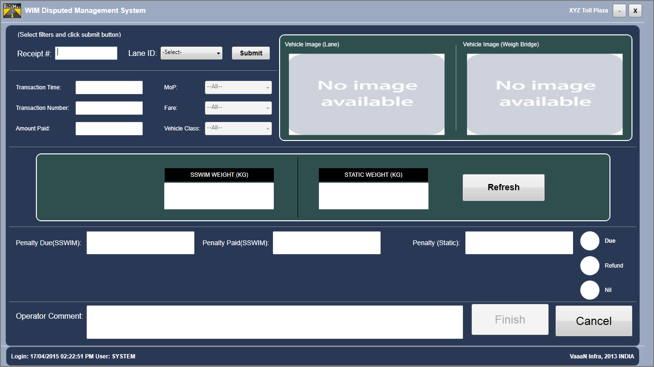

Figure WDMS Screen



The WIM Disputed Management System is installed on system where static weigh bridge is located.

## Selection of transaction

To proceed with transaction, a WDMS operator is required to enter receipt number and lane id from which a receipt was generated and handed over by commuter for weighing vehicle on static weigh bridge.



Figure Enter receipt number



Figure Select a lane id

After entring receipt number and lane id, click on submit button.



Figure

## Transaction Information

A selected transaction via receipt number provided by commuter could be displayed as shown below:

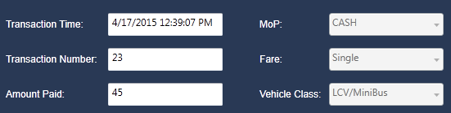

Figure Transaction details

|  |  |
| --- | --- |
| **Terms** | **Description** |
| Transaction Time | A time of transaction processed. |
| Transaction Number | Number generated for a transaction. |
| Amount Paid | Amount paid b6y commuter. |
| MoP | Method of payment |
| Fare | Single is the fare associated with the transaction. |
| Vehicle Class | Vehicle for which transaction is processed. |

## Vehicle Image

A vehicle image, when transaction is processed on lane and live streaming of the camera installed on static weigh bridge could be visualized as shown below:

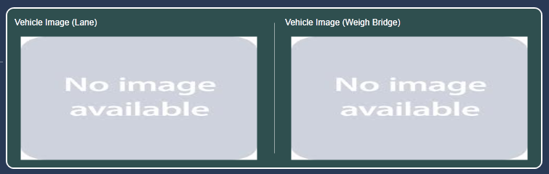

Figure Lane Image & Weigh Bridge Live Streaming

## Weight by SSWIM & Static Bridge

Information of weight from lane and static bridge is attained by clicking refresh button, when vehicle is standing on Weigh Bridge.



Figure – SSWIM & Static Weight

## Penalty Amount

A penalty amount is calculated as per configured toll rate depending upon type of fare selected (single, return, district registered). Calculated penalty is shown below:

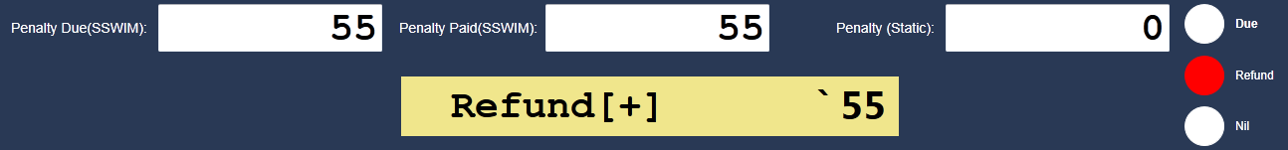

Figure – SSWIM & Static Weight

A penalty could be refunded back, could be taken from commuter (overweight vehicle) or it could be nil, which is visualized in the above figure. An amount is required to be refunded back to commuter, since penalty is already paid.

## Finish a Transaction

A user could write comments in the provided space for a particular transaction. Clicking on finish button completes a transaction, otherwise click on Cancel button.



Figure

Clicking on **Finish** button, a penalty receipt would be generated.

**[End of Document]**